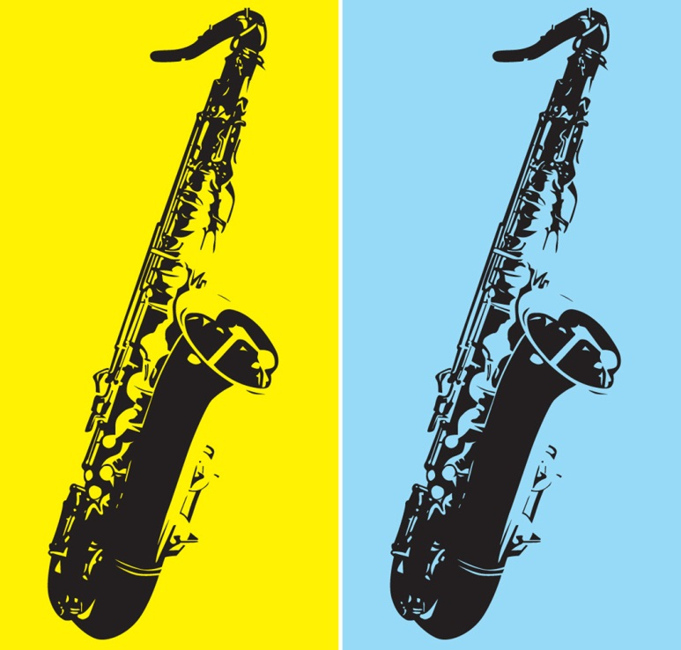
Black History Month

Celebrate Jazz Music and Its Contributions to America LIVE!

The U.S. Department of Education’s Student Art Exhibit Program and Blacks In Government, in partnership with the
Thelonious Monk Institute of Jazz, invite you to this celebration of Black History Month and to the Department’s first

LIVE JAZZ INFORMANCE
Friday Feb. 22 at noon to 1 p.m.
At the U.S. Department of Education, LBJ Auditorium
400 Maryland Ave. SW, Washington, D.C.

This event is an informational performance—an "informance"—that will demonstrate the values of jazz as they reflect the values of the U.S. Under the direction of Dr. J.B. Dyas, vice president for education and curriculum development at the Thelonious Monk Institute of Jazz, gifted music students from the Institute's National Performing Arts High School Program will play various styles of jazz and talk with their audience about what jazz is, why it is important to America, and how a jazz ensemble represents a perfect democracy. They also will provide further insight into important American values that jazz represents: teamwork, unity with ethnic diversity, the correlation of hard work and goal accomplishment, and the vital importance of really listening to one another.

Featuring Special Guest Jazz Recording Artist
Tim Green
Rising star, saxophonist, composer and arranger

To attend
RSVP by Feb. 20 to
jacquelyn.zimmermann@ed.gov

Questions?
Jackye Zimmermann
202-401-0762





