Archived Information
Critical Issues in Schools Today:
What High Performing Schools Can Tell Us

At the No Child Left Behind Blue Ribbon Schools Awards Ceremony, held in Washington, D.C., on November 4-5, 2004, representatives of twenty high-performing schools took part in eight Critical Issues Panels. A synopsis of their presentations and discussion follows.

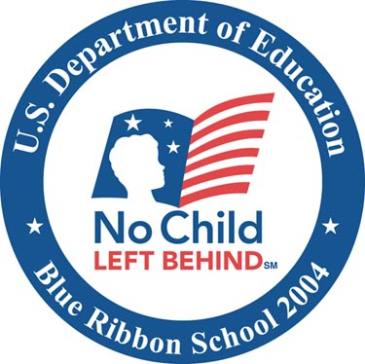

What Matters Most?

Before the Critical Issues Panels, school personnel were invited to select their top five strategies for creating high performing schools.

Overwhelmingly, High Expectations for student success—held by students, school staff members, and parents—was rated the most important factor (125 schools).

Next came rigorous Curricula, aligned with state content and performance standards and articulated across grade levels (119 schools). Following curricula were a Common Vision and Shared Values about academic success for all students (81 schools), a Communitywide Commitment to educational excellence (80 schools), and ongoing Professional Development, based on research and embedded in classroom instruction (76 schools).

Multiple Assessments to monitor student progress and inform instruction (60 schools) and administrators taking on Instructional Leadership (58 schools) were also judged important.

High Expectations

Columbus High School, Columbus, GA
Susan Bryant, Principal

Students enter this Blue Ribbon School following an admissions process that includes academic tests, a commitment to work, and solid 8th grade achievement. High expectations begin with summer reading and math packets given to all incoming students. Once in school, students are expected to complete daily homework assignments, 20 hours of annual community service, extensive SAT preparation, field trips, and a senior project. All courses are honors level; students are expected to maintain a “C” average or above. Eighteen Advanced Placement courses are available to students in the 10th grade or above. Each Senior project, judged by members of the community, involves 100+ out-of-class hours, a research paper and portfolio, and an oral presentation.

Students are also held to high behavioral and ethical standards. They receive both character education and etiquette training. The school maintains an Integrity Committee and students are expected to interact with mutual respect. Student incentives include Honors Night, a Day of Distinction, True Blue Awards, Perfect Attendance Awards, Academic Letters, Brag Cards, SAT Prizes, Positive Postcards, and Winners’ Circles.

Faculty are involved in a range of school decisions, including admissions, community service, field trips, and extracurricular activities.



Curriculum

California Academy of Mathematics & Science,
Carson, CA
Kathleen Clark, Principal

Resurrection Catholic School,
Lakeland. FL
Nancy Genzel, Principal

Woodrow Wilson School,
Weehawken, NJ
Ronald Treanor, Principal

Curricula in all Blue Ribbon Schools are tied to state standards. All use research-based instruction, tailored to student needs as identified through assessment. Blue Ribbon Schools group students by areas where tests have revealed they need more work.

Beyond those core principles, Blue Ribbon Schools work in many different ways. Schools with high populations of English language learners frequently use small group instruction and interaction. Many schools develop “pacing guides” to determine the sequence and timing of academic skills. Some schools place several core teachers with student groups to work in highly interdisciplinary ways. Others use substitute teachers to cover classes so teachers can plan together during school hours. Several Blue Ribbon Schools are part of a movement to restructure high schools into smaller learning communities, each with a distinct focus.

One school likened constructing a curriculum to creating a building. It begins with a foundation (mission) and a building crew (school and community stakeholders). The crew works with supplies (teaching and learning strategies) under the guidance of a boss (school leaders) and foremen (teachers) to create a course of studies.

Another school uses a completely different metaphor: “weaving the arts into the fabric of instruction.” Integrating the arts into a curriculum aligned with state standards, it works to create a student-centered curriculum and learning environment. Following a block schedule, it uses the arts as an entry point for interdisciplinary, cooperative learning—a scaffold for students who have difficulty as independent learners.



Professional Development

Carmel High School, Carmel, IN
Michele Satchwell, Teacher

Martin H. Traphagen Elementary School,
Mt. Vernon, NY
Joseph C. Jordano, Principal

T. H. Rogers Elementary School, Houston, TX
Nancy Manley, Principal

For Blue Ribbon Schools, good Professional Development is:

- Meaningful. It clearly answers the question, “why are we doing this?” It is conceived, planned, and largely executed by, teachers, though it is part of both schoolwide and districtwide professional development plans.
- Individualized. It is tailored to the needs of each individual teacher. Blue Ribbon Schools use researched best practices for adult learning as well as student learning.
- Useful. It informs and improves practice right away. It focuses on root causes and long-term consequences rather than symptoms and quick fixes. It is ongoing, and usually involves follow up and further coaching.
- Significant. It can be embedded in daily practice.
- Based on improved student improvement. Driven by data, professional development is focused on increasing student accomplishment.
- Evaluated. Blue Ribbon Schools measure both how well professional development was implemented and what kinds of increases in teachers’ and students’ learning resulted from it.

How does a school create a professional learning community? Some professional learning communities are cross-curricular; others are vertically organized across grades. Still other Blue Ribbon Schools bring teachers together over specific grade-level content. In one school, for example, “there is only one lesson plan for the 4th grade.”

Blue Ribbon Schools frequently take a systems approach, recognizing that schools are systems with identifiable, recurring patterns—and that change results from “fixing systems instead of people.” One Blue Ribbon School analyzed the process of “group development” by its four stages: forming, storming, norming, performing. A group’s identity takes shape in recognizable patterns:

During forming, the group’s high expectations and initial enthusiasm typically outweigh the anxiety of trying something new. Issues of inclusion and trust are paramount as the group tests itself and tries to figure out its structure. The leader gives the group direction: defining goals and tasks, assigning roles, and developing skills.
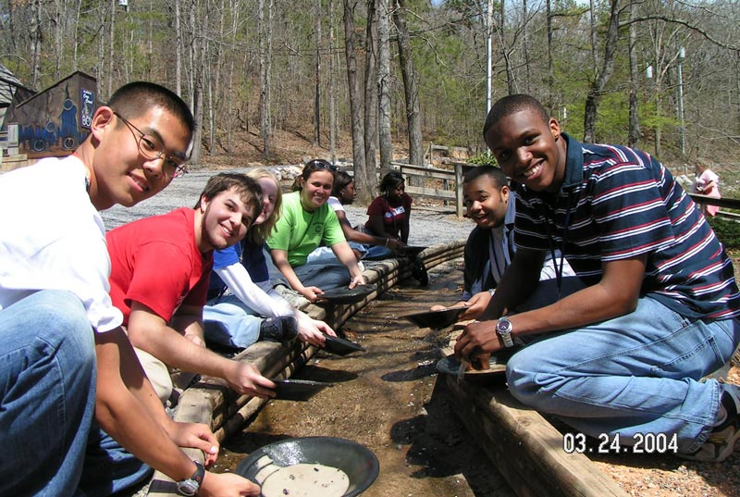
During storming, the group’s identity becomes extremely fragile. Despair, frustration, and disappointment, confusion, and outright rebellion may occur as the difficulty of the task before it becomes clearer. The leader keeps the group focused on its goals.

During norming, the leader offers constructive feedback and coaches group members in their developing skills. Participants begin to trust each other, demonstrating confidence, respect, and support. The group takes responsibility for itself and what it needs to know and do.

During the final, performing, phase, the group becomes productive. Relationships become interdependent and collaborative, and the group expresses confidence in its own abilities. By this time, the leader’s role has diminished. The period of intense coaching and support has ended, although the leader continues to offer instruction and help the group complete its identified tasks.

The value of good professional development extends beyond student improvement. Blue Ribbon School teachers talked about “the value and joy of collaboration” and observed that student improvement becomes a common conversational topic. Good professional development changes a school’s culture.

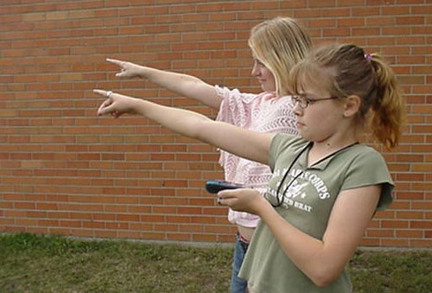
Leadership

Belle Isle Enterprise Middle School, Oklahoma City, OK
Lynn Kellert, Principal

Columbus Elementary School, Mt. Vernon, NY
Peter M. Ragaglia, Principal

Frankford Elementary School, Frankford, DE
Sharon Brittingham, Principal

Saint Alphonsus Liguori School, Prospect Heights, IL
Peter Tantillo, Principal

One Blue Ribbon School leader put the issue of leadership in its historical context:

“Our greatest challenge is preparing students for the Informational Age using an Industrial Age school model. Industrial Age classrooms must be transformed to Information Age learning environments focused on learning for all.”

Student achievement is a Blue Ribbon School administrator’s highest priority. Blue Ribbon School leaders believe that every child can achieve high standards. They also believe that effective leaders partner with all the school’s teachers and staff members (including administrative, custodial, medical, and cafeteria workers as well as the school psychologist, social worker, and speech clinician).

Blue Ribbon Schools have found that schools that are themselves healthy organizations foster high student performance. One Blue Ribbon School has even created an Organizational Health Instrument. Used to evaluate the school’s internal workings and guide planning and decision making, it measures:

Goal Focus—the degree to which teachers have clarity about and accept, support, and advocate for schoolwide goals and objectives.

Cohesiveness—the degree to which staff members work, both independently and as teams, to accomplish the schools’ goals.

Adaptation—the degree to which a school tolerates stress and maintains stability while coping with external demands for change.

Strategies for improving a school’s organizational health include:

- developing interdependent teams, drawn from a variety of groups;
- adapting schedules so teams have times to consult and work together;
- increasing communication skills (such as giving specific feedback) of all team members;
- understanding the natural stages of team development and developing an “esprit de corps;”
- developing a community of leaders—including parents; and
- providing training, often through pairing teachers with mentors, coaches, or master teachers.

One Blue Ribbon School was part of a districtwide “lead teacher” program: some 25 to 30 lead teachers through the district developed curricula and pacing guides to decide which academic skills would be taught when. Lead teachers are typically relieved of some administrative duties.


Parent Involvement

Handley Elementary School, LaPorte, IN
Dorothy Davis, Principal

Pearl River Central Junior High School, Carriere, MS
Durwood Baucum, Teacher

Blue Ribbon Schools recognize the profound value of parental involvement in students’ lives. When parents take an active interest in their children’s education, student achievement increases, behavior and attendance improves, students begin to see their own potential, and learn to value education as a lifelong endeavor.

Welcoming the involvement of parents and guardians, Blue Ribbon Schools also work to encourage it by engaging in dialogue about what constitutes parental support (particularly at the middle and high school levels) and accommodating parents’ income, time, and work pressures. Blue Ribbon Schools have identified five ways to build strong relationships with parents:

- Maintain school Internet websites and e-mail contacts so students and parents can gain school information.
- Implement after-school programs at churches and businesses.
- Offer classes for parents in subjects of interest, such as parenting.
- Sponsor “Parent of the Year” awards.
- Invite parents to carry out specific jobs, such as school monitor.

They have also identified four ways that parents can help:

- Schedule daily homework time in an environment conducive to learning.
- Keep in touch with the school and check on their children’s progress.
- Monitor time their children spend watching TV, using the computer, or socializing with friends.
- Offer their children daily praise and encouragement.

Blue Ribbon Schools recognize that “parent involvement” properly includes the community at large and engage local media as well as community leaders in helping schools. Some schools have involved the local Rotary Club; others work with HOSTS (Helping One Student To Succeed), a national volunteer mentoring program that pairs students who need help in reading and language arts with community members who want to make a difference in a child’s life.



Differentiated Instruction

Isaac Dickerson Elementary School, Asheville, NC
Martha Hayes, Teacher

Primary (grades K-2) students at one Blue Ribbon School are divided into multiage classes of students aged 5, 6, and 7 years, in a pattern familiar to children from their own families and neighborhoods. K-2 students stay with the same teacher for two years.

Students learn through real-world skill development—taking field trips in the community, publishing their writing on the computer, making videos, conducting research on the Internet, etc. The students maintain the school gardens and playgrounds and are involved in community service projects.

The work teachers and learners do is shaped by learner choice and designed with rigorous and ongoing assessment. Teachers serve as facilitators and collaborators. Peer teaching, small group work, and team work all occur in classrooms, and the connections between classroom work and the surrounding community and the larger world are clear: the audience for students’ work extends beyond the teacher.

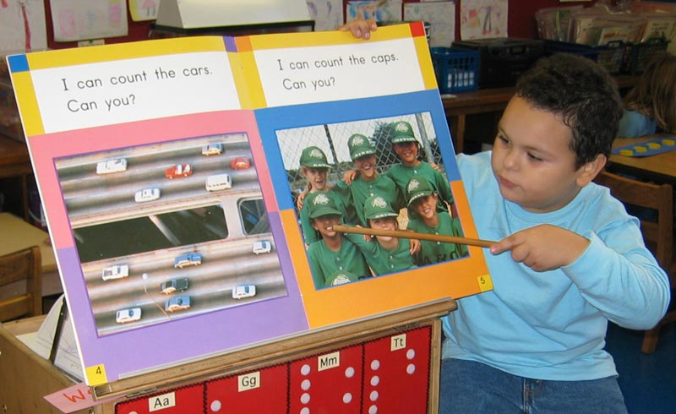

Assessment

Esparto Middle School, Esparto, CA
Carole Hiltman, Principal

Keystone Elementary School, Memphis, TN
JoAnne Jensen, Principal

Kittredge Magnet School,
Atlanta GA
Gail Humble, Principal

Madison Heights School,
Phoenix, AZ
Denise Donovan, Principal

Pisgah Forest Elementary School, Brevard, NC
Ron Kiviniemi, Principal

In Blue Ribbon Schools, assessment provides the vital feedback students, parents, teachers, and school leaders need in order to improve student learning. Based on the same standards that shape curricula, the assessments are woven into student learning. Blue Ribbon School teachers use tests in the context of what they want their students to know: tests monitor student learning and guide future instruction. Teachers know that test data are information about their teaching—not grounds for punishment—and use data to plan specific remedies for students who are not meeting expectations. Blue Ribbon School teachers also undergo rigorous evaluations of their own performance.

Some Blue Ribbon Schools begin teaching testing strategies in kindergarten. Most Blue Ribbon Schools use a variety of assessment tools, from formal and informal test data, surveys, class observations, and anecdotal information. One Blue Ribbon School posts assessment scores—but for whole classes, not individual students. School leaders use assessment data not only to shape instruction, but to inform professional development opportunities. Both teacher evaluation data and student achievement data inform individual teachers’ Professional Development Plans.

Blue Ribbon Schools typically create opportunities for teachers and parents to understand test results. They offer teachers workshops on analyzing test results and provide time for teachers to analyze students’ classroom work and assessment results. Blue Ribbon Schools communicate about test results with parents face-to-face and work with parents to develop action plans based on a student’s strengths and deficiencies.

Most important, Blue Ribbon Schools use test results to improve learning. Guided by assessments of student weaknesses, Blue Ribbon School teachers break lessons into small parts and give students extra practice. They offer students with disabilities a range of supports, from preschool instruction to specialized oral language programs. They know that high expectations of students yield high achievement, and give students responsibility for their own learning at the same time that they offer students a range of learning strategies. For example, a Blue Ribbon School’s reading strategies might include speaking assignments, role-playing, storytelling, oral book reports, character dress-ups, graphs, Internet use, creating pamphlets, preparing research articles, working with computerized reading programs, journal writing, or competing for points in the Accelerated Reader program. Math strategies might use alternate assessments in game format, drill activities, and extra practice at home and in school.
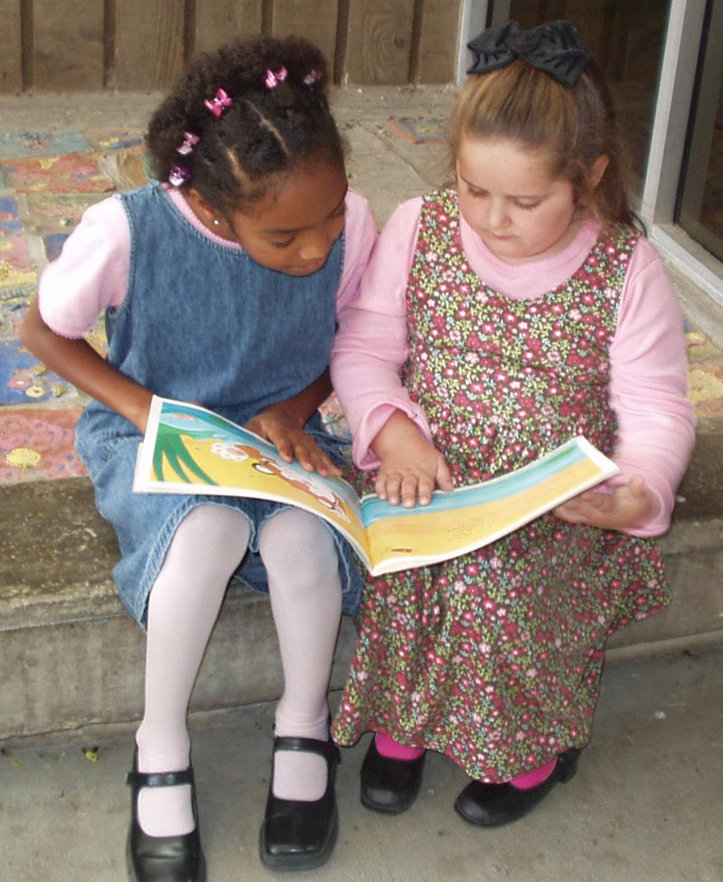

Some school pre-test students for their knowledge of learning objectives; this allows teachers to differentiate the curriculum as they work with students in small groups, so that students who need more help can learn at a faster pace.

Some Blue Ribbon Schools go even farther with assessment, analyzing data from former classes of students for teaching trends and areas of strong and improving teaching practice, and analyzing data from incoming students for students’ need for instruction.

Teachers also undergo assessments, based on best teaching practices; Blue Ribbon Schools hold teachers accountable for implementing changes and improving practice. They use their student achievement data to develop Personalized Professional Development Plans.

In one Blue Ribbon School, the principal insisted that any student who got less than 70% correct on an assessment test receive tutoring. “Just meeting the standard isn’t good enough” in her school, she said. Students who need more learning time are tutored by teachers who haven’t taught that particular student. Every person in the school, including janitorial, cafeteria, and secretarial staff, assists in the students’ learning.



Technology

Edgewood Elementary School,
Columbus, GA
Roxann Elder, Teacher

Blue Ribbon Schools are not unique in the disparity between students’ and teachers’ knowledge of technology. Most students know digital technologies far better than their teachers. While this disparity can distract both students and teachers, in some Blue Ribbon Schools, it opens an opportunity for partnering in the educational experience.

Blue Ribbon Schools work to adapt technology to classroom needs, rather than allow it to dominate classrooms. Professional development in technology respects “tried and true“ pedagogy while offering appropriate enhancements to the educational experience: teaching objectives are central. Blue Ribbon Schools use technology to adapt lessons to students’ learning styles while respecting teachers’ comfort zones.

