Individuals using assistive technology may not be able to fully access the information contained in this file.

For assistance, please send an e-mail to NRC-FLAS@ed.gov and include “508 Accommodation” and the title of the document in the subject line of your e-mail.

Northern Illinois University Center for Southeast Asian Studies “Teach Southeast Asia II”

Title VI National Resource Center Foreign Language and Area Studies (FLAS)

Proposal for August 2022-August 2026

National Resource Centers (NRC) Program Northern Illinois University

TABLE OF CONTENTS
Project Narrative
- Commitment to the Subject Area on Which the Center Focuses. 1
- Quality of Language Instructional Program. 4
- Quality of Non-Language Instructional Program. 9
- Quality of Curriculum Design. 13
- Quality of Staff Resources. 17
- Strength of Library. 20
- Impact and Evaluation. 23
- Outreach Activities (NRC) 28
- FLAS Awardee Selection Procedures. 33
- Program Planning and Budget (NRC). 35
  - Competitive Preference Priorities (FLAS) 43
- Priorities. 44
TABLES
Table 1: Institutional Support for SEA Studies AY2021-22 1
Table 2: Recent CSEAS Memoranda of Understanding (MOUs). 2
Table 3: SEA Language Enrollments Fall 2018-Spring 2022. 6
Table 4: Course Depth Samples Over Past 4 Years. 11
Table 5: Ethnicity of 2,346 NIU Students Enrolled in SEA Course from 2018-Present. 26
Table 6: Selected Distinguished Alumni of CSEAS’s SEAS Program. 28
Table 7: Top 50 Countries Accessing CSEAS Crossroads Podcast. 32

APPENDICES
Appendix 1. Course List Appendix 2. Position Descriptions Appendix 3. Curriculum Vitae Appendix 4. Letters of Support Appendix 5. Alumni Data
Appendix 6. SEAS Course Student Data

LIST OF ACRONYMS

AAPI – Asian American Pacific Islander AAS - Association of Asian Studies
ACTFL - American Council on the Teaching of Foreign Languages ANTH - Anthropology
APLU - Association of Public and Land-Grant Universities
ARTH - Art History
ASEAN - Association of Southeast Asian Nations ASK - Advanced Study of Khmer
AY - Academic Year
BA - Bachelor of Arts BUS - Business
CAPSEA - Cooperative Acquisitions Program for Southeast Asia CC - Community College
CEO - Chief Executive Officer CIA - Central Intelligence Agency
CLAS - College of Liberal Arts and Sciences CLS - Critical Language Scholarship
COB - College of Business COE - College of Education
CORMOSEA - Committee on Research Materials on Southeast Asia COTS - Council on Thai Studies
COTI - Consortium for the Teaching of Indonesian COTS - Council of Thai Studies
COTSEAL - Council of Teachers of Southeast Asian Languages CSEAS - Center for Southeast Asian Studies at NIU
CSEAS-MSI - Center for Southeast Asian Studies and Minority Serving Institution CVPA - College of Visual and Performing Arts
EAP - Endangered Archives Programme
ECC - Elgin Community College EDU - Education
EdD - Doctor of Education
EET - Engineering and Engineering Technology ESE - Environment Sustainability, and Energy ETA - English Teaching Assistant
FAFSA - Free Application for Federal Student Aid FCNS - Family, Consumer and Nutrition Sciences FLAS - Foreign Language and Area Studies
FLST - Foreign Language Special Topics FLTA - Foreign Language Teaching Assistant FLMT - Foreign Language Teaching Methods FT – Full-time

FTE – Full-time Equivalent G - Graduate (student)
GA - Graduate Assistant
GEPA - General Education Provisions Act GEOL - Geology and Environmental Geosciences
GETSEA – Graduate Education and Training in Southeast Asia GPA - Grade Point Average
GYLC - Global Youth Leaders Camp
HEED – Higher Education Excellence in Diversity HHS - Health and Human Sciences
HIST - History
IAM - Illinois Association of Museums IEW – International Education Week
ILAS 440 - Seminar in Student Professional Development CLAS - Liberal Arts and Sciences
LCTL - Less Commonly Taught Language LGBT - Lesbian, Gay, Bisexual and Transgender MA - Master of Arts
MOU - Memorandum of Understanding MSI - Minority-Serving Institution
MSI-CC - Minority-Serving Institution Community College
MSI/HSI - Minority Serving/Hispanic Serving Institution NGO - Non-Governmental Organization
NESB - National Security Education Board NIU - Northern Illinois University
NRC - National Resource Center
OCLC - Online Computer Library Center PA - Public Administration
POLS - Political Science
PhD - Doctor of Philosophy PT – Part-time
PYLP - Philippines Youth Leadership Program RET - Research Experience for Teachers
SEA - Southeast Asia or Southeast Asian SEADL - Southeast Asia Digital Library SEALC - Southeast Asian Language Council SEAM - Southeast Asia Materials Project SEAS - Southeast Asian Studies
SEAsite - Southeast Asian Language and Culture website SEASSI - Southeast Asian Studies Summer Institute SEAYLP - Southeast Asia Youth Leadership Program
SOAS - University of London School of Oriental and African Studies STEM - Science, Technology, Engineering and Mathematics
TA - Teaching Assistant

TBD - To be Determined
TEAACH – Teaching Equitable Asian American Community History Act TESOL -Teaching English to Speakers of Other Languages
TeachSEA - Teach Southeast Asia
TICFIA - Technical Innovation and Cooperation for Foreign Information Access UG - Undergraduate (student)
UN - United Nations
US - United States of America
USDE - US Department of Education
USINDO - United States-Indonesia Society
UW-Madison - University of Wisconsin-Madison VPA - College of Visual and Performing Arts WLC - World Languages and Cultures
YSEALI - Young Southeast Asian Leaders Initiative

NRC-FLAS Project Narrative NIU CSEAS “Teach Southeast Asia II”

(A1.) Commitment to Subject Area. NIU is a comprehensive teaching and research institution with a diverse and international student body of approximately 17,000. A member of the Association of Public and Land Grant Universities (APLU), NIU is classified by the Carnegie Foundation as an R2 Research High University. NIU was also awarded an elective classification for Curricular Engagement and Outreach and Partnerships, which recognizes institutions of higher education for their collaboration with their larger communities (local, regional/state, national, and global). NIU provides a learning environment that is rich in culture, diverse in experience, and steeped in engaged learning. The Center for Southeast Asian Studies, founded in 1963, stands out as the flagship area studies center in NIU's complex academic setting. NIU's 59- year commitment to SEA studies has been steady and cumulative and is reflected in the financial support NIU provides CSEAS. CSEAS Associates are tenured or tenure-track, instructors and library staff in 4 of the university’s seven colleges, across 13 departments.

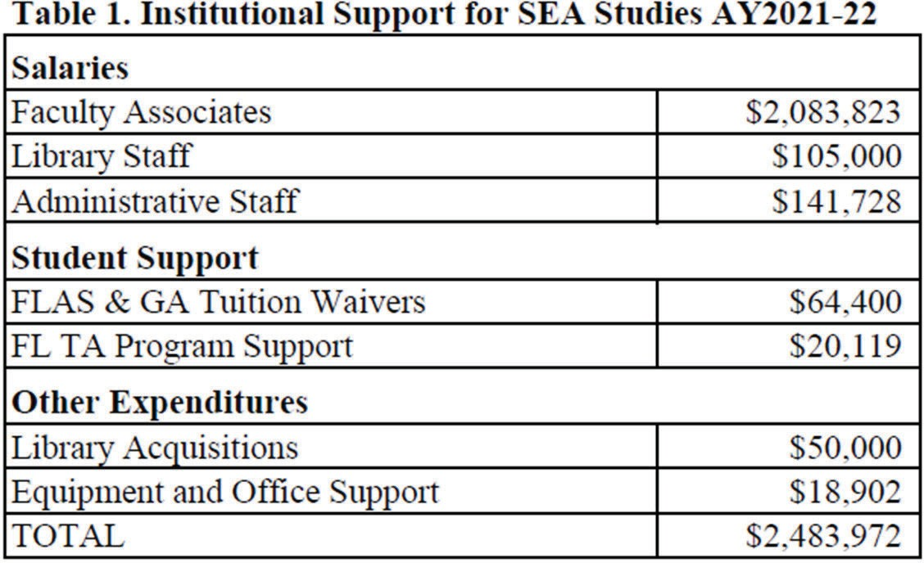

(A2. Financial and other commitments). NIU provides a stand-alone CSEAS building along with its office equipment, furnishings, and upkeep; an FLTA office; and the SEA language- culture website (SEAsite) cloud storage. Over the last decade NIU has funded human resources including the director, an office administrator, tenured language professors in Burmese and Thai and an instructor for Indonesian, and partial funding for Tagalog and Khmer instructors’ salaries (70% and 50% respectively), 50% of our SEAS 225 GA, and 60% of a communications specialist. Except for portions of the Khmer and Tagalog instructors, salaries for 23 core SEA faculty members and 10 other associates and affiliates of the CSEAS are borne entirely by NIU. (A3. Teaching commitment). Over the past four years, NIU funded the teaching of SEAS course enrollments of 2,344 (1,743 in SEA area studies, 601 in languages).
(A4. Library commitment). In 2019-21, funding for NIU’s superb Southeast Asia collection was approximately $150,000 a year, all provided by NIU, including $50,000 in acquisitions funds and $105,000 in salaries for personnel, which includes a curator, an assistant, and a student worker. Other NIU costs are the time devoted by library faculty and staff to the collection.
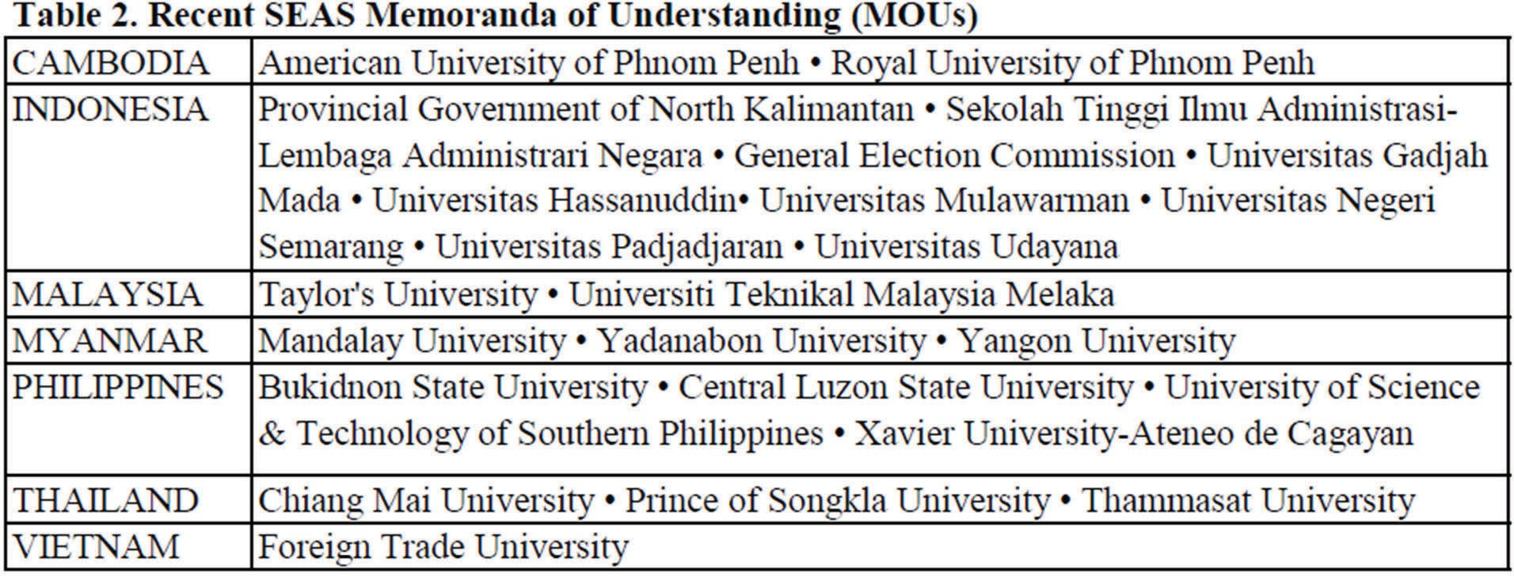

(A5. Commitment for linkages with institutions abroad). Currently CSEAS has 24 active Memoranda of Understanding (MOUs) with universities and provincial governments in Cambodia, Indonesia, Myanmar, Malaysia, the Philippines, Thailand, and Vietnam. They range from student and faculty exchange commitments between CSEAS and Myanmar (including a current post-doc in Environmental Studies from Yangon University) to dual-degree programs between NIU and Chiang Mai University in Thailand, to collaboration with Sauk Valley Community College and the American University of Phnom Penh in Cambodia. CSEAS has a faculty teaching exchange with Xiamen University in China. We previously sent five faculty associates to teach summer short courses on SEA and brought two professors to NIU to teach summer short courses on China foreign policy and SEA. This exchange was paused during COVID, but we plan to continue when travel to China resumes. During the past grant cycle, 14 graduate and undergraduate students traveled to SEA to undertake intensive language and culture study at partners including Chulalongkorn University (Thailand), Central Luzon State University (Philippines), Parami Institute (Myanmar), and Khmer School of Language (Cambodia).
Roughly half of these NIU students studying SEA languages abroad were undergraduates. This number is only for summer 2019; since the pandemic began, summer language students have attended SEASSI rather than traveling to the region, though one student in Thai language participating in our new Public Administration exchange program has been taking classes online at Chiang Mai University during summer 2021 and the 2021-22 academic year.
(A6. Outreach commitment). CSEAS outreach activities have been directed by 2 part-time Outreach staff persons and 2 Outreach GAs and promoted by our Communications Specialist. During the past two years, the outreach position has not been funded as a full-time position, and

we have used temporary staff to fill in for outreach and advising. In this proposal, we are seeking funding to reinstate a full-time outreach position, with the salary partially matched by NIU. At the same time, in the new grant cycle, we propose revising our communications specialist position to include a greater focus on social media and new technologies. We will conduct a search for this new part-time position at the beginning of the grant cycle. We have included partial funding for this revised position in the grant (see job description in the appendix).
Faculty associates undertake local outreach activities on a volunteer basis, for example giving presentations or demonstrations for families and students at local primary schools, engaging students and the community in observing regional festivals such as Lunar New Year, or offering performances of the gamelan orchestra and Thai music ensemble for local events.
(A7. Qualified students in fields related to the Center). CSEAS students consistently leverage their Southeast Asian Studies (SEAS) education into advanced degrees and careers in public service, academia, NGOs, business, and other fields, as seen in these alumni examples. Tammy Duckworth, a 1996-97 FLAS fellow who received an honorary doctorate in political science from NIU in 2010, was elected U.S. Senator from Illinois in 2016. Anies Baswedan, who received his Ph.D. in 2007, is the current Governor of Jakarta and likely presidential candidate in Indonesia. Soveacha Ros is the official spokesperson of the Cambodia Ministry of Education (see G8 placements below.)

B. Quality of Language Instructional Program
(B1. Language enrollment). NIU has 2 tenured professors teaching SEA languages (Burmese and Thai) and 4 native-speaking instructors (Tagalog, Khmer, Indonesian, and Lao). One of these instructors has now completed a doctoral degree in Education (Aoyama), and a second (Gallo-Crail) is a PhD Candidate. NIU has borne the national responsibility of training

Americans in 6 of the 7 major SEA languages, all 5 of them Priority Less Commonly Taught Languages (LCTLs). This staff of 6 is further supported by Fulbright FLTAs in Burmese, Indonesian, Tagalog, and Thai classes (and we are applying for a Lao FLTA for AY22-23), and one language TA (that alternates between languages). Learning materials and instructional technology through SEAsite and NIU’s Department of World Languages and Cultures’ (WLC) Multimedia Learning Center bolster these human resources. NIU also teaches Mandarin (an official language of Singapore) and Portuguese (an official language of East Timor).
The introductory level of each SEA language is taught 5 hours per week (10 hours per academic year), with consistently high enrollments in first-year courses, and 600 students enrolled in SEA languages over the past four years (see Table 3 on Fall 2018-22 SEA language enrollments).
Intermediate Thai and Indonesian are also taught 5 hours per week, with 3 days per week for intermediate Burmese, Khmer, Lao and Tagalog and 3 days per week for advanced levels of 5 languages (except Lao). Because introductory levels are taught 5 days per week, SEA language courses fulfill the NIU language requirement in one year and are thus an attractive alternative for undergraduate students. These early classes also are a natural tool for CSEAS to recruit SEAS minors or contract majors, and to introduce U.S. students to the region’s languages and cultures. NIU fully funds the two tenure track positions in Burmese and Thai as well as the Indonesian instructor position, which we hope to convert back to a tenure track position in the future.
Salaries for Tagalog and Khmer instructors are supported 70% and 50% by NIU and 30% and 50%, respectively, by the NRC. Funding for the new Lao Instructor is included in this grant at 50%, with the other half requested from other Title VI centers, as has been the practice with support for Lao language at the University of Wisconsin-Madison’s Southeast Asian Studies Summer Institute (SEASSI) in recent years. Lao will remain an online class so students can join remotely as students-at-large from other institutions. Since NIU’s tuition is lower than the other

Title VI centers, this arrangement is affordable for students. Khmer will stay online for an additional year to gauge demand for remote learning (in 2021-22 three students joined the class remotely from other universities); and in 2022-23 we will pilot advanced Burmese online. In 1997, with funding from the U.S. Department of Education and U.S. Department of Defense, CSEAS inaugurated SEAsite, an extensive set of online language learning resources and materials, including structured lessons supported by images, streaming audio, and interactive self-tests on 7 SEA languages: Burmese, Indonesian, Khmer, Lao, Tagalog, Thai, and Vietnamese. Each country’s site also includes materials on such topics as art, cuisine, history, music, ethnicity, and politics. SEAsite is used in our language teaching at NIU and by many universities and individual learners around the world. In 2021, SEAsite had nearly 37 million hits, about 91,000 hits per day from 463,623 unique IP addresses. On an average day, there were about 20,000 page views from some 1.2 million total visitors. CSEAS is updating content and streamlining the format of SEAsite in addition to linking up to the distance and online language offerings we are developing. The strongest use of the site nationally and internationally is in Tagalog.

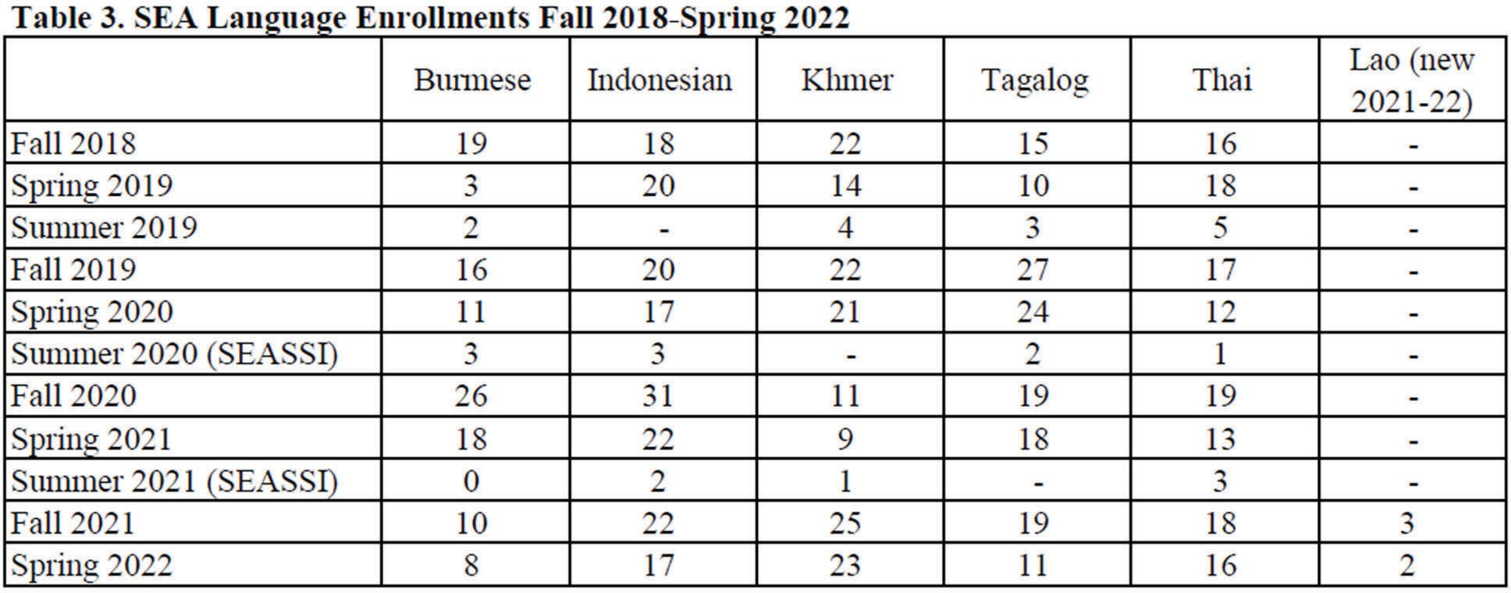

(B2. Levels). As noted in our enrollment statistics above, we provide daily SEA language classes at the introductory, intermediate and advanced levels of five languages on 3- or 5-day schedules and have recently added one level of Lao. This flexibility in higher-level language classes allows us to tailor courses to the needs of enrolled (mostly graduate) students. Our language classes consistently draw students who want to advance their SEA language acquisition in-country. In 2019, we sent a record number of NIU students (14) to Cambodia, Indonesia, Myanmar, the Philippines, and Thailand to study language as summer FLAS fellows, but language study in the region was suspended for the next two years due to COVID. Students did summer study at SEASSI instead (11 in Summer 2020 and 5 in Summer 2021). We hope to resume in-country programs in Summer 2022.
(B3a. Language staffing and pedagogy). SEA language training at NIU is well equipped in terms of teaching staff and assistants. Our language teachers take advantage of internal and external opportunities to upgrade their skills and to develop new teaching materials to improve student skills in speaking, reading, and listening, particularly at intermediate and advanced levels. Rhodalyne Gallo-Crail (Tagalog), Rahmi Aoyama (Indonesian), and Kanjana Thepboriruk (Thai) have trained in the American Council on the Teaching of Foreign Languages (ACTFL) Oral Proficiency Interviews, and Aoyama and Gallo-Crail are ACTFL-certified testers. The NIU language faculty participate in training programs offered by the Council of Teachers of Southeast Asian Languages (COTSEAL) and the new Southeast Asian Language Council (SEALC) coordinating committee; funding to continue to attend these trainings, as well as ACTFL trainings, is included in this proposal. In March 2022, the last SEALC training of this grant cycle will take place at NIU. During the upcoming grant cycle, SEALC training will focus

on reading materials development (2023), listening proficiency assessment (2024), and listening materials development (2025).
(B3b. FLTA Pedagogy training). NIU regulations require all instructional assistants to undergo training in pedagogy. In addition to this required training, the FLTAs also take FLMT 597, the WLC Department’s teaching methods course. This keeps them current on proven pedagogical theories, emphasizing practical application and successful incorporation of methodologies and materials in the university level foreign language classroom.
(B4. Performance-based). Our instructors’ aim is to develop and use materials that train students to function as speakers, rather than to meet achievement-driven goals. All our SEA language classes require spontaneous student response to authentic speakers and materials. Textbooks are used primarily as reference sources, and most class work consists of partner work, group discussion, role-play activities, language games, and extracting specific information from authentic texts and visual materials. In addition, all SEA classes are taught in smart classrooms equipped with electronic devices and internet connections so that instructors can employ a variety of media for cultural enrichment, in-class assignments, and as background for language instruction (such as SEAsite, Blackboard, Google Earth, and YouTube). Students participate in performance-based tasks that require them to record speech and conversations in the target language for online submission and evaluation. Students participate in peer-led small group tasks that allow for optimal language use and interaction. In many instances, assessments are facilitated by students with other students or in small groups with teachers and TAs as language and cultural resources. Students also participate in cultural field trips to SEA events and communities in nearby Chicago to experience and simulate in-country immersion.
Following the ACTFL guidelines for language proficiency, all SEA language students are regularly assessed through oral proficiency interviews to gauge their progress throughout the

semester. In compliance with the Government Performance and Results Act (GPRA), all students will now be administered pretest and post-tests each year to determine if FLAS fellows have increased their foreign language reading, writing, and/or listening/speaking scores by at least one proficiency level. The first-year goal for all languages is the development of students’ spoken competency equivalent to the ACTFL proficiency rating of novice-high or up to intermediate low. Second-year courses are designed to bring students to intermediate proficiency; and third- and fourth-year instruction centers on mastery of authentic materials to promote competency at ACTFL’s intermediate-high to advanced levels. All language classes rely on weekly or bi-monthly spoken and written quizzes. Our SEA language classes consistently produce students who perform at the high intermediate and advanced levels, as measured by scholarship awards to NIU students for in-country immersion training, such as Boren Awards, the Critical Language Scholarship, and the Fulbright-Hays/Council for the Teaching of Indonesian (COTI) scholarship.

(C.) Quality of the Center’s Non-Language Instructional Program

(C1. Quality and extent of disciplinary variety). The center’s strengths are reflected in the extensive number of SEA courses offered. In the last four years, we have offered 126 unique non-language SEA courses across 12 departments in 3 different colleges (Liberal Arts and Sciences, Health and Human Sciences, and Visual and Performing Arts) with a total of 2,344 graduate and undergraduate enrollment. Our SEAS minors and graduate students represent 30 majors across 6 colleges (Liberal Arts and Sciences, Business, Visual and Performing Arts, Health and Human Sciences, Engineering, and Education).
The quality of our courses is underscored by the number of Fulbright scholars NIU has produced over the years (66) devoted to educational exchange between CSEAS and the region. Recent scholars include Jiu-Ching Wang (Indonesia), Kheang Un (Cambodia), Eric Jones (Malaysia),

Kenton Clymer (China), Judy Ledgerwood (Cambodia), Matthew Jagel (Cambodia), Amy Levin (Myanmar/Burma), and Doris McDonald (Indonesia). Our faculty and associates regularly receive the highest honors awarded by NIU—two Presidential Research Professors: Wei Luo (Geography) and Kenton Clymer (History); six Presidential Engagement Professors: Melissa Lenczewski (Environmental Studies), Catherine Raymond (Art History), Judy Ledgerwood (Anthropology), Kurt Thurmaier (Public Administration), Andrea Molnar and Susan Russell (Anthropology); Woodrow Wilson Fellow: Kenton Clymer (History); a Thai Consulate Engaged Teaching Award: Kanjana Thepboriruk (World Languages and Cultures); Distinguished Departmental Teaching Award: Melissa Lenczewski (Geology and Environmental Geosciences), Judy Ledgerwood (Anthropology); and six Outstanding International Educator awardees: Kheang Un (Political Science), James Cohen (Education), Eric Jones (History), Catherine Raymond (Art History), Trudy Jacobsen (History), and Jui-Ching Wang (Music).

(C2. Course depth). We deliver a deep slate of SEA courses across the disciplines. Our largest teaching disciplines, Anthropology, Political Science, History, and Art History offered 25, 23, 23, and 11 unique SEA courses respectively over the last four years (See Table 4 below). Sixteen additional unique SEA courses were taught in other majors. An undergraduate History student, over the course of a degree, can complete SEA courses on the history of SEA before 1800, since 1800, on China and SEA, intelligence, colonialism, and several on the Vietnam War. Political Science offered courses on political Islam, political violence, China-SEA Relations, ethnic identity and conflict, revolution and genocide, SEA politics, and an introduction to international relations. Our new hires in the last five years in Political Science and Anthropology have expanded our course offerings to include International Relations with a focus on ASEAN and a new course on Indigeneity in SEA respectively.

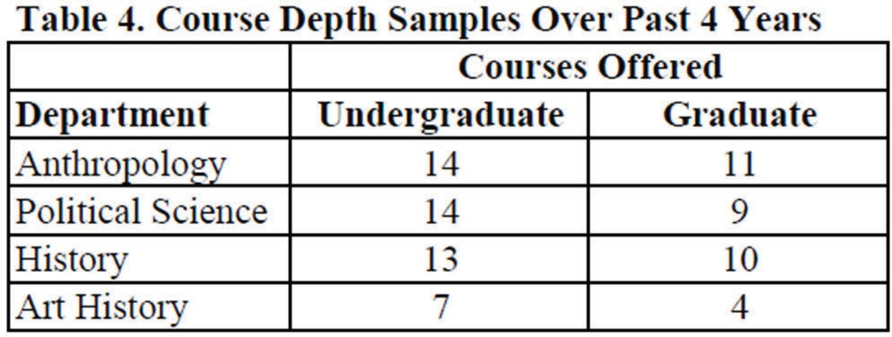

In the upcoming grant cycle, we promise impressive depth in specialized course coverage in several disciplines and SEA regions. CSEAS boasts six faculty who are committed specialists on Island SEA (Indonesia/Malaysia/Brunei/E. Timor/Philippines): Aoyama, Gallo-Crail, Hamayotsu, Jones, Surjadi, and Wang. Three of our faculty have and continue to publish leading research on Cambodia (Ledgerwood, Un, and Jacobsen), two on Thailand (Thepboriruk and Morton), and three on Burma/Myanmar (Raymond, Than, and Morton buttressed by support from the Center for Burma Studies). Seven analyze SEA or ASEAN from a regional approach (Glas, Luo, Wilson, Schraufnagel, Thurmaier, Lenczewski, and Shibata).
(C3. Instructional staffing). SEAS courses are taught by 24 core SEA faculty members and 10 other associates and affiliates. Our main focused disciplines with tenured SEA professors are Anthropology (2), Art History (1) History (2), World Languages (2), and Political Science (4). CSEAS also has links with faculty in Geology and Environmental Geosciences (3), Music (1), Public Health (1), Art (1), Public Administration (1), and Family, Consumer, and Nutrition Sciences (1).
NIU has a strong tradition of offering study abroad opportunities in SEA, including Experiencing the Arts in Bali, History in Malaysia, Business in Vietnam, and Cambodian Culture and Society. This latter was a collaboration with our Community College partners from Waubonsee and Sauk Valley community colleges. Three field schools are proposed for the next grant cycle, one on human rights in Thailand and the Philippines in collaboration with university

partners; one in Thailand and Cambodia focused on public health and civil society; and one on religious change in Thailand and among Thai Americans (co-funded in recently submitted the Luce Grant).
(C4. Pedagogy training). NIU has completely revamped its Center for Innovative Teaching and Learning, in part to help faculty learn best practices for teaching remotely, but also to train on a range of other pedagogical issues, including teaching effectiveness, accessibility, inclusive teaching, trauma-informed teaching, and other topics. NIU also upgraded many of their computers, cameras, microphones, and other equipment and provided training on these new tools and their related platforms. Individual departments also have pedagogy training and support for teaching, including mentorship programs for new faculty and classroom observation and feedback from colleagues.
(C5. Interdisciplinary undergraduate). Our core interdisciplinary course is SEAS 225, Southeast Asia: Crossroads of the World, an undergraduate introduction to SEA. This course, managed by the CSEAS Assistant Director and a Graduate Assistant, covers a variety of topics taught by 9 to 11 CSEAS faculty associates. Topics have included literature, religion, prehistoric migrations, political systems, tropical hazards, colonial history, the Vietnam War, gender issues, minority issues, population and health issues, and genocide. Presentations integrate lectures, visual and performing arts, assigned readings, multimedia, and in-class discussion and extra- curricular cultural events. This remarkable multidisciplinary course is the chief introduction to SEA and a major source of our minors in SEA studies. The SEAS minor is designed to ensure an interdisciplinary approach. Students must take courses in multiple departments in addition to their SEA language requirement. In the past four years, 78 individuals have signed up for our SEAS minor and they mirror the diversity and interdisciplinarity of our faculty and course offerings. They come from 30 majors in six colleges: Liberal Arts and Sciences (CLAS),

Business (COB), Visual and Performing Arts (VPA), Health and Human Sciences (HHS), Engineering and Engineering Technology (EET), and Education (COE).
Of the collaborations we have built across disciplines, the most successful have been collaborations with Public Health and with NIU’s interdisciplinary Environmental
Studies program. Shibata in Public Health has taught interdisciplinary field schools with Wilson (Geographic and Atmospheric Sciences) and Lenczewski (Geology and Environmental Geosciences) and has begun research projects with Indonesian and Burmese counterparts.
Lenczewski is currently undertaking research with colleagues in Burma, Cambodia, and Thailand on water quality and climate change with funding applications pending to Fulbright and the Luce Foundation.

(D). Quality of Curriculum Design

(D1. Quality undergraduate instruction in SEA). Since 1976, NIU has offered a minor in SEAS. The undergraduate minor in Southeast Asian Studies is the hub of our undergraduate SEA training program and has been particularly adapted to provide knowledge and training for students who anticipate careers in government, in K-12 teaching, and in international business or academic institutions that offer programs dealing directly or peripherally with SEA. The minor requires 19-21 hours and must include 10 semester hours of an intensively taught SEA language (Burmese, Indonesian, Khmer, Lao, Tagalog, or Thai) or 12 semester hours of Chinese language. Demonstrated competence in an approved SEA language may be substituted for the required language courses. An additional 9 semester hours from at least two departments must be selected from among the 90 SEA courses listed in our catalog. CSEAS also offers a Southeast Asian Studies contract major, negotiated by individual students with CSEAS and CLAS. Every year,

CSEAS distributes information about the minor via targeted discussions with student advisors in the university’s seven colleges, via information on the CSEAS website, and at NIU recruitment events at high schools and area community colleges. Our gateway course to the minor is SEAS 225, which fulfills a general education requirement and is taken by students across the university. Over the last five years, this course has had up to 35% enrollment of students from outside the social sciences and humanities in the colleges of Business, Visual and Performing Arts, Health and Human Sciences, Engineering, and Education. We have professionally filmed and cataloged these lectures to design an online version of the class. This plan was delayed by COVID, but also advanced by it, given that many faculty are now more comfortable with online teaching. This multidisciplinary course is team-taught by CSEAS Associates across several departments. NIU offers more than 26 undergraduate courses with 100% SEA content and 35 courses with 25% to 50% SEA content. The number of students enrolled in SEA classes varies year by year based on course offerings. Enrollments in SEA-focused courses across the grant period were 1,743.

The core requirement for the current minor and contract major in SEAS is language. Students must complete at least 10 hours instruction in one of the national languages of SEA taught at NIU (all priority LCTLs). Most of our minors choose to continue to intermediate language classes with an additional 10 hours of language instruction. Students who complete 20 hours of language instruction generally reach an intermediate proficiency level (the exact level varies by language and student aptitude), and are prepared to enroll in advanced language courses, proceed to graduate programs, and conduct fieldwork in SEA.
Indeed, the NIU regulation that requires B.A. candidates to fulfill a foreign language requirement has resulted in some of the nation's highest undergraduate enrollment in SEA language courses. Every year on average, almost 150 students enroll in Burmese, Indonesian, Khmer, Tagalog, and

Thai classes. Most SEAS minors have been drawn to the field by their enrollment in these language courses (or their introduction through SEAS 225). By putting SEA studies and languages at the core of baccalaureate program requirements, NIU and CSEAS have been able to reach out to a diverse, multicultural undergraduate population.
Several new SEA courses were recently developed and taught, including Introduction to Asian American Studies (ILAS 290), Revolt, Revolution and Genocide (POLS 377), Politics of Identity, Ethnicity, Religion and Conflict (POLS 664), Urban Life in Asian Cities (ANTH 491), The Art of Living and Dying (ANTH 333), and Indigeneity in SEA (ANTH 491). Several other courses were completely redesigned, including the Asian American Cultures class (ANTH 302) and the Peoples and Cultures of Southeast Asia (ANTH 407). Our depth in a variety of disciplines and country specializations ensures a high-quality undergraduate training program. Over the past four years, 2,344 students enrolled in SEA content courses (1,743 non-language, 601 language). All countries of the region are covered by courses in history, political science, anthropology, art history, geography, and music, but NIU's faculty expertise particularly includes Burma, Cambodia, Indonesia, and Thailand. NIU has the only Center for Burma Studies in the U.S. In the last five years, we have added positions in Political Science/International Relations and Cultural Anthropology and in the College of Education in Counseling and Higher Education. In our pending Luce grant, we seek funding to hire a specialist on SEA/SEAsian American literature and film.

(D2. Advising). Much of CSEAS staff time is dedicated to supporting undergraduate minors and contract majors. New candidates for the minor are advised by the CSEAS Outreach Coordinator and by the CSEAS Director and Assistant Director. We have maintained a steady enrollment of about 30 undergraduate minors across the past 4 years, even given declining enrollments at NIU;

25 graduate students were pursuing SEA certificates at NIU. Graduate students are advised by the Assistant Director as well as by SEA specialists in their departments. Particular attention is given to FLAS awardees.
At the graduate level, our certificate has been in place eight years and students report greater breadth and flexibility in coursework options as we maintain substantive training in the field of SEAS. Following the trends in area studies, and within NIU, the program opens the certificate to “at-large” students who are not enrolled in degree programs, such as government officials, workers in non-profits/NGOs, educators, and businesspeople.
NIU SEA course listings at the graduate level include 40 courses, 23 of them with 100% SEA content. The gateway graduate seminar (SEAS 625) is taught as an interdisciplinary course parallel to SEAS 225 and is coordinated by the Assistant Director. This course has been significantly redesigned, and will be taught in Spring 2023 by Micah Morton, the new faculty member in Anthropology.
CSEAS is also able to refer students to a wide range of opportunities through our network partners. NIU has been a leading member of national consortia such as the Consortium for the Teaching of Indonesian (COTI) and Advanced Study of Khmer (ASK), both of which organize intensive language training in study abroad programs. Over the years, we have sent students to these programs when available as well as to other approved language training programs in the region. Through these programs and through MOU arrangements with SEA universities we have links that allow students to study languages and often to stay on after their programs conclude to explore research possibilities or conduct research for their theses.
CSEAS’s counterpart National Resource Centers (NRCs) collaborate with NIU in cooperative efforts to teach SEA languages in the U.S. during the summer via SEASSI. The CSEAS Assistant Director serves on the SEASSI Advisory Board and on SEALC. CSEAS encourages its

students to take advantage of the United States-Indonesia Society (USINDO) language program in Indonesia, and we had students regularly attend pre-COVID. NIU is planning to apply to manage the COTI program in Indonesia in summer 2024.

(E.) Quality of Staff Resources

(E1. Teaching faculty). CSEAS continues to be successful in maintaining a diverse interdisciplinary group of faculty associates and affiliates that includes 28 faculty and instructors from the humanities, physical sciences, health and human sciences, business, visual and performing arts, and the university library (see Appendix 1). This cohort of scholars, which includes instructors for six of the major Southeast Asian languages, provides classes for approximately 34 SEAS minors and 25 graduate students currently in anthropology, history, and political science as well as art history, music, and geology. Since fall 2018, undergraduate and graduate student enrollments in SEAS classes, including language classes, totaled 2,344 (1,743 in SEA area studies, 601 in languages). CSEAS faculty members also serve on the Center’s council and on various CSEAS committees, including a FLAS selection committee.
CSEAS faculty members are nationally and internationally recognized for their regional expertise. Most are proficient in at least one SEA language, and several have received NIU Presidential Awards for Teaching, Research, or Engagement, the university’s highest awards. They appear in print regularly in journals, newspapers, and online publications as well as in projects such as books and museum/art installations. Most associates are tenured and thus eligible for paid sabbaticals every 7 years. Core faculty usually teach 2-3 courses per semester and advise their own undergraduate and graduate students for an average of 40% teaching, 40% research, and 20% service position. Faculty associates travel to the region frequently for

research or conferences, supported internally through grants and awards from CSEAS, their departments, the NIU Foundation, and the Division of International Affairs. Many also attend professional meetings within their disciplines and to the Association of Asian Studies (AAS) annual meeting. Art History Professor Catherine Raymond, Director of NIU’s Center for Burma Studies, the only such center in the U.S., coordinates the International Burma Studies Conference, which brings Burma scholars worldwide to NIU every two years. CSEAS rotates the hosting of the Council on Thai Studies (COTS) conference with UW-Madison and Ohio University.
Associates have regular opportunities for professional development. CSEAS language faculty participate in SEALC/COTSEAL professional workshops. CSEAS faculty travel grants also provide opportunities for CSEAS associates to travel to SEA to collaborate across disciplines with domestic and overseas colleagues on programs sponsored by the CSEAS or other institutions. While traveling in SEA, many associates help develop MOUs between NIU and educational and governmental institutions in the region (currently 24 active MOUs in seven countries) and connect with in-country alumni.
(E2. Center staffing). Daily operations of CSEAS are administered by a core staff of full-time employees including the Director, Office Administrator, a Communications Specialist (full-time with partial NIU funding), and an Outreach Coordinator (an open position currently staffed by part-time program specialists). An Assistant Director serves part-time with NIU and Title VI funding. Also on staff are two full-time Administrative Directors for two U.S. State Department- funded SEA student exchange programs, the Philippine Youth Leadership Program (PYLP) and the Southeast Asia Youth Leadership Program (SEALYP) respectively. Judy Ledgerwood, former Acting Dean of CLAS and Professor (and former Chair) of Anthropology, returned to her role as Director of CSEAS in July 2021. Dr. Ledgerwood conducts research in Cambodia and

with Cambodian communities in the U.S. As Director, she teaches one course per semester and is on a 12-month contract. Eric Jones, Associate Professor in History, returned to his role as Assistant Director in July 2021 after serving four years as Acting Director. A specialist on colonial Malaysia and Indonesia, he is fluent in Indonesian, Malay, and Dutch, and was previously named NIU’s Outstanding International Educator. Dr. Jones continues to help serve on committees for SEALC and GETSEA (along with Ledgerwood) in coordinating activities between Title VI centers. Jui-Ching Wang, Associate Professor of Music, returned to her position as director of NIU’s World Music Program and the CSEAS’s gamelan ensemble in 2021. Dr. Wang is supported by gamelan and Thai music instructors Alex Yoffe and Chamni Sripriram. The Communications Specialist produces a weekly e-bulletin and annual newsletter, manages the CSEAS website and social media, writes articles for campus and local media, and serves as the press liaison for Center events and programs, working closely with the Outreach Coordinator. Together with the Outreach GAs, these mission-critical personnel are responsible for promoting and expanding the reach of CSEAS programming; organizing cultural, academic, and social events; supporting faculty programming, projects, and collaborations; and advising undergraduate SEAS minors. The Outreach team is crucial to expanding our K-16 teacher training and community college initiatives, including planning and executing workshops and developing online K-16 curricula (in 2021-22, for example, we began adding teaching modules (https://www.niu.edu/clas/cseas/resources/crossroads.shtml) tied to 21 of our 77 Crossroads Southeast Asia podcasts). Outreach works to identify, develop, organize, publicize, manage, and evaluate external and campus programs or activities that link and extend CSEAS’ resources to the public.
Through the CSEAS’ many and diverse programs and projects, faculty, staff, and students have

numerous opportunities to manage program logistics and costs, coordinate volunteers, produce

reports, and synthesize evaluations. Staff and project directors coordinate programs domestically and overseas, often working with SEAYLP, PYLP, and CSEAS alumni in Southeast Asia to maintain and develop institutional and program linkages. CSEAS graduate assistants develop transferable professional skills as they recruit speakers for our weekly lecture series, coordinate logistics and student volunteers for events and organize programs for visiting scholars. One graduate assistant gains valuable teaching experience as the TA for our undergraduate SEA survey course, and an hourly, extra-help worker helps edit the podcast.
Faculty associates mentor SEAS graduate students by honing their skills within and beyond their disciplines and connecting them to careers in public service, academia, and national security.
Faculty also offer SEA study abroad programs ranging from anthropology, history, and political science to the performing arts. We have found these experiences to be powerful motivators for
U.S. students to pursue advanced SEA language and area studies.

(F.) Strength of Library

(F1. Holdings, Support). NIU Libraries contain over 2 million volumes of library materials of different formats, including monographs, periodicals, microforms, maps, archival documents, recordings, audiovisual materials, and electronic databases. A highlight of this research library is the Donn V. Hart SEA Collection. Occupying almost half of the fourth floor of the main library building, this is one of the major SEA collections in the US. Begun in 1963 with a donation of books on Malaysia by a CSEAS founder, the collection has grown dramatically over the past 50+ years. Today the number of Southeast Asia books at NIU is estimated at 200,000 catalogued items. The collection contains materials in over 70 languages, of which 44% are in English, French, and Dutch while 54% are in the vernacular languages of Southeast Asia, usually the

national language of each country. The collection holds over 500 periodicals and 2,000 electronic sources accessible to NIU’s users. English language sources are especially valuable for undergraduates and the general public, while graduate students, faculty and researchers are the principal users of vernacular holdings. The strongest holdings of books in vernacular languages are Indonesian, Thai, and Malay with Burmese and Tagalog also well represented. Special materials include extensive collections of palm-leaf and paper manuscripts from Burma and Thailand, historical Southeast Asia maps, archival documents, and early printed books on the region. The collection also includes excellent holdings of SEA music recordings and films. In 2019-21 funding for this collection was approximately $150,000 a year, all provided by NIU, including $50,000 in acquisitions funds and $105,000 in salaries for personnel, which includes a curator, an assistant, and a student worker. Other NIU costs are the time devoted by library faculty and staff to the collection.
(F2. Accessibility). Teachers, students, and the general public have easy access to our online catalog from anywhere in the world. As a state-funded institution, users within the U.S. and in other countries are welcome to use the resources available on site and can borrow books from NIU through an interlibrary loan system. NIU Libraries participates in the I-Share Online Catalog System and the nationwide Online Computer Library Center (OCLC) cataloguing and circulation system. The collection's future is enhanced by NIU's subscription to a large number of databases and to the Library of Congress’ cooperative acquisitions programs (CAPSEA). In addition, the Curator works closely with CORMOSEA (Committee on Research Materials on SEA), SEAM (SEA Materials), and consortia from American and SEA universities.
NIU hosts the Southeast Asian Digital Library (SEADL), http://sea.lib.niu.edu, the largest digital

project in the world today dedicated exclusively to Southeast Asian Studies. Between 2005 and

2011, the USDE awarded the NIU Libraries two Technical Innovation and Cooperation for Foreign Information Access (TICFIA) grants for the development of SEADL, a collaborative project among over 30 institutions in SEA and in the US, led by NIU Libraries, to make research material from Southeast Asia freely accessible online to all. SEADL now contains tens of thousands of digital images of early printed books, manuscripts, archival documents, and photographs from SEA. It also features video interviews of former political prisoners from East Timor and victims of the Khmer Rouge from Cambodia, documentaries on Burmese traditional dance, and selective television programs from Indonesia. Working in collaboration with CORMOSEA, a part of AAS, this significant project has brought together U.S. universities with strong Southeast Asia NRC centers, as well as universities in Europe and throughout SEA. In 2019, NIU received a five-year grant (2019-2024) of $760,000 from the Henry Luce Foundation to continue the work on SEADL. The grant enables NIU to hire a full-time web developer for SEADL and add new content to the digital library, including the digitized manuscripts from the National Library of Cambodia and the videos documenting the religions of Cham people in Vietnam. Funded by three grants from the Endangered Archives Programme of the British Library (EAP531, EAP698, EAP1005), since 2014, NIU Libraries has been collaborating with the Center for Vietnamese and Southeast Asian Studies of the University of Humanities and Social Sciences in Ho Chi Minh City, Vietnam to preserve Cham manuscripts, https://sea.lib.niu.edu/islandora/object/seadl%3Acham. The project has digitized 977 manuscripts, including 57,800 images. In 2016-17, NIU Libraries collaborated with the libraries of University of Washington and Arizona State University on a consortium project, funded by the Luce Foundation, to assist academic libraries in Myanmar by providing two library workshops in the country and bringing three librarians from Myanmar to NIU for

training.Libraries collaborated with the libraries of University of Washington and Arizona State University on a consortium project, funded by the Luce Foundation, to assist academic libraries in Myanmar by providing two library workshops in the country and bringing three librarians from Myanmar to NIU for training.

(G.) Impact and Evaluation

(G1. University impact). As the only Title VI center at NIU, CSEAS has a major impact on the life of the university. With some 120 classes, with about half at the graduate and half at the undergraduate levels in NIU’s course catalog, many NIU students take SEA classes and attend outreach events even if they are not minors or graduate certificate students. More than 600 students studied SEA languages across the previous grant period. In the grant cycle’s first two years, thirty-four people on average attended our Friday lecture series of 51 speakers. COVID- 19 dictated that most on-campus activities be cancelled during year three. With only six speakers that academic year, and with a pivot to a virtual lecture series, attendance still averaged 31 attendees. Because of COVID, the CSEAS lecture series was moved from in-person sessions to online sessions and then in 2021 to hybrid sessions. While it took some time to sort out the best practices, the new hybrid format has allowed for growth in the number of attendees. In fall 2021, the attendance at these lectures grew to an average of 50. Participation rates and feedback are collected and tabulated for each event, with a 5-point rating scale (l=poor to 5=excellent) – the average response on this rating scale is 4.5.
(G2. Community impact). Dozens of NIU faculty across 3 colleges have served as mentors for Indonesian Ph.D. students who have come to NIU for short-term fellowships to use the library and to improve their research and writing skills. The NIU Art and Anthropology museums regularly hold SEA exhibits and the NIU Music program regularly features SEA music

performances. Because of ongoing outreach efforts and the impact of the SEAYLP and PYLP programs, DeKalb and surrounding communities are very involved with CSEAS programming. Hundreds of local families have served as host families for SEAYLP, PYLP, and YSEALI (Young Southeast Asian Leaders Initiative) participants and multiple area high schools have hosted these students for shadowing programs and leadership training. Area NGOs regularly interact with CSEAS students, hosting them as interns and providing training and employment. CSEAS regularly hosts outreach activities at local primary and middle schools, and at the DeKalb public library. We have hosted a Thai New Year event for the past several years, involving local children in this traditional Thai celebration, for example.
(G3. Regional/national impact). NIU has long exercised a significant impact on the world of SEA language instruction. We publish commonly used textbooks for teaching Burmese and Vietnamese through the NIU Press imprint, now hosted at Cornell; and have led in the development of new materials for learning Tagalog. One of our most obvious areas of national impact is our language-learning website, SEAsite. Another is the aforementioned SEA Digital Library Project, which has digitized an array of significant collections of photographs and manuscripts. CORMOSEA serves as an advisory committee to the collection with access shared publicly, with the collection hosted and maintained by NIU. Since we developed a podcast series in the last grant cycle, it has become a major player in the Southeast Asia broadcast market, with more than 55,000 listens to the 82 episodes, sharing innovative research from important scholars in the field for a wider audience. Our international audience comes from over 90 countries. Outside the U.S., we are most listened to in Thailand, Singapore, and Cambodia. (G4. Matriculation). From AY2018-19 to the present, NIU has had 60 FLAS awardees. Of those 60, 32 are either still pursuing in their current degrees or have continued on to advanced degree programs. Twenty-four awardees completed their degrees and are now in the workforce;

4 left their respective programs before finishing their program. Of the 2,326 students who enrolled in a SEA course in the last grant cycle, 437 were Political Science majors, 253 were in Health and Human Sciences, and198 in Communications (see Appendix on student majors). (G5. National needs, dissemination). CSEAS fulfills national needs by training scholars, federal and state employees, NGO workers, and businesspeople. Over the last 10 years, we have trained 12 students who went on to serve in U.S. government and national security positions, including the military. These include staff of the Department of Homeland Security, the CIA, Military Intelligence, the JAG Corps, and NSA. We have run several training programs for the
U.S. State Department, including SEAYLP, PYLP, and YSEALI. NIU faculty regularly provide briefings and scholarly analysis about SEA for diplomatic officials, intelligence officials, and the general public. We produce language training materials for Burmese, Vietnamese, Indonesian, and Tagalog, as well as the crucial online resource SEAsite. Our CSEAS website and SEADL (http://sea.lib.niu.edu/) provide crucial resources for K-12 and university-level teachers as well
as researchers. With its growing listenership, our 119-episode podcasts series’ broadcasts CSEAS events with diverse perspectives, wide-ranging views, and international debate. These events are no longer one-off presentations but instead a perpetual resource since we are using the podcasts as a base from which to build out discussion materials for teachers for classroom use.
Materials are posted to our CSEAS website at https://www.niu.edu/clas/cseas/resources/crossroads.shtml. Because of the popularity of the podcast medium, we also started a podcast on the Vietnam War through Film, which has received an impressive 14,000 plays in a little over a year.
(G6. Equal access). In line with wider NIU goals on diversity, equity and inclusion, CSEAS initiated partnerships with other NIU units such as the centers for the Study of Women, Gender and Sexuality (CSWGS), Latino & Latin American Studies, Black Studies and the Asian

American Resource Center. Several classes are cross listed with other centers and departments, including the Gender in Southeast Asia course with CSWGS and the LGBTQ Certificate Program. Of the students enrolled in SEA classes over the last grant cycle, 54% were students of color, including 17% African American, 12% Latinx and 19% Asian American. Among the FLAS awardees in the last grant cycle, 62% were women; 37% were Asian/Pacific Islander, 7% were African American, and 3% were Latin American.

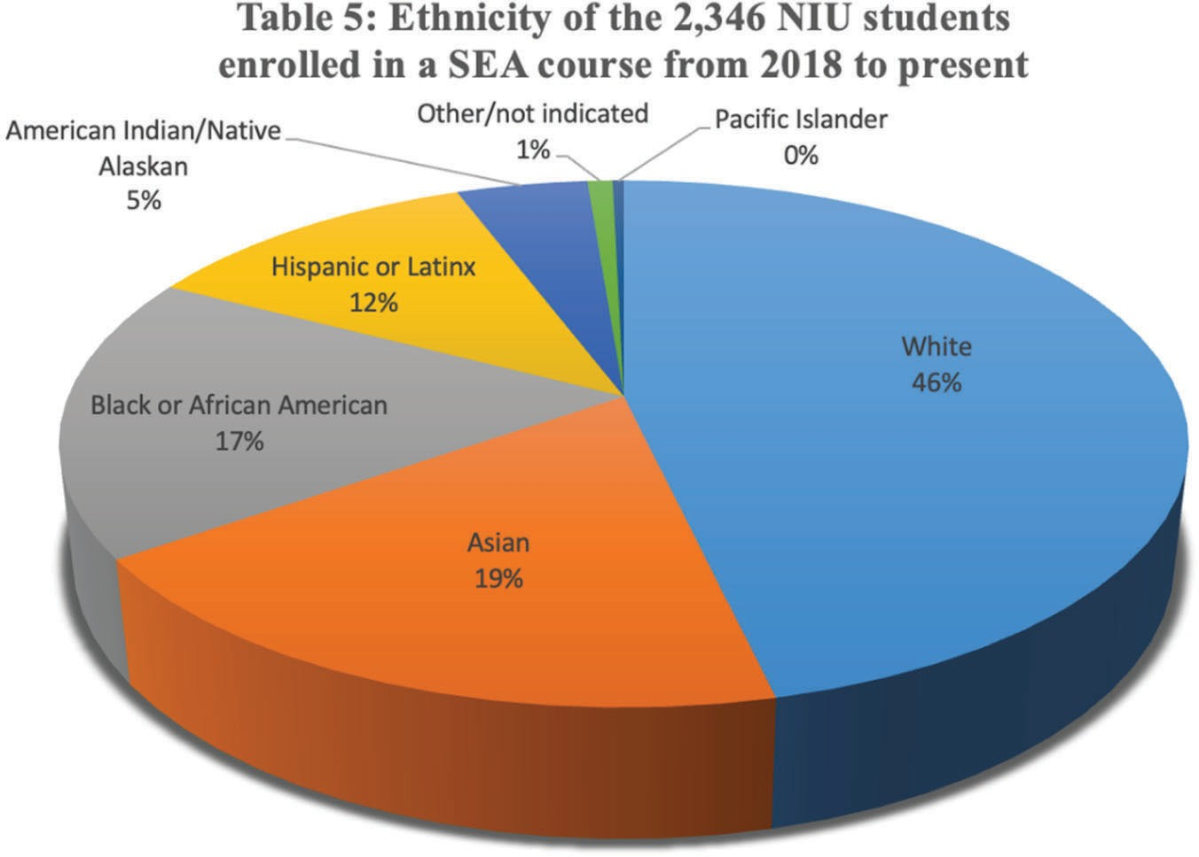

In our new proposal to the Luce Foundation, CSEAS has proposed a dual hire in SEA and SEAsian American Studies in the English Department in SEA/SEAsian American, and Transnational Literature and Film. If funded, the new hire would help lead new initiatives

reenergizing SEAS through closer alignment with critical Asian American and transdisciplinary studies, and with Asian American heritage communities in the greater Chicago area.
(G7. Evaluation plan.) CSEAS has worked primarily with an in-house evaluation expert to develop evaluation tools that more directly measure specific outcomes. We use a comprehensive plan for evaluating program outcomes and implementing improvements. The evaluation examines our impact on the university, community, region, and nation; our impact on the educational and work lives of collaborating community college instructors, K-12 teachers, and graduates of NIU; attraction and retention of participants from under-represented groups; and efforts that encourage the placement of knowledgeable teachers and graduates in areas of national need. The measurements will continue to include self-reported assessments from current and past program participants (community college and K-12 teachers), students, faculty members, staff, and affiliates of CSEAS. At the end of each semester, course enrollments, workshop/conference attendance, and evaluations from program participants are collected for each course or event sponsored or supported by CSEAS. In more recent years, we have also used external evaluators to help review programs using the CIPP (Content, Input, Process and Product) Evaluation Model from the Poorvu Center for Teaching and Learning at Yale University (https://poorvucenter.yale.edu/CIPP), using survey tools and focus group interviews.
These same tactics (https://poorvucenter.yale.edu/CIPP), using survey tools and focus group

interviews. These same tactics will now be used across all projects while in progress and at the conclusion of each project and subproject. We will collect feedback at all events, and during and at the conclusion of each project phase. Because of COVID travel limitations, the visit by an external evaluator was delayed in the current grant cycle but is now scheduled for spring 2022.

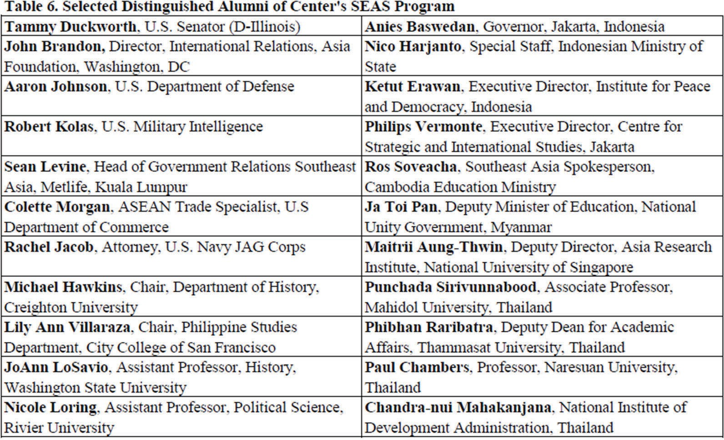

(G8. Placements and specialists). CSEAS is proud to say that graduates from its program go on to fill important roles in state, local, federal government, education, business, foreign governments, international organizations and NGOs. A degree from NIU focusing on Southeast Asian language and area studies is a major career springboard for our graduates. A recent survey of 151 alums found them in the following professions: higher education educator (29), business (28), U.S. govt (20), higher education staff (19), NGO (10), Asian govt (6), media (6), law (5),
K-12 ed (3), geology (2), counseling (2). Those serving in federal government positions included national security positions such as staff of the Department of Homeland Security, the CIA, military intelligence, the JAG Corps, and the NSA.

(H.) Outreach Activities

Fostering greater U.S. understanding of Southeast Asia through cultural activities, educational programs, and people-to-people engagement will continue to be the cornerstone of our outreach programming. Our faculty, outreach staff and FLTAs: (1) present lectures and conduct teacher-

training workshops at area community colleges, (2) bring Southeast Asian youth exchange students and educators to interact with students and teachers at area high schools, (3) accompany youth leadership fellows to volunteer at community nonprofit organizations in DeKalb County,
(4) demonstrate SEA music and crafts to pupils, parents, and teachers at elementary school multicultural fairs and at public libraries, (5) introduce SEA languages to hundreds of secondary school students at international and domestic events (both in person and virtually), (6) sponsor Lunar New Year and other regional cultural festival events on and off campus, (7) teach gamelan and Indonesian children’s singing games in regional and statewide workshops for music teachers, and (8) produce a podcast series of conversations with visiting specialists in SEAS. We also collaborated with two community college educators to create a Cambodia study abroad program for students at their two institutions.
(H1. K-12). In the next grant cycle, we plan to continue to our partnership with the College of Education to: (1) assist in K-12 SEA curriculum development, particularly with regard to the new Illinois TEAACH Act to produce materials on Asian migration to the U.S. and Asian American History, (2) hold teacher training workshops for elementary and secondary teachers, in collaboration with Southeast Asian American Associations in the Chicago area, (3) shepherd an additional Southeast Asia study abroad program for educators (funded by a pending Fulbright Group Projects Abroad proposal) to the Philippines, and (4) conduct a workshop on Southeast Asian art and music workshop at the with NIU’s Pick Museum of Anthropology’s exhibit on performance in SEA geared to elementary school teachers.
NIU participates in International Education Week (IEW) each year, a joint initiative of the U.S. Department of State and the U.S. Department of Education. IEW draws attention to NIU’s increasing strides towards internationalization, and provides numerous opportunities for students,

faculty, and staff to celebrate the many cultures on our campus and in our community. CSEAS has been a leader in IEW events at NIU, showing through outreach its dedication to increasing the world’s knowledge and understanding of Southeast Asia. Our activities include collaboration with departments across campus to bring lecturers with transdisciplinary interest but a SEA focus to campus; partnering with local schools and libraries to perform SEA stories, songs, and language demonstrations for children; and organizing festivals celebrating the cultures of SEA. Due to the pandemic, these activities were all in jeopardy in the ending grant cycle. However, CSEAS, in partnership with the SEA Club and the Center for Burma Studies, adeptly pivoted to online events and was able to keep IEW at NIU going strong.
One effort we are particularly proud of is taking our tradition of language tables – one table on campus each day with activities for NIU students to discover for themselves an SEA language – not only online, but international. CSEAS and Fulbright Foreign Language Teaching Assistants, with support from language instructors and SEAS students, organized a full week of virtual language tables in partnership with institutions within SEA. Each morning, NIU students and community members joined participants in SEA for an hour of introduction to the language, language practice, and cultural exchange. Our inaugural year, fall 2020, was a success, with more than 260 participants. The second year, 2021, grew even larger, with more than 550 participants joining for the SEAS language tables with an additional 200+ joining for an English language table, offered to allow for our counterparts in SEA to practice English with NIU students. During COVID, we learned new skills and realized new opportunities to connect NIU students with SEA, and plan to build on these ideas for even more successful outreach.
Involving Americans is key to our outreach programs, our cultural events, and most importantly to our Department of State exchange programs. The exchange programs bring SEA students and

young adults to NIU for leadership training. For these programs, we put particular emphasis on living with U.S. host families for a minimum of one week. SEAYLP and PYLP participants also shadow their American counterparts at three local high schools. SEAYLP includes a Global Youth Leadership Camp (GYLC) in which 15 selected area high school students join the program for a weekend at a rustic retreat center and for three days in Washington D.C., where they engage in a diplomatic simulation at the Department of State among other activities.
(H2. Postsecondary). The CSEAS’ weekly lecture series has historically drawn scholars from around the Midwest, with the NIU Graduate School funding at least two national or international speakers per year. During the last two years, during the pandemic, CSEAS expanded the reach of this platform, inviting speakers from around the country and from Southeast Asia. We have grown attendance significantly, first by taking the event completely online, and for the 2021-22 academic year by moving to a hybrid format. Some faculty, students, and staff attend in person, distanced and masked, while many more participate remotely. Open to all, the series offers students, faculty, and the public (including CC students and faculty) opportunities to engage and debate with SEA scholars on critical topics and emerging research from the region. Attendance in the last grant cycle averaged just over 570 attendees each academic year, while in just the fall semester of 2021 alone we logged 575 attendees. Since 2016, the lecture series has been included in NIU’s College of Business’ Global Passport Program, which requires students to attend globally diverse lectures on campus; attendance by business students has grown significantly this year with the new hybrid format.
CSEAS hosts or collaborates on several conferences at NIU during a typical grant cycle. These include the Council on Thai Studies (COTS), the International Burma Studies Conference (hosted by the NIU Center for Burma Studies), and the annual Southeast Asia Student Conference, which in addition to NIU students draws community college students,

undergraduates, and graduate students from other SEA programs in the U.S. During the next grant cycle, we plan to work with the Center for Burma Studies to take the highly successful “Art of Surviving” exhibit on the lives of Karen refugees on the road to area community colleges and other smaller private universities.
CSEAS has plans for three new field schools in the next grant cycle, one to Thailand and the Philippines on human rights, one to Thailand and Cambodia on public health and civil society, and one in Chicago focusing on Thai Americans. Each of these field schools will also be open to community college participation.

(H3. Business, Media and the General Public). CSEAS actively engages a larger audience through social media (Facebook and Twitter), a weekly e-bulletin during the academic year, our annual Mandala newsletter, and our podcast series, Southeast Asia Crossroads. Our

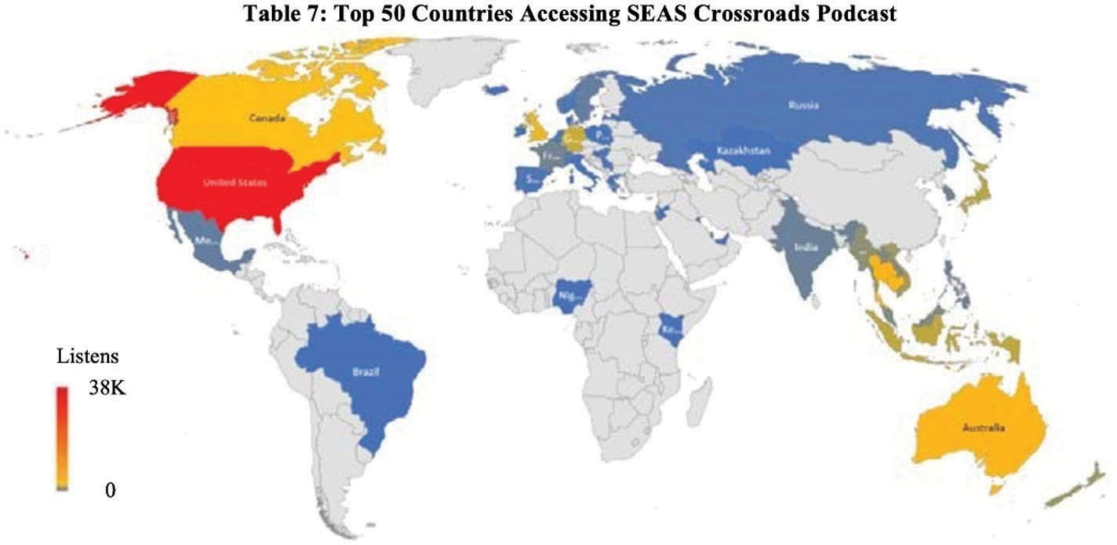

e-bulletin and newsletter circulate to approximately 800 individuals; we also print 250 copies of the newsletter to distribute at conferences and selected events. We have steadily grown our social media presence with 2,332 followers on our Facebook page and 258 followers on Twitter.

Our podcast series, which so far includes 82 conversations on wide-ranging SEA topics, has had more than 57,000 listens from the U.S. and 89 other countries since we began production in September 2016.
Most CSEAS outreach activities at NIU are open to the public; cultural events attract the most community enthusiasm and attendance. While many performances were canceled during COVID, in fall 2021, in collaboration with NIU’s School of Music, Dr. Jui-Ching Wang organized a celebration showcase of Southeast Asian performing arts to celebrate the 150th anniversary of the founding of NIU. The gala was attended by representatives from the Indonesian and Thai consulates, including the Thai Counsel General, the President of NIU, and other dignitaries. It was also live streamed to a worldwide audience. NIU’s College of Visual and Performing Arts annually presents a World Music Concert under the coordination of Dr.
Wang. We will continue to support this live music and dance event, which includes the gamelan orchestra and regularly draws several hundred attendees. We will also collaborate on several workshops with the Pick Museum of Anthropology during their 2022-23 exhibit on Southeast Asian performing arts and continue to offer performances at area schools and other public venues.
(H.) FLAS Awardee Selection Procedures. Advertising. Advertising for FLAS begins in early

fall through the CSEAS e-bulletin, CSEAS staff visits to all SEA language classes, the NIU online scholarships system, flyers, and social media, MSI-CC visits, and our associates presenting to their classes and students. In November/December we also run an application writing workshop. In fall 2021, working with colleagues in COE, we conducted recruitment sessions with 6 high schools in the western Chicago suburbs with high concentrations of Southeast Asian American heritage students. We translated information on FLAS awards to

Tagalog, Lao, and Karen languages to provide information to parents on our programs. Because we have just added Lao, we anticipate interest from the Lao communities in Elgin and Rockford, Illinois. We also conducted an online session advising on how to write personal statements for the fellowship application.
How students apply. Students apply online through a Qualtrics form on the CSEAS website.

Here they submit vital personal information, academic background, statement of purpose, transcripts, and a CV. They also describe ways their program of study and career ambitions meet Title VI priorities. A separate link allows academic and language references to submit their letters and evaluations. Selection criteria. The FLAS selection committee evaluates each
application on a 100-point scale according to the following criteria: 20 points-High Financial Need (from FAFSA, expected family contribution below $1,000), 20 points
Statement of Purpose, 15 points-Academic Letters of recommendation, 10 points-Language Evaluation, 10 points-Study/research/career interests align with Title VI priorities, 10 points-Overall GPA, 10 points-Recent GPA (previous two semesters), 5 points-Academic distinctions (honors, prizes, class ranking, etc.). Selecting fellows. The FLAS selection
committee is chosen from among CSEAS associates by the CSEAS Advisory Committee (which functions like an Executive Committee). The 5-member committee must have at least one SEA language instructor. Care is taken to prioritize a broad representation of fields, disciplines, and countries/areas/languages of focus. Selection timeline. Summer FLAS applications are due Jan.
15. The FLAS committee meets and submits its Summer FLAS rankings by Feb. 1 followed by recipient announcements. AY FLAS applications are also due Jan. 15. The FLAS committee meets and submits its AY FLAS rankings by Mar. 1 followed by award announcements.

(I.) Program Planning and Budget (NRC). For more than a half-century, CSEAS has been driven by a desire to understand the region, engage its peoples and environments, and share those insights with the campus, national, and global community. Our Title VI NRC and FLAS proposals, Teach Southeast Asia II, combine CSEAS’ long tradition of excellence in teaching SEA with the closely overlapping priorities of the Department of Education. Teach SEA II develops programs that deliver breadth and depth of training in SEAsian modern language and area studies to NIU students, K-16 teacher education programs, and our partner community college MSIs. CSEAS continues its role as a national leader in developing SEA language curriculum and innovative pathways for students to engage in it. We foster diverse perspectives on SEA through academic debate, student and faculty travel, our podcasts and speakers’ series and classroom simulations engineered to encourage a wide range of views. We encourage government service in areas of national need, as well as in Education, Business, and Non-Profit sectors. We add new programming in this cycle to connect NIU students with alumni in government service and non-profit careers to help create new career pathways, in cooperation with the NIU Political Science Dept. and the Center for Non-Profit and NGO Studies. Crucially, CSEAS does all of this at a lower cost than many other universities; our overall tuition and other costs are less than other Centers. This is one reason NIU was chosen by the GETSEA consortium as a host site for all the centers for Lao language instruction.
TeachSEA: Educate Global. A CSEAS partnership with NIU’s College of Education (COE) plans to send preservice K-8 teachers to intern and teach English in Southeast Asian classrooms. In the last grant cycle, year 1 activities included travel to the region to discuss the program with area partners. Then in years 2 and 3, COVID prevented travel, but pre-travel contact with NIU preservice teachers and teachers in Indonesia was highly successful and plans to take 15 students

to Indonesia (what would have been 5 per year across 3 years) are on track for summer 2022. The first two years (year 4 of the current grant and year 1 of the new grant) will be held in Indonesia at SMA Pradita high school in Solo, Java. NRC funding is sought for 3-5 preservice K-8 teachers and a COE faculty member each year to oversee instruction for one month in a school in Southeast Asia. The COE faculty member agrees to conduct teacher-training workshops for Southeast Asians in country, mentor emerging SEA teachers and scholars, and integrate SEA into their classrooms at NIU. Not only does this ensure an increasing pool of teachers-in-training exposed to SEA, but also lays the groundwork for pre-service K-8 teachers and COE faculty members to learn Southeast Asian languages and culture.
Educate Global ensures increased SEA content in future teacher training courses and clinical experiences. It provides students with unique and valuable internship experiences for careers in education. We will give preference to those enrolled in our SEA language and content courses to incentivize teacher training in SEA languages, area studies, and our SEAS minor. These students would be outstanding AY and Summer FLAS candidates, and potentially future educators credentialed in Southeast Asian Less Commonly Taught Languages (LCTLs). To ensure COE rigor, candidates must be undergraduate students who have been fully admitted into Early Childhood Education, Elementary Education, Middle Level Teaching and Learning, Physical Education, or Special Education licensure programs or must be graduate students in the same licensure programs.
TeachSEA: SEA Teacher Licensure. NIU has 37 nationally recognized teacher licensure programs. With NRC support, we intend to increase SEA language training and area studies training on the NIU campus for pre-service teachers in those licensure programs so they will teach SEA content in their future classrooms. As an outgrowth of the collaboration in the last grant cycle, CSEAS and the COE developed a course pathway for student teachers to major in

education and minor in SEAS. Recruitment for this new pathway, which has begun for fall 2022, focused on Southeast Asian American heritage students in the western suburbs of Chicago.
CSEAS conducted school visits and prepared recruitment materials in Karen, Tagalog, and Lao. The plan is to set aside 2 FLAS fellowships each year for students committed to completing a degree in Education and becoming a teacher in Illinois. Through the NRC we fund pre-service education students (with oversight from NIU faculty in their discipline and cooperating teachers where they student teach) to integrate SEA as part of their teaching portfolio and to produce classroom lesson modules. We will advertise through the licensure programs, through our CSEAS associates, and through our SEA content courses across the university. As in the last grant cycle, we plan for pre-service students to gain experience by teaching in our youth leadership programs for students from SEA. Between the CSEAS’s State Department-funded Southeast Asian Youth Leadership Program (SEAYLP), and the Philippine Youth Leadership Program (PYLP), each year we normally have more than 100 new high school and college-age SEAsians on our campus. Unfortunately, these programs ran virtually during the last two years. Both grants have been renewed and planning is underway to return to the NIU campus in spring 2022. SEA Teacher Licensure students will then have opportunities to workshop their modules in front of classrooms of Southeast Asian students from 10 countries. Feedback and brainstorming sessions will be built into the interactions. Students working toward licensure will be able to tell future employers they taught in front of impressively diverse classrooms.
In reaction to rising hate speech and violence against Asian Americans in the last two years,

Illinois passed the TEAACH Act requiring that schools teach courses on Asian American history and culture. As part of activities proposed in our Luce grant, CSEAS will collaborate with SEAsian American non-profits in the Chicago area to devise curriculum to meet these new

standards. We plan to create a new history course designed for teacher licensure students to prepare them to teach SEA and SEAsian American history and cultures.
TeachSEA: SEA Language. NRC will support 50% of the Khmer instructor’s salary, 30% of the Tagalog instructor’s salary, 50% of a Lao instructor’s salary and 50% of a full-time TA. Across the last grant cycle, CSEAS Director Eric Jones became a convening member of the Southeast Asian Language Council (SEALC), formed as a vehicle for collaboration on joint projects supporting our shared goals in strengthening SEA language instruction in North America. SEALC collaboration has involved shared endeavors in support of professional development and materials development for SEA languages. Building on the success of the collaborative series of Southeast Asian Language Teaching Workshops,
SEALC ran collaborative pedagogy workshops across the last Title VI 4-year cycle, including one session at NIU planned for March 2022. CSEAS is requesting funding for our language teachers to continue to travel to these pedagogy workshops during this grant period. We have also added funding for language teachers to alternate attending ACTFL training.
The Graduate Education and Training in Southeast Asian Studies (GETSEA) was formed with the mission of enhancing graduate education in Southeast Asian Studies across North America. With funding from the Henry Luce Foundation, GETSEA works across all the SEA NRCs to address graduate student needs. For example, in conjunction with SEALC, GETSEA awards tuition scholarships for students enroll in SEAsian languages not taught at their home institution and join via synchronous video instruction (at NIU: Lao, Khmer and advanced Burmese). The centerpiece of GETSEA’s collaborative programming is its series of online, open access graduate mini-courses focused on specialized topics in SEAsian studies. NIU is committed to continuing collaborative efforts through GETSEA at the conclusion of the Luce

grant. We will contribute to the mini-courses by providing the speaker fee ($1,000) for one mini-course instructor in Year 3 and in Year 4. This collaboration: expands the Southeast Asia expertise and curricular content available to graduate students at any institution, supports network-building among graduate students in SEAsian studies, provides opportunities to establish a mentoring relationship with faculty at other Southeast Asia centers, and encourages collaboration as well as curricular innovation and experimentation.
Lao is perhaps the least taught of the less commonly taught national SEA languages. As part of GETSEA/SEALC collaborations, NIU taught intermediate Lao language online in the 2021-22 academic year with funding from Luce. To continue these collaborations, CSEAS is requesting funding for 50% of the Lao instructor cost in this proposal, and for the other NRCs to each contribute $1000 from their NRC budgets to pay for the other half of the Lao instructor’s costs. NIU and our fellow NRCs are also requesting $1,000 per year to support the teaching of Lao at SEASSI. CSEAS will begin to offer FLAS awards for Lao. Khmer language is being taught online during the 2021-22 academic year, and students joined from 4 other universities with scholarship funding from GETSEA. We propose leaving Khmer online for an additional year to see if demand for this format continues beyond the COVID period. We also plan to add advanced Burmese in an online format for AY2022-23 to gauge interest from other universities. TeachSEA: SEA Online. In the last grant cycle, we had planned gradually to move courses online so that we could develop our graduate certificate as an online credential. Little did we know that over the course of the last two years all our courses would go online. Consequently, we are all better trained in online instruction than before the pandemic. Further, CSEAS purchased new laptops, microphones, and cameras as some courses have stayed online and other events have moved to a hybrid format. Multiple sessions of the SEAS 225 course were recorded and can be used for future online courses. Most importantly, we added Lao as an online course

as a resource for all NRCs and other universities and have kept Khmer online as a similarly shared resource.
NIU’s SEA language-learning website (www.seasite.niu.edu) remains a leader in web-based curricular materials by funding a SEAsite part-time staff person. Our web materials and the technology supporting them demand regular updating. Our podcast series allows us to project the many interesting presentations and conversations on our campus to the wider world. Our Friday lecture series that had 20 or so in-person attendees now has dozens of remote attendees and hundreds of podcast listeners (currently over 57,000 total listens). We are continually evaluating which events to keep digital in the aftermath of this major shift to digital interactions – the Burma Studies Conference ran in a hybrid format while the Council on Thai Studies Conference was entirely virtual. One advantage is that these conferences drew many more attendees from the region, which increases the diversity of opinion in these exchanges.
TeachSEA: MSI Study Abroad. Our sustained relationships with MSI-CCs have resulted in the meaningful incorporation of SEA area studies content into CC classrooms. CSEAS worked with two community colleges to sponsor a study abroad program to Cambodia in 2018. The program was cancelled in 2020 and 2021 but is planned to run again in 2022. We are using funding from the cancelled years to cover more costs and increase scholarship funding to recruit lower-income students to this field school. This model of simultaneously developing and supporting MSI-led study abroad programs is an important pathway to sustained MSI-CC interest in the region and a pipeline for students to join our NRC degree programs. We are proposing three new study abroad programs in this new grant cycle, one to Thailand and the Philippines on human rights, one to Thailand on religion, and one to Thailand and Cambodia on public health and civil society – all three of these new field schools could include MSI-CC participation.

TeachSEA: Model ASEAN. Building on the success of the International Model ASEAN conference held in Indonesia in 2019, and the Model ASEAN simulation planned with the NIU Political Science Department, a Rockford community college, and area MSI high schools in spring 2022, we propose an ASEAN conference in spring 2024 (year 2). This conference will include area specialists, representatives from ASEAN member state consulates in Chicago, NIU POLS faculty and graduate students and area CCs. Then in year 4, spring 2026, we plan to repeat the large-scale Model ASEAN simulation with NIU POLS Model UN students, area MSI CC and high school students, and SEAYLP students participating as delegates.
TeachSEA: SEA Teaching Modules. SEA Teaching Modules will become the new web portal for channeling CSEAS’s various TeachSEA II efforts. As a budget category, it allows us to give small awards to students or honoraria to faculty who deliver SEA teaching content for us to make nationally available. Portfolio content from SEA Teacher Licensure, podcast teacher resources, role-play simulations from Model ASEAN, new dynamic language content, sample CC syllabi, K-16 lesson plans, and Educate Global outcomes can all be supported with this initiative.

Library. A significant part of research materials for Southeast Asian Studies are publications produced by local governments and non-profit organizations. These materials, which are not commercially distributed, can only be acquired by visiting the institutions in SEA. Rare manuscripts, archival documents, and politically sensitive publications are also not available for distant purchases. Due to funding cuts, NIU Libraries is unlikely to support acquisitions trips.
We therefore request funding for two such trips over the grant period, to cover travel and acquisition costs. Library outreach to CC partners, funds to purchase books for their libraries for reference use in classes that relate to SEA, are also requested.

International Symposia/Conferences at NIU. CSEAS continues its long tradition of excellent conferences, exhibits and performances. Built into the conferences is funding to involve MSIs, CCs and teaching partners. We propose to serve as the venue for the following international events in 2022-26:
International Conference on Burma Studies in 2025. Since 1987, the Center for Burma Studies has supported the promotion of Burmese culture and has hosted or coordinated 15 international conferences on Burma studies, more than half of them on the NIU campus. Collaborating with the Burma Studies Foundation, we propose inviting Burmese guest scholars to give keynote speeches, workshops, and presentations at this next conference.
The Art of Surviving: The Journey of Burmese Karen Refugees in Illinois: Born out of this successful exhibit on NIU’s campus in 2021, this exhibit will be transformed into a traveling format. It will be exhibited at Judson College, Waubonsee College, and other CCs in the region (co-funded with Luce grant funding). A new Burma art exhibit, Food for the Soul: Belief and Healing in Burma/Myanmar in the Age of COVID, is scheduled for 2023 on the diversity of multiethnic cultures and religions coexisting in Burma/Myanmar.
SEA/World Music Conference, April 2025: Will include performance collaborations with area SEA consulates and Asian American SEA ensembles in the Chicago area as well as area community colleges.
Workshop on Thai Buddhism and the History of the Thai Community in Chicago, Summer 2025: We will work with and train a cohort of 15 Thai American secondary school students to conduct life history interviews with their community elders as a means of learning their personal and communal histories while addressing intergenerational tensions that have arisen in recent years. This project will result in the production of English and Thai language multi-media online learning modules addressing the important yet little known history of Chicago’s Thai

community. These modules can directly translate into new teaching materials to fulfill the Illinois TEAACH Act requiring Asian American histories be taught in public schools (co-funded with the pending Luce grant).
Council of Thai Studies (COTS) conference. NIU will continue to play a leading role in this flagship organization for the teaching of Thai language and area studies in the US by supporting student and faculty travel to the conference and by hosting it in 2023. For the 2022 COTS conference at the UW-Madison, NIU emeritus faculty Clark and Arlene Neher and John Hartmann will be honored to celebrate the 50th anniversary of the founding of COTS.
Southeast Asia Student Conference. CSEAS hosts a SEA Student Conference each year, involving dozens of SEA faculty and students from NIU, other universities, and MSI-CCs. This annual event is a prime showcase for our commitment to undergraduate and graduate student success by helping them achieve an important professional academic milestone. Student participants present their conference research papers (read and judged by a panel of CSEAS associates) and enjoy feedback from fellow students, CSEAS faculty, and a prominent Southeast Asianist invited as keynote speaker.

(I.) FLAS Competitive Preference Priorities

(FLAS Competitive Preference Priority 1, FLAS Fellowships for Students who Demonstrate Financial Need). CSEAS will give a preference to undergraduate and graduate FLAS applicants who demonstrate high financial need by having little to no expected family contribution (under $1,000). This preference is operationalized in the FLAS selection committee’s evaluation rubric that weighs financial need 20 out of 100 points. The other 80 points are awarded in a mix of qualitative and quantitative measures for high academic

achievement. Many NIU students will qualify for this preference, as more than 80% of NIU students qualify for federal or state need-based aid programs.
(FLAS Competitive Preference Priority 2, Academic Year FLAS Fellowships Awarded in the Less Commonly Taught Languages). All of our core SEA languages (Burmese, Indonesian, Khmer, Lao, Tagalog, and Thai) meet this criterion.
With NRC-FLAS funding, CSEAS can continue its distinguished tradition of training generations of students in Southeast Asian area studies courses and language training, helping them to engage the region, and preparing them for the global careers of the 21st century.

(J.) Absolute Priorities. (J.1.) Reflect Diverse Opinions and a Wide Range of Views and Generate Debate on World Regions and International Affairs:
CSEAS has long designed its programming to address this priority, by including voices from a wide range of sources, including from Southeast Asia. This includes collaborations with the region’s embassies and consulates and with students and adult participants from our SEAYLP and PYLP youth leadership programs. The reach of our programming has been dramatically extended by our podcast series, which now has worldwide reach. During the pandemic, we have been able to invite a wider range of scholars to participate in our hybrid and online lecture series and the follow-on podcasts that follow these lectures. We have also worked with the Council of American Overseas Research Centers in SEA, the Center for Khmer Studies, the American Institute for Indonesian Studies, and the Inya Institute in Burma/Myanmar. In the US, CSEAS collaborates with a range of Asian American non-profits and NGOs with Southeast Asia transnational connections, including the National Cambodian Heritage Museum in Chicago.
Connections with immigrant and refugee organizations often provides very different viewpoints from the consulates or other home country perspectives. Our new ASEAN focus in the last grant

cycle, with the hire of an ASEAN specialist and the running of conferences on ASEAN with other post-secondary institutions, as well as participants from the region, has opened a more extended range of voices in international relations.
(J.2). Encourage Government Service in Areas of National Need: NIU has a long history of training students who go on to work for the US federal government, including in security services such as the CIA, NSA, and the Department of Homeland Security (see discussion of alumni above). Preference is given in FLAS scholarship selection to students who state a future goal of working in government service. The NIU Public Administration (PA) program has a specialization in local government, which is pursued by American students with an interest in Southeast Asia and by students from the region. We have PA exchange programs with two universities in Thailand. These programs serve as successful feeders into local and state government in Illinois and the Midwest. NIU also has a strong Non-Profit and Non- governmental (NNGO) program, which draws a number of students with SEA minors. Of our alumni from the region, many work for NGOs when they return to their home countries. Finally, we also have a strong record of accomplishment of placing students in university and community college teaching positions, positions in libraries, museums and archives, and in the business sector. Our proximity to Chicago means that students can sometimes do internships or otherwise make connections with businesses in the greater Chicago area while they are still students.
(J.2.) Absolute Priority 2: Teacher Training Activities: In the upcoming grant cycle, we plan

to continue our successful collaborations with the Teacher Licensure programs and the Educate Global program in NIU’s College of Education. Educate Global at COE places K-8 pre-service teachers in elementary and middle school districts abroad to provide first-hand experiences with different cultures, international colleagues, and international internship/teaching. In our partnership with COE, CSEAS utilizes its linkages and in-country networks to send Educate

Global students to SEA schools. These teacher education students become prime candidates for participation in CSEAS programs, for taking SEA languages at NIU, and for meeting the expected national K-12 language program needs in the less commonly taught SEA languages. Although Educate Global was not able to take student teachers to SEA because of the pandemic, we were able to establish the connections with an Indonesian high school and conduct online training sessions. This program is continuing this (2021-22) academic year, and we plan to take a group to Indonesia to co-teach with Indonesian teachers in summer 2022. In this next grant cycle, we plan to continue this program, in the first year again to Indonesia, with the possibility to conducting similar teacher training programs in Cambodia and/or Thailand in future years.
In collaboration with the College of Education’s teacher licensure programs for primary and middle school, we have created a new pathway for students to major in Education and minor in Southeast Asian Studies. We have recruited for these new pathways in MSI high schools in the Chicago suburbs with large numbers of SEA heritage students, including producing recruitment materials in Tagalog, Lao, and Karen. The goals include recruiting heritage students to study SEAS, and training teachers who are from these communities who will return to teach in their home areas. Illinois has a severe teacher shortage, and there is significant evidence in the education literature that teachers from students’ communities can be supportive and attuned to local community needs. In the face of recent violence against Asian American Pacific Islander (AAPI) communities, Illinois passed the TEAACH Act, which requires schools to teach about Asian American history and cultures. CSEAS and the COE are linking with AAPI communities in the state to help draft these curricula. Teaching modules, lesson plans, and classroom materials developed as part of these collaborations will be shared via our website as national resources on teaching SEA. Educate Global at the COE places K-8 pre-service teachers in elementary and middle school districts abroad to provide first-hand experiences with different

cultures, international colleagues, and international internship/teaching. In our new partnership with COE, the CSEAS utilizes its linkages and in-country networks to send Educate Global students to SEA schools. These teacher education students become prime candidates for participation in CSEAS programs, for taking SEA languages at NIU, and for meeting the expected national K-12 language program needs in the less commonly taught SEA languages. (J.3.) Competitive Preference Priorities: Partnerships with Minority Serving Institutions (MSIs) or Community Colleges:
MSIs play a key role in past, present, and future CSEAS projects. Active collaborations with 6 community colleges (5 of them MSIs) include funding and encouraging their involvement and attendance in all our activities (speaker series, conferences, workshops, outreach activities). In addition, we create specific programs for them. By recruiting MSI-CC colleagues, helping them develop SEA area and course content, and taking them and eventually their students to SEA, we create a climate conducive to the perpetual delivery of SEA area studies. We work together to recruit their MSI colleagues into SEA cohorts. One such SEA cohort at Waubonsee and Sauk Valley CCs led our sponsored Study Abroad Cambodia in Summer 2018 and plans to take a second group in summer 2022. Close relationships with MSI-CC cohorts spawn student interest; two students from the 2018 study abroad came on and did degrees at NIU. Simultaneous distance language learning and SEAsite content then create pathways to FLAS eligibility and SEA area studies exposure. In spring 2022, we are also running a Model ASEAN simulation, with participation from Rock Valley CC and area MSI high schools, as well as the NIU Model UN group and SEAYLP participants from SEA. We plan to repeat this conference again in the next grant cycle. We have also contacted the College of Lake County CC, an MSI/HSI (Minority Serving/Hispanic Serving Institution) to begin new collaborations in the next cycle, including possible participation in the new field school to Thailand.

(J.4.) Areas of National Need for Expertise in Foreign Languages: The areas of national need for expertise include the SEA languages taught by NIU: for the Department of Education, the Department of State and USAID: Burmese, Khmer, Lao, Indonesian, Thai, and Tagalog; for the Department of Defense: Burmese, Indonesian, Thai and Tagalog, and for Peace Corps: Indonesian, Thai, and Tagalog.

