Individuals using assistive technology may not be able to fully access the information contained in this file.

For assistance, please send an e-mail to: NRC-FLAS@ed.gov and include “508 Accommodation” and the title of the document in the subject line of your e-mail.

(NRC & FLAS) COMMITMENT TO THE SUBJECT AREA

As a global institution that strives to accelerate solutions to the world’s greatest challenges, Stanford University has a long history in supporting international education, research, and community engagement. In 2005, the university established Stanford Global Studies (SGS)to
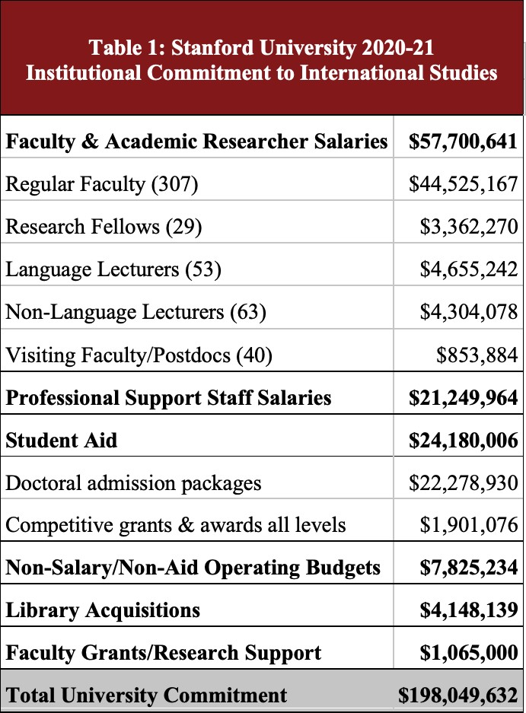
foster collaboration among faculty, students, and scholars across 14 interdisciplinary centers and programs. Since then, the university has focused on strengthening its area centers as well as demonstrating its commitment to international and area studies across the institution by increasing the number of faculty who focus on regional or global issues. For example, over the past decade Stanford has dedicated substantial resources to hire more than 10 faculty members with expertise in South Asian and Islamic Studies who
represent a wide array of disciplines. Additionally, the university has focused on enhancing and expanding international experiential opportunities. For instance, since 2012, SGS’ Global Studies Internship Program (GSIP) has offered more than 700 students representing a diverse range of majors across the humanities, social sciences, and STEM fields the opportunity to participate in virtual and in-person internships in over 30 countries around the globe. In 2019, Stanford announced its Long-Range Vision, which prioritizes preparing students for global citizenship and ensuring purposeful engagement with global issues. One important initiative to emerge from this vision is the new Civic, Liberal, and Global Education curriculum for first-year

students, making a commitment to engage students in liberal education and challenge them to examine their roles as global citizens in complex, diverse societies.
In 2020-21, there were 303 regular faculty, 28 research fellows, 55 non-language lecturers, 57 language lecturers, and 40 visiting faculty/postdocs in 57 departments and programs who focused at least 10% on international studies, 242 of whom focused 100% on international studies. Over 550 students focusing on global topics, many of whom receive substantial university financial aid, can be found in almost all departments and schools across campus. This community of scholars is served by 181 full- and part-time professional staff across 30 departments and centers. Table 1 provides a summary of the University's estimated 2020-21 expenditures for international studies faculty, staff, student aid, and program support.
Operation of the Program: The Stanford International National Resource Center will carry out its mission through the Stanford Global Studies Division (SGS) and its 14 constituent area centers in cooperation with the Stanford Program on International and Cross-Cultural Education (SPICE), the Bing Overseas Studies Program (BOSP), area-focused teaching units such as the Division of Literatures, Cultures, and Languages (DLCL), and
internationally-focused research centers within the Freeman Spogli Institute for International Studies (FSI). SGS advances research, education, and community engagement on regional and global issues by supporting undergraduate and graduate programs, organizing outreach events, administering research grants and fellowships, offering internships and language study opportunities, and collaborating with other campus units to promote global education. As a division, SGS draws on the strengths and expertise of its 14 centers and programs: Abbasi Program in Islamic Studies, Center for African Studies, Center for East Asian Studies, Center for Latin American Studies, Center for Russian, East European and Eurasian Studies, Center for

South Asia, France-Stanford Center, GSIP, Center for Human Rights and International Justice, Mediterranean Studies Forum, Moghadam Program in Iranian Studies, Program in International Relations, Taube Center for Jewish Studies, and The Europe Center. SPICE makes the university’s research and teaching accessible to K-14 educators by hosting teacher-training workshops on international topics and partnering with Stanford faculty to produce
award-winning online teaching materials on a wide range of global topics. Currently, SPICE has produced over 90 content-rich, standards-aligned curriculum units for K-14 teachers that cover diverse global topics and all world regions. In addition to providing courses, degrees, and research programs in French and Italian, German Studies, Iberian and Latin American Cultures, and Slavic Languages and Literatures, the DLCL is also home to the Stanford Language Center (SLC), which advances training in 54 languages, including 50 Less Commonly Taught Languages (LCTLs). BOSP provides academic and experiential programming for undergraduate global engagement through quarter-length offerings at its 10 overseas centers, an average of
10-15 overseas seminars and faculty-initiated programs each summer, and a consortium program in Kyoto. Composed of eight specialized international studies research centers, FSI organizes research projects, programs, and lectures on global topics in governance, security, health, energy and development to engage students, scholars, and corporate and governmental affiliates. In total, 98 schools, departments, centers, and programs across campus contribute to international studies at Stanford, including 41 explicitly international degree-granting undergraduate and graduate programs.
For the 2022-25 grant cycle, we are requesting partial support for the SGS Executive Director (25%, Budget 1Ai), the SGS Finance Manager (10%, Budget 1Aii), two Language Lecturers (100%, Budget 1Bi and 1Bii), the SGS Outreach and Academic Coordinator (100%,

Budget 1Ci), and a SPICE Curriculum Writer (100%, Budget Cii) to carry out the proposed projects in Section I.
Teaching Staff: In 2020-21, there were 386 regular faculty, research fellows, and

non-language lecturers in 54 departments and programs working at least 10% in international studies, 175 of whom teach and research 100% on international studies. Stanford provided an estimated $44 million in salaries and benefits to faculty members engaged in teaching international studies courses. This sum is based on average faculty salaries for rank and field supplied by the School of Humanities and Sciences, with proportional sums calculated for those devoting less than 100% time, as listed in Appendix 3. This total does not reflect an estimated
$5.5 million in salaries and benefits for 93 language lecturers and visitors/postdocs working wholly or partly on international topics employed by SGS, the SLC, FSI, Hoover Institution, and other campus departments and research units.
Library Resources: Encompassing 24 libraries and more than 9.7 million volumes, Stanford University Libraries (SUL) is one of the largest research and academic facilities in North America. Significantly, SUL is home to a number of area collections–including African, East Asian, Estonian and Baltic, French and Italian, Germanic, Islamic and Middle East, Jewish, Latin American and Iberian, Slavic and Eastern European, and South Asian collections–that together contain more than 5 million holdings. These area collections serve a wide range of international programs and are managed by 17 full-time staff. As demonstrated in Section F, support for these area collections is a major priority of the SUL, with the university spending more than $5 million annually on salaries and acquisitions.
Linkages with Institutions Abroad: With an active presence in more than 100 countries, Stanford engages the global community through education, scholarship, and outreach. The Bing

Overseas Studies Program (BOSP) maintains 10 overseas centers in Australia, Germany, South Africa, Italy, Turkey, Spain, England, France, and Chile to support academic and experiential programs focused on educating students for global citizenship. Established in 2012, the Stanford Center at Peking University serves as a base of operations for research, teaching, training, and outreach activities across all disciplines in East Asia. The School of Engineering’s Stanford Technology Ventures Program accelerates global entrepreneurship education through
multi-year partnerships with international universities and organizations. Over the past four years, SGS’ Global Studies Internship Program (GSIP) has collaborated with 121 organizations in 39 countries to provide transformational overseas experiences for Stanford undergraduates in business, nonprofits, education, the arts, and government. These highlighted programs provide only a sampling of the numerous global engagements that Stanford supports through its international centers.
Outreach Activities: SGS regularly hosts lectures on pressing global topics, professional development offerings for K-14 teachers, and conferences, symposia, and workshops showcasing Stanford’s international scholarship, offering 452 such events in 2020-21 that served more than 36,000 participants. The Hoover Institution on War, Revolution, and Peace hosts numerous domestic and foreign government officials and visiting delegations, providing access to Stanford’s global research and expertise. SPICE engages K-14 educators across the nation with its multidisciplinary international curriculum materials and teacher-training workshops [AP 1, CP 1]. The Graduate School of Education (GSE), which includes the Stanford World Language Project, Center to Support Excellence in Teaching, Stanford History Education Group, and Stanford Teacher Education Program, organizes teacher-training workshops related to critical world regions, issues, and languages for K-14 instructors nationwide [AP 1&2, CP 1] .

The SLC is actively engaged with the American Associations of Teachers of Modern Greek, Spanish and Portuguese, and Turkic languages; the California Association of Japanese Language Teachers; and Chinese Language Teachers Association (CTLA); and regularly hosts the annual CLTA pedagogy conference.
Support for Qualified Students: Stanford recruits the top students from the U.S. and abroad into its undergraduate and graduate programs. In the current year, Stanford’s admission rate was a record-breaking 3.95%, with 96% of incoming undergraduates ranking in the top 10% of their high school graduating class. Incoming undergraduates for the 2021-22 academic year represent 77 home countries and 49 U.S. states. Each year, on average, 70 students from over 20 countries are admitted into competitive master’s programs in International Policy, East Asian Studies, Latin American Studies, and Russian, East European and Eurasian Studies through SGS and FSI. With a 2021-22 admissions rate of 5.7%, doctoral programs are equally competitive, drawing highly qualified students from top global institutions. Last year, more than 200 Ph.D. students were conducting research in area and international studies through affiliations with SGS.
In 2020-21, the university provided an estimated $22 million in financial aid packages for over SGS-affiliated doctoral students. SGS provided nearly $2 million in student aid and tuition allowances for undergraduate and graduate students pursuing degrees in international and area studies. The Knight-Hennessy Scholars Program, which prepares graduate students for global leadership, is the largest fully endowed graduate fellowship in the world. Each year, nearly 100 exceptional students receive full funding for up to three years to pursue graduate degrees across Stanford’s seven schools. The university also offers summer language study grants, international research grants, and public service fellowships for undergraduates and graduates completing studies in international fields.

(NRC & FLAS) QUALITY OF LANGUAGE INSTRUCTIONAL PROGRAM

  - Language Instruction and Enrollments: Over the past four years, the Stanford Language Center (SLC) has offered instruction in 54 languages, including 50 Less Commonly Taught Languages (LCTLs), 31 priority languages, and 27 critical languages as identified by the National Security Education Program. Table 2 shows total language course enrollments at
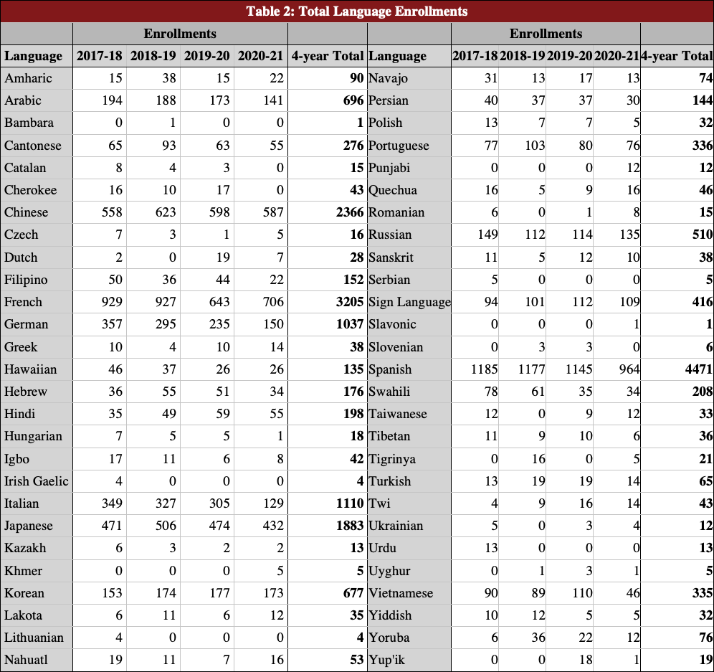
Stanford from 2017-18

through 2020-21, reflecting our continuing commitment to provide LCTL training. In
2020-21, SGS and its NRCs expanded access to LCTL training by providing $746,000 for instruction and study in Arabic, Chinese, Hebrew, Japanese, Korean,
Luganda, Malay, Náhuatl, Polish, Persian, Portuguese, Quechua, and Russian.

Language Levels Offered and Foreign-language Courses in Other Disciplines: In

2020-21, Stanford students could study nine languages at or beyond the 3rd-year level: Mandarin Chinese was offered through the 5th-year level; Japanese, Korean, and Russian through the
4th-year level; and Arabic, Hebrew, Hindi, Persian, and Portuguese through the 3rd-year level. Students who demonstrate levels of achievement equivalent to a third year of language study

may apply for the Proficiency Notation and an official certificate from the American Council on the Teaching of Foreign Languages (ACTFL). In 2019-20, 33 students received such notations in Chinese, French, Italian, Japanese, Korean, Portuguese, Russian, Spanish, and Turkish. Over the next four years, SGS will collaborate with SLC to fund additional LCTL languages beyond the 1st-, 2nd-, and 3rd-year levels.
Several language classes are designed specifically for professional school students, notably Business and Medical Chinese. Additional heritage-track courses offer accelerated learning for semi-native speakers wishing to become fluent in writing and reading and—increasingly—also for non-heritage speakers with prior advanced training who do not fit into the standard 1st- through 3rd-year tracks. Finally, while the primary language of instruction at Stanford is English, many undergraduate- and graduate-level courses require reading and analyzing primary sources. Many departments, such as Anthropology, Religious Studies, and Sociology, offer advanced courses in which non-English source readings are assigned and discussion of primary materials in the target language is incorporated to the greatest extent possible.
  - Language Teaching Staff and Pedagogy Training: SLC teaching staff includes nearly 60 full-time lecturers and 30 part-time lecturers who collectively teach more than 50 languages covering all world regions. All SLC instructors have M.A. or Ph.D. degrees, and 95% have completed the initial stages of oral proficiency interview (OPI) training and certification. Significantly, 74% of instructors have completed all OPI training and been certified as testers, and continue to undergo periodic norming and recertification. In addition, the SLC has provided support for instructors to pursue the ACTFL certification process for writing; to date, 41 instructors have been certified. Graduate teaching assistants (TAs) receive targeted language pedagogy training through observation, practice teaching, mentoring, and a language pedagogy

practicum, The Learning and Teaching of Second Languages, which focuses on the development of oral proficiency through the upper levels and upper register speaking and writing for literature learning and teaching. TAs also complete a Modified Oral Proficiency Interview (MOPI) Assessment workshop, achieve limited OPI Tester Certification, and teach three 1st-year language courses through SLC, and can apply to the Certificate in Language Program Management program, which entails additional language pedagogy training and oral and writing proficiency assessments. In addition, many tenure-line faculty in the EALC, the DLCL, and other international and area programs are actively involved in language pedagogy and teach primary-source materials in their courses.
SLC manages all foreign language classes and enrollments, hires language lecturers, supports curricular development, and monitors and assesses language pedagogy and student performance. All SLC language programs are standards-based with clearly articulated proficiency goals in speaking, listening, reading, and writing. To guarantee quality instruction, the average class size is 12. Classroom instruction is supported by the Digital Language Laboratory, which provides multimedia resources and computer-based learning activities, and supports a range of large-scale online assessments including Oral Diagnostic Assessments, English for Foreign Students placement reading tests, and 600+ Simulated Oral Proficiency Interviews (SOPIs) each spring.
Stanford provides approximately $5.1 million in funding for lecturer salaries as part of its commitment to support SLC language instruction.
  - Performance-based Instruction, Resources for Language Instruction, and Proficiency Requirement: SLC sponsors frequent professional development training based on ACTFL standards, including OPI, SOPI, and WPT workshops. All language instructors are given the opportunity to attain certification in these testing methods with funding provided by SLC.

Language programs at Stanford are proficiency-oriented and standards-based. A proficiency orientation guides students to speak, listen, read, and write in ways that are useful in real-world settings. Standards-based refers to the World Readiness Standards on Foreign Language Learning, which attend not only to linguistic competence but also to the linkages between languages, cultures, and academic content. First-year programs emphasize speaking and writing at the sentence level. Second-year programs move to a presentational, paragraph-based model, and are designed to enable students to study abroad or continue with upper-level literature and culture classes. Classes are taught in the target language as much as possible. Each language program at Stanford has articulated proficiency goals and levels that are based on the national Foreign Service Institute/American Council on the Teaching of Foreign Languages
(FSI-ACTFL) scale. Goals for first-year instruction are an Intermediate Mid (IM) level of oral proficiency in the cognate languages (e.g., Spanish) and Novice High (NH) in the non-cognate levels (e.g., Japanese), with similar standards for reading and writing. Nationwide studies show that language majors typically achieve an IM rating on OPIs. According to the Foreign Service Institute, an IM in the cognate languages and an NH in the non-cognate languages are generally met after an average of 300-400 hours of instruction; Stanford courses meet 150 hours over the course of an academic year. SLC systematically assesses both oral and writing proficiency and also offers a reading proficiency exam to measure higher order reading ability in several languages. By leveraging technology available in the Digital Language Laboratory, including online oral assessments and SOPIs, Stanford language teachers are able to regularly and efficiently assess students’ oral skills in foreign languages, leading to high performance among students. Every spring quarter, the SLC conducts a self-study of language programs to determine whether students completing one year of language study are meeting the articulated standards.

Oral proficiency data in Arabic, Chinese, French, German, Hebrew, Italian, Japanese, Korean, Portuguese, Russian, and Spanish are collected through SOPIs and indicate that SLC programs have consistently been significantly ahead of the pace projected by the Foreign Service Institute.

(NRC & FLAS) QUALITY OF NON-LANGUAGE INSTRUCTIONAL PROGRAM

1a) Quality and Extent of Course Offerings: On average, Stanford regularly offers approximately 1,500 international non-language courses–with more than 500 with 100% international studies content–each or every other year. In 2020-21, there were 652 courses with 100% international content in addition to more than 1,600 non-language courses that contained 25% or more. Stanford also hosts visiting faculty each year who provide one-time courses focusing on particular regional or thematic issues in international studies. Last year, enrollments in all non-language courses with 25% or more of international content exceeded 16,400.
1b) Course Offerings in the Professional Schools: With internationally-focused faculty in all of the professional schools, Stanford regularly offers more than 100 professional school courses with at least 25% or more international content annually. For example, the GSE offers a cross-cultural training program in International Comparative Education. Stanford medical students can concentrate in global health by taking an array of comparative and international studies courses. Business students must complete a Global Experience Requirement. Similarly, Stanford Law School launched a new Global Law Program that includes a quarter abroad in international law and finance, a global legal practice course, overseas study trips, and core courses on comparative law and international issues. Law students also have the option to pursue a joint J.D./M.A. in International Law and African, East Asian, Latin American, or Russian, East European and Eurasian studies through SGS. Stanford law students can also enroll in classes at

universities in eight different countries that feature instruction in both English and foreign languages.
- Depth of Course Coverage: International studies coverage is most extensive in the fields of Anthropology, History, International Policy, International Relations, Language and Culture, Political Science, Religious Studies, and Sociology. These departments offer instruction from the introductory through advanced graduate levels. Art/Art History, Comparative Literature, Economics, and Law also have substantial faculty coverage in international studies. Courses with at least 25% international content can be found in 98 departments, programs, and schools.
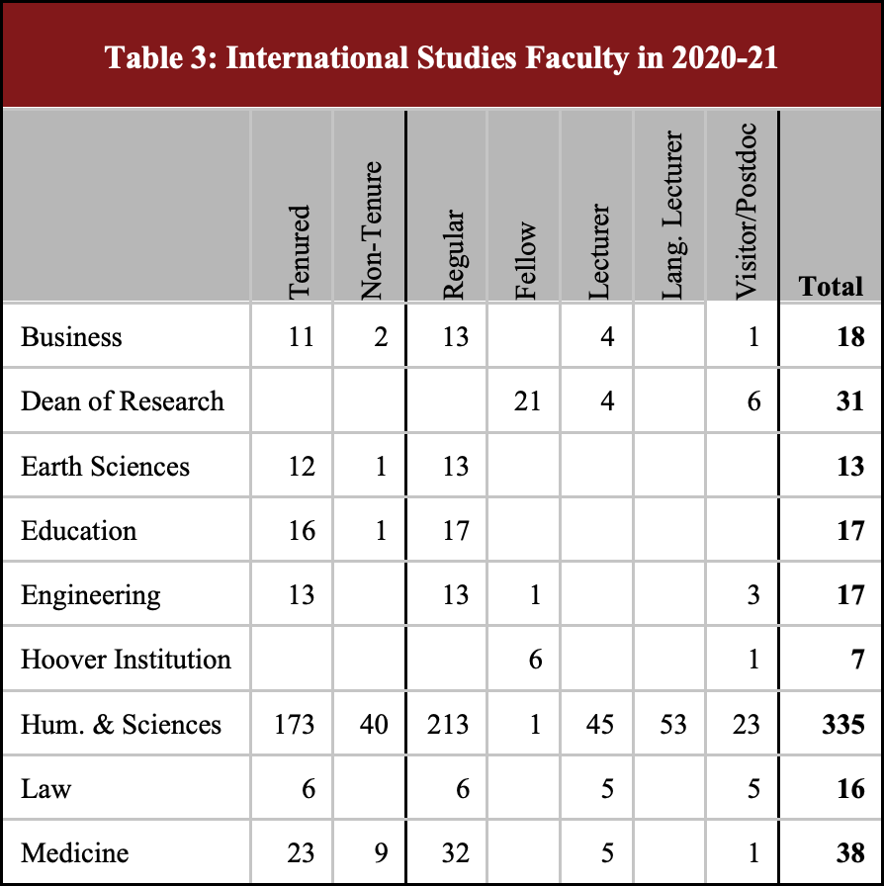
- Sufficient Non-Language Faculty and Pedagogical Training: Table 3 summarizes international studies faculty as of 2020-21. In all, 303 regular faculty, 28 research fellows, and 55 non-language lecturers research and teach at least
10% on international studies. An additional 41 visiting faculty/postdocs working 10-100% time on international studies contribute to occasional or special course offerings. Pedagogical training for faculty and graduate TAs is prioritized at Stanford and offered through home departments and multiple programs. Each department provides mandatory
pedagogical workshops for TAs; notably, History, Art History, Education, Linguistics, and the DLCL provide robust TA-training workshops and pedagogy courses. The Center for Teaching and Learning leverages evidence-based and inclusive learning and teaching practices to provide a suite of programs, workshops, resources, teaching grants, training sessions, and consultations for all Stanford instructors and TAs.

- Interdisciplinary Courses: Several regular courses offered in the departments of Anthropology, History, Sociology, and EALC have an explicit interdisciplinary focus. Many other international studies courses are jointly taught such as Human Society and Environmental Change (History and Earth Systems). Several interdisciplinary programs offer courses with international content, including Comparative Literature, International Policy Studies, International Relations, Interdisciplinary Studies in the Humanities, and Management Science and Engineering. SGS provided $450,000 for 69 globally-focused courses in 2020-21 alone.

(NRC & FLAS) QUALITY OF CURRICULUM DESIGN

1a) Undergraduate Student Instruction and Training: Stanford offers undergraduate students a wide range of non-language courses with international concentrations through numerous interdisciplinary programs. An average of 1,500 non-language courses with international content are offered each year, and many undergraduates satisfy general requirements in world cultures, humanities, and social science disciplines through coursework in international and area studies. Major and minor degrees with significant international content are available through 26 departments or programs, almost all of which include an honors option and many of which also have additional language requirements. SGS offers interdisciplinary majors, minors, certificates, and honors programs in area and international studies, including B.A. and honors programs in International Relations (IR) and a Global Studies minor. Most SGS students complete overseas studies and acquire fluency in a second language as part of their degree requirements. In 2020-21, there were 241 students enrolled in SGS’ undergraduate programs.
1b) Appropriateness of Undergraduate Requirements: Undergraduate degrees with a global focus emphasize modern-language training, interdisciplinary coursework, and study abroad experiences. There are 12 undergraduate majors and 13 minors that explicitly focus on

international studies offered by 10 departments and several of SGS’ centers. Majors in these fields of study must complete at least 60 units of coursework in international and area studies and are either required or strongly encouraged to complete at least one quarter studying abroad. Most programs also require proficiency in a foreign language at or above the 2nd-year level, an advanced writing course, and a capstone essay. Students with an overall GPA of 3.3 or higher may earn honors by pursuing directed individual research, taking honors seminars with a faculty advisor, completing a thesis, and presenting their work at a senior colloquium. The IR major includes 30 units in core courses, including 15 units in international politics, comparative governance, and American foreign policy courses; 35-55 units in two topical or regional specializations in global studies; a 10-week study abroad requirement; and 2+ years of foreign language study. Stanford students may also develop their global competencies through the interdisciplinary Global Studies minor, which requires a minimum language proficiency at the 2nd-year level, a Critical Issues in Global Affairs gateway course, and 25 units in content courses dealing with the history, cultures, societies, and institutions of different world regions.
An additional 19 majors and 22 minors provide students with opportunities to focus on international topics and specializations through coursework, language training, and study abroad experiences. Undergraduates in several other departments, including Anthropology, Comparative Literature, Political Science, Religious Studies, and Urban Studies, often pursue honors coursework on global topics. All undergraduates are required to complete one year of
college-level study or the equivalent in a foreign language. Over 19,000 students enrolled in language courses from 2017 to 2021, with LCTL courses accounting for over half of total language enrollments.

2a) Graduate Student Instruction and Training: Graduate programs are designed to provide rigorous interdisciplinary study of global issues, societies, and cultures as preparation for further scholarship or professional careers. Stanford offers 9 M.A. programs, 8 Ph.D. programs, and 6 Ph.D. minor programs with an explicit global focus. An additional 8 M.A., 12 Ph.D., and 7 Ph.D. minor programs offer international coursework and specializations. SGS’ M.A. programs in East Asian, Latin American, and Russian, East European and Eurasian studies are grounded in an interdisciplinary curriculum that emphasizes rigorous coursework in historical and contemporary topics within area and international studies, advanced language training, and independent research. The M.A. in International Policy requires students to complete core courses on international content knowledge and skills; an area of specialization in cyber policy and security, international security, governance and development, or energy, natural resources, and the environment; customizable electives; and a capstone experience based on international fieldwork. Stanford’s Ph.D. programs prepare students to contribute original scholarship and pursue advanced research and teaching careers in international and area studies. Ph.D. candidates participating in multidisciplinary programs in Anthropology, Art/Art History, Education, History, Political Science, Religious Studies and Sociology complete extensive international coursework and skills training, advanced language study, and research on global topics. In 2020-21, there were roughly 230 SGS-affiliated Ph.D. students specializing in area and international studies.
2b) Appropriateness of Graduate Requirements: Graduate programs emphasize advanced content knowledge, interdisciplinary skills, language training, and overseas experience to position students for successful careers in government, education, and the private sector. M.A. students typically must complete a minimum of 45 units of coursework in the core curriculum and an area of specialization, demonstrate content knowledge and skills through oral and/or

written exams, attain intermediate to advanced language proficiency in a second language, and produce a capstone research paper or thesis under the direction of a faculty advisor. Ph.D. students generally complete intensive coursework and research, hold teaching or research assistantships, acquire intermediate to advanced proficiency in one or more foreign languages, pass a university oral examination that tests their command of the field of study, and write an original dissertation. The roughly 1,500 non-language classes with international foci that are taught each year include offerings in the schools of Business, Law, Earth Sciences, Medicine, and Education, most of which have specialized global study trips or exchange programs that combine practical training with international studies.
3a) Academic and Career Advising Services for Students: The advising system at Stanford is comprehensive, with each undergraduate being assigned to a faculty advisor, an advising director, and a peer advisor. M.A. and Ph.D. students are advised by departmental administrators as well as individual faculty. SGS M.A. students are assigned individual faculty advisers and also receive academic and career counseling from centers’ associate directors. SGS disseminates information on global work and study opportunities to all Stanford students through regular email announcements; academic departments offer specialized workshops on interviewing strategies and grant-writing skills; and the Office of Academic Advising provides a full suite of resources for undergraduate students. The Stanford Career Education center provides extensive career programming, including job fairs, workshops, information sessions, one-on-one counseling, and alumni networking. An established career mentorship program managed by the Stanford Alumni Association links current undergraduate and graduate students with alumni in a variety of industries. SGS annually organizes a career development series featuring alumni who are currently working in government, law, business, and the nonprofit sector.

4) Formal Arrangements and Access for Research or Study Abroad: A hallmark of international studies at Stanford is the wealth of overseas study opportunities. Although ongoing global disruptions caused by the coronavirus pandemic have resulted in suspended programming, Stanford has pivoted to offer other globally-focused experiences while monitoring public health and travel advisory guidance, with plans to resume regular overseas programming as conditions improve. In non-pandemic years, the Bing Overseas Studies Program (BOSP) administers quarter-length programs at its 10 overseas centers, with many offering additional in-country internship opportunities. BOSP also offers 10-15 Overseas Seminars and Faculty-Initiated Programs in multiple destinations across Africa, East Asia, South Asia, Southeast Asia, East Europe, and the Western Hemisphere. From 2014-15 until 2018-19, a total of 3,369 students participated in BOSP’s overseas programs. Before the pandemic, approximately 50% of students in each graduating class participated in a BOSP program during their undergraduate career at Stanford. In addition, the Stanford Law School has eight exchange programs with law schools in Austria, China, France, Germany, Israel, Japan, Singapore, and Spain that offer students immersive experiences to learn firsthand about global legal systems.
International internships are offered primarily through BOSP (as noted above), SGS, FSI, the Graduate School of Business (GSB), and the School of Engineering. The Stanford Global Studies Internship Program (GSIP) provides undergraduate and graduate students with immersive, cultural, and professional opportunities around the world. Over the past four years, GSIP has collaborated with 121 organizations–including 18 academic institutions, 47 business entities, 37 nonprofit organizations, 10 government agencies, 5 think tanks, and 4 UN organizations–in 39 countries to offer more than 300 internships. In 2020-21, in response to the coronavirus pandemic, GSIP offered 52 virtual internships in 20 locations around the world.

Undergraduate and master’s students may pursue summer and field research internships focused on various topics in international policy through FSI’s Global Opportunities and Enrichment for Students. Stanford engineering students may participate in international internships,
service-learning programs, faculty-led programs, and study tours through Global Engineering Programs. Several GSB programs–including the Global Management Immersion Experience and Stanford-Tsinghua Exchange Program–expose students to the cultures, business environments, and social norms of countries around the world.
Students may also participate in programs supported through a number of international consortia or collaborative arrangements. Stanford currently is a member of the Inter-University Center for Japanese Language Studies in Yokohama, the premiere institution for the teaching of advanced Japanese, and the Inter-University Program for Chinese Language Studies, which provides year-long and summer Chinese language programs at Tsinghua University, Beijing. SGS’ Center for South Asia has established partnerships with Ashoka University in New Delhi and Habib University in Karachi to foster collaborative projects and study abroad seminars. SGS’ Center for Human Rights and International Justice is currently working with 24 partners–including government agencies, museums, universities, and nonprofits–around the world in support of research opportunities.
SGS, Vice Provost for Undergraduate Education, Overseas Resource Center, and Stanford in Government Program all provide funding in varying amounts for undergraduates to study abroad or conduct research. In addition to FLAS fellowships offered through Stanford’s two NRCs, SGS also provides roughly $20,000 annually in Global Perspectives Awards that support research abroad and language training. In total, SGS provided nearly $190,000 in competitive awards to support global internships for undergraduate/graduate students last year.

(NRC & FLAS) QUALITY OF STAFF RESOURCES

1a) Qualifications of the Teaching Faculty and Professional Staff: As demonstrated in Appendix 2, the 307 regular faculty, 29 research fellows, 63 non-language lecturers, and 53 language lecturers who specialize in international and area studies and languages are exceptionally qualified to conduct teaching and research. Regular tenure-track faculty, research fellows, postdoctoral and visiting scholars, and the majority of lecturers hold a Ph.D. or equivalent degree, and have extensive overseas experience with strong ties to foreign universities and research centers. All core faculty members have the ability to read, write, and speak one or more languages of their target countries. Many sit on academic advisory and editorial boards and thesis committees at other universities, or hold honorary appointments at overseas institutions, and have received awards and fellowships from such notable organizations as the MacArthur Foundation, American Council of Learned Societies, and National Endowment for the Humanities. Similarly, many of Stanford’s professional staff hold advanced degrees with specializations in international studies, have lived or worked abroad, and possess fluency in one or more foreign languages.
1b) Professional Development Opportunities: A host of programs, workshops, resources, and teaching grants offered through the Center for Teaching and Learning provide faculty with support to continually enhance their teaching expertise. The Office of Faculty Development, Diversity and Engagement (OFDDE) provides professional development in mentoring, writing, and leadership. Assistant professors receive a full year of paid leave before coming up for tenure, and all faculty receive regular sabbaticals. Faculty in the humanities receive $5,000 in research funds annually. Additional competitive course development and research grants are available through the SGS, Dean of Research, the Stanford Humanities Center, FSI, and other

campus programs. Stanford offers professional staff a variety of programs to enhance professional development, including $800 annually in funding for training and continuing education courses. The university also supports extensive free training courses in various business skills and a series of leadership programs including an intensive four-day Stanford Manager Academy.
1c) Teaching, Supervision and Advising of Students: Stanford faculty members work closely with students at all levels. Ladder-rank faculty members teach an average of four courses per year, actively supervise student theses and projects at all levels, and engage with students through numerous colloquia and seminars. Full-time non-language lecturers teach six courses per year and advise students, and language lecturers teach nine courses per year. Funding from SGS, VPUE, and the Vice Provost for Graduate Education allows students at all levels to conduct paid research with international studies faculty.
- Adequacy of Center Staffing and Oversight: In total, there are 184 professional staff in 28 departments, centers, and libraries at Stanford who work at least 25% time on international studies. Together, they plan and administer the university’s numerous research, publication, teacher training, and outreach programs related to international studies.
SGS is led by the Faculty Director and Executive Director as well as a Faculty Committee of 12 members who directly oversee strategic planning and outreach for individual centers within the Division. Additional oversight for SGS’ activities is provided by an Advisory Committee–currently led by two Stanford faculty, the Dean of the Stanford Law School, and the Director of the Stanford Humanities Center–tasked with expanding SGS’ outreach and partnerships at Stanford and promoting global issues to external constituencies within and outside of the U.S.

Direct oversight of NRC activities rests with the Project Director Jisha Menon, Associate Professor of Theater and Performance Studies. She received her Ph.D. in Drama from Stanford in 2004, her M.A. in English from Jawaharlal Nehru University in 1996, and her B.A. in English from Bangalore University, and has written and taught extensively on South Asia, publishing her second book, Brutal Beauty: Aesthetics and Aspiration in Urban India, in 2021. She is supported by the Executive Director, Katherine Kuhns, who brings 25 years of experience in international program development to help lead SGS’ 14 centers and programs and oversee strategic planning and operations for the Division. She also co-teaches the Global Studies minor gateway course, Critical Issues in Global Affairs. She holds a Ph.D. in International and Comparative Education from Stanford, an M.A. in International Economics from Johns Hopkins University School for Advanced International Studies, and a B.A. in Russian and Soviet Studies from the University of Arizona. SGS Finance Manager, Donna Even-Kesef, who received her B.S. in Business from High Point University, coordinates finances between the NRC centers and other Stanford units, assists with expense tracking and grant reporting, and is the main liaison with Stanford’s grants and contracts office. SGS Outreach and Academic Coordinator, Kristyn Hara, plans and manages all collaborative NRC projects, serves as the first point of contact for programmatic inquiries, and represents Stanford outreach activities to potential partner institutions. A former Fulbright Scholar, she received her Ph.D. and M.A. in Anthropology from the University of Chicago, and her B.A. in Anthropology from the University of California, Berkeley. Curriculum Development Specialist Jonas Edman writes curricular materials for K-14 classrooms and coordinates SPICE’s professional development seminars on East Asia for middle school teachers. He received his B.A. in History from Stockholm University in 2008 and a Single Subject Teaching Credential in Social Science from California State University, Sacramento in 2010.

- Non-discrimination and Encouraging Employment From Underrepresented Groups: Stanford prohibits discrimination and harassment and provides equal opportunity for all employees and applicants for employment regardless of race, religious creed, color, national origin, ancestry, physical or mental disability, medical condition, marital status, sex, age, sexual orientation, gender identity, veteran status, or any other trait or status protected by applicable law. The OFDDE assists deans, chairs, and search committees in developing diverse faculty applicant pools, serves as a resource for recruits and newly hired faculty, and promotes retention efforts to ensure continued faculty diversity. In 2009, the President’s Awards for Excellence through Diversity Program was established to recognize individuals and programs that make exceptional contributions to enhancing diversity, and the Diversity and Inclusion Innovation Fund was launched in 2013 to support faculty, student, and staff initiatives that advance diversity across the campus. In 2018, Stanford launched IDEAL (Inclusion, Diversity, and Equity in a Learning Environment), a set of campus-wide initiatives to ensure that diversity of thought, experience, and approach is represented in all sectors of education and research and that all members of the campus community have broad access to Stanford’s opportunities and benefits. As a result of these efforts, between 2017 and 2021, while the overall faculty at Stanford grew by only 3%, the number of under-represented minority faculty increased 15%.
The Office of Accessible Education (OAE) ensures that all university units and facilities comply with federal and state law as well as university standards of equal, fair access. The university complies in all ways with the Americans with Disabilities Act and all classrooms and administrative buildings used for SGS functions are accessible.

(NRC & FLAS) STRENGTH OF LIBRARY

1a) Strength of the Library Holdings: As one of the largest academic and research libraries in North America, the Stanford University Libraries (SUL) consists of 24 libraries that hold over
9.7 million physical volumes and 2 million e-books and is supported by an annual acquisitions and salaries budget of $77.7 million. SUL encompasses 10 robust area studies collections as well as a substantial international collection on war, revolution, and peace as part of its extensive archive. The African Collection contains over 150,000 monographs, serials, and digital materials about and from Sub-Saharan Africa, with notable holdings including African newspapers and map collections. With a central focus on language, literature, and history,
the French and Italian Collection consists of more than 550,000 monographs, serials, and digital materials that also cover the cultures, societies, and politics of France, Italy, and Francophone Belgium, Canada, and Switzerland. The Baltic and Estonian Collection houses 40,000 monographs, serials, and digital materials, including a notable collection of personal papers and church records of Latvian American pastor, author, bibliophile, and collector Richard Zariņš. The Germanic Collection includes more than 670,000 books, manuscripts, ephemera, microfilm, and data files on the cultures, societies, and politics of Germany, Austria, and German-speaking Switzerland, but also the Netherlands, the Flemish-speaking areas of Belgium, Luxembourg, Sweden, Norway, and Iceland. With more than 160,000 Hebraica and Judaica print, archival, electronic, and audiovisual materials, the Jewish Studies Collection has particular strengths in Hebrew and Yiddish literature, Hebrew language and linguistics, and Jewish cultural, economic, political, social, and religious history. The Latin American and Iberian Collection contains over 600,000 books, periodicals, and videos with notable holdings including one of the most comprehensive collections of pre-1900 travel accounts of Brazil in North America. The Islamic and Middle Eastern Collection contains nearly 200,000 printed

monographs, journals, and audio and visual items on the Islamic World and the Middle East. A notably large collection, the Slavic and Eastern European Collection includes more than 1 million volumes on Russia, the countries of the former Soviet Union, and Eastern Europe. As a member of Library of Congress’ South Asia Cooperative Acquisitions Program, Stanford has received thousands of materials from India, Pakistan, Afghanistan, Sri Lanka, Nepal, Bangladesh, and Tibet, further growing its South Asian Collection of more than 160,000 holdings. One of the top East Asia research facilities in the world, the East Asia Library (EAL) contains Chinese, Japanese, and Korean Collections on historical and contemporary politics, cultures, literature, languages, and sciences with total holdings across the three collections amounting to nearly 2 million monographs, serials, and digital materials. Finally, the Hoover Institution Library and Archives hold more than 1 million volumes and over 5,000 archival collections–in 69 languages and from more than 150 countries–on war, revolution, and peace.
1b) Financial Support for Acquisition and Staff: In 2020-21, the total acquisitions budget for all SUL area studies collections was approximately $4.1 million. SUL currently employs 29 full- and part-time staff whose combined salaries and benefits currently equal approximately $4.2 million annually, to manage and support these collections. In addition, senior librarians and curators are sent to professional workshops and conferences convened by organizations such as the American Library Association. SUL also invests heavily in information technology, audio visual equipment, and website development. For the 2022-25 grant cycle, we are requesting
$20,000 annually for special acquisitions of both print and digital materials to strengthen and expand SUL’s growing African, Islamic and Middle Eastern, and South Asian collections (Budget 5A).

1c) Educational Levels on Which the Center Focuses: SUL works closely with faculty and doctoral students to determine acquisition goals for its area studies collections. Special orientation sessions are held annually for incoming undergraduate and graduate students to familiarize them with collection holdings. Subject specialists are available to provide
discipline-specific advice, advanced research assistance, and consultations on SUL’s area studies collections for all students. They teach research methods and tools through workshops, exhibits, and public outreach events. SUL also provides course- and topic-based guides to collections, tools, and services that accompany interdisciplinary courses in area and international studies.
2) Cooperative Arrangements: Stanford participates in several cooperative agreements for sharing materials, privileges, and services. A Research Library Cooperation Program allows on-site and interlibrary borrowing privileges between faculty, staff, and graduate students at UC Berkeley, Stanford University, and UT Austin. The University of California/Stanford University Reciprocal Services Program provides eligible Stanford users with the same on-site access and borrowing privileges as counterparts at each of the U.C. campus general libraries while offering expedited interlibrary loan service and access to special collections. An international Stanford University/University of Göttingen Reciprocal Agreement supports interlibrary loan service between SUL and Universitätsbibliothek Göttingen, which ranks among the largest libraries in Germany. Stanford also participates in Area Studies Programs at the Center for Research Libraries, which acquire, preserve, and provide access to area studies materials that are at risk and/or not readily available to North American researchers. Teachers and students from other institutions may use the Stanford collections free of charge for seven days in any twelve-month period, allowing on-site use of the collections and access to the catalog and reference collections. A SUL Library Card may be purchased for an annual fee, which

allows access to the collections in the main and auxiliary libraries. The catalogues of Hoover, Green, and EAL libraries are available to the public online through the SUL website.

(NRC & FLAS) IMPACT AND EVALUATION

  - Significant Impact on the University, Community, Region, and the Nation: As a global institution with nearly 20 explicit international programs and engagement hubs, Stanford provides leadership in international education with substantial local and nationwide impact. At the institutional level, this impact is demonstrated by course enrollments, graduate placements, and event attendance. In 2020-21, Stanford offered 2,315 courses with greater than 25% area content in International Studies, with 18,821 undergraduate and graduate student enrollments. Of these courses, 349 were LCTL language courses with 1,756 student enrollments. Students who complete SGS’ rigorous, terminal M.A. programs in East Asian, Latin American, and Russian, East European and Eurasian Studies gain deep multidisciplinary content expertise in area and international studies and critical language skills that prepare them to pursue careers in the education, business, and nonprofit sectors. Last year, a total of 61 students pursued competitive master’s programs in SGS. The Global Studies minor, inaugurated in 2015, consistently enrolls students representing a diverse range of disciplines (roughly 50% from STEM fields), giving students in technical fields the ability to develop their global competencies. Over 450 virtual SGS-organized public events on global topics brought together more than 36,000 attendees from a broad set of constituencies including the government and military, the private sector,
non-profits, foreign officials, students and scholars, and the general public. Effects of these and other outreach activities ripple out to the state and national level. Each year, SPICE produces approximately 2,000 curriculum units in International Studies, which are distributed nationwide and reach an estimated 200,000 students. Over the past two grant cycles, SPICE hosted

teacher-training workshops for more than 360 K-12 and community college educators from around the country. Finally, SGS core faculty and affiliates are leaders in their fields, regularly producing cutting-edge research through an estimated 20-30 books and approximately 1,050 academic articles annually. They also share their expertise by lecturing in the U.S. and around the world, appearing in radio and TV interviews, writing editorial pieces in major publications, and serving on advisory boards and in other policy-making capacities. Our proposed outreach activities (Budget 8A-J) will have similar statewide, national, and global impact.

2a) Post-graduate Employment, Education, or Training in Areas of National Need:

Post-graduation placement data is maintained at the department and program level, and reflects only first post-graduation activity reported at approximately six months after completion.
Longitudinal employment data is currently not collected. Available data for initial placements of B.A.- and M.A.-level students in area studies-related degrees gathered over the previous decade shows that, on average, roughly 37% of graduates find employment in the private for-profit sector, primarily in the areas of banking & finance, marketing, consulting, and computer & technology. Roughly 23% go on to pursue advanced degrees in a variety of professional and academic disciplines. Just over 10% of students find employment in the non-profit sector.
Approximately 4% of graduates go on to work in education at the K-16 level in both administrative and teaching capacities. A small percentage of undergraduates enter government service directly after graduation; however, roughly 5.73% of terminal graduate students pursue government careers due in part to the university’s strong record of enrolling active-duty military Foreign Area Officers. In total, Stanford offers 16 terminal master's degrees where an
area-studies specialization is possible, producing more than 200 graduates each year who are more likely to enter areas of national need including education, economics, and information

technology. Doctoral students from Stanford primarily enter into teaching and research positions, often at leading academic institutions in the U.S. and abroad; however, a greater number of doctoral graduates are now also pursuing careers in the business and non-profit arenas.
2b) Efforts to Increase Placements in Areas of National Need: SGS’ M.A. degrees are terminal interdisciplinary programs designed for students intending to pursue careers outside of
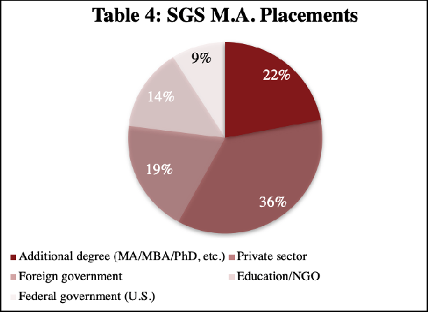
academia. Surveys of SGS alumni indicate that they are placed in a variety of careers addressing national needs. Nearly 100% of those responding to the survey report use of LCTL or area studies expertise in their current or recent employment. Table 4 summarizes career sectors for graduated respondents in the
previous four years. SGS and its centers encourage career paths in government, nonprofit, and private sectors through career development workshops featuring alumni in these fields that are open to all students; arranging summer internship opportunities with leading companies in the
U.S. and abroad; and curating an online alumni job placement network focused on private-sector jobs. Doctoral students primarily pursue academic careers and often go on to teach at prestigious institutions around the world. In the 2022-25 grant cycle, SGS will support its Centers for East Asian Studies (CEAS), Latin American Studies (CLAS), and Russian, East European and Eurasian Studies (CREEES) to increase enrollments of terminal M.A. students to expand the number of area studies experts entering careers in areas of need. SGS works closely with the Haas Center for Public Service which provides students with pathways in community engaged

learning and research, community organizing and activism, direct service, philanthropy, policy and governance, and social entrepreneurship in regions across the U.S. and the world.
- Addressing National Needs and Disseminating Information: Stanford addresses national needs in international studies on several fronts. First, by supporting high-quality LCTL and international and area studies instruction, we train the next generation of scholars and business leaders. An average of 50 LCTLs are available to students on demand, accounting for roughly 2,300 enrollments annually. Since 2014, SGS’ CEAS has awarded 67 academic-year and 55 summer FLAS awards in 5 languages—Cantonese, Japanese, Korean, Mandarin, Vietnamese—including 31 undergraduate, 68 master’s-level, and 23 doctoral-level awards. Similarly, SGS’ CLAS has awarded 56 academic-year and 33 summer FLAS awards in 5 languages–Haitian Creole, Kaqchikel Maya, Náhuatl, Portuguese, and Quechua–including 9 undergraduate, 54 master’s-level, and 13 doctoral-level awards to date. Between 2014 and 2018, SGS’ CREEES awarded 25 academic year FLAS fellowships that supported 20 master’s, 1 doctoral, and 2 professional school students for intermediate- and advanced-level LCTL study, and 31 summer FLAS awards for undergraduates and graduates. Graduated FLAS recipients have gone on to diverse careers in foreign service, energy consulting, finance, law, biomedicine, computer technology, trade and investment, venture capital, and academia. Stanford promotes service in areas of need by connecting them with past FLAS alumni to learn about
non-traditional career paths, offering job search workshops geared towards private-sector employment, and hosting internship opportunities where language training is a required skill. Second, SGS’ centers make training available to terminal master’s degree students who are more likely to pursue non-academic careers in the private sector or government. Third, SGS faculty’s numerous lectures, books, articles, white papers, and online resources inform debates in foreign

policy, health care, engineering, and business. Finally, SGS regularly disseminates research and pedagogical materials for K-14 teachers through SPICE, GSE, and other specialized international entities.
- Evaluation Plan and Use of Recent Evaluations: Planning and design of performance measures for the 2022-25 grant cycle will be carried out in consultation with independent, external evaluators (Budget 8K), Cathy Ringstaff (Ph.D., Stanford, Education–Educational Psychology) and Aleata Hubbard Cheuoua (Ph.D., Northwestern University–Learning Sciences). Dr. Ringstaff and Dr. Hubbard Cheuoua, Senior Research Associates at WestEd, have served as a PI or co-PI on various IES and NSF studies, and have extensive experience evaluating the impact of innovative education and professional development programs.The evaluation plan will be designed to measure the short- and long-term impact of articulated program goals. WestEd evaluators will use a mixed-methods approach, which will include surveys, interviews, and observations for current participants, as well as longitudinal follow-up surveys and interviews for past cohorts. All qualitative data will be transcribed and loaded into qualitative data analysis software (i.e., nVivo). Researchers will use a combination of grounded theory (Strauss & Corbin, 1998) and established methods for coding these data (Miles & Huberman, 1994). Throughout the process, researchers will use peer debriefing and auditing to check codes and concepts, which will be further sorted to generate categories. All quantitative data will be loaded into statistical analysis software (i.e., SPSS) and analyzed using standard statistical analysis techniques. WestEd staff will conduct monthly meetings with Stanford NRC staff to provide formative feedback, and will provide summative quarterly reports. Because we have now worked with WestEd to collect eight years of robust data, we have begun authoring papers for educational research and

international education journals as well as presenting at global education-focused conferences–another way that we are able to disseminate the results of our outreach activities.
WestEd is a preeminent educational research, development, and service organization with over 600 employees and 17 offices nationwide. The agency’s mission is to promote excellence, achieve equity, and improve learning for children, youth, and adults. In developing and applying the best available resources toward these goals, WestEd has built solid working relationships with education and community organizations at all levels throughout the U.S., playing key roles in facilitating the efforts of others and in initiating important new improvement ventures. Over the past 50 years, WestEd and its two predecessors, Far West Laboratory for Educational Research and Development and Southwest Regional Laboratory, have carried out more than 2,000 successful projects contributing to the nation’s R&D resources. WestEd has a stable funding base and organizational structure for carrying out the work of this proposal. Evaluation efforts by WestEd in the current grant cycle have informed iterative program changes and adjustments, and feedback from current partners and participants has been incorporated into the design of new programs proposed here. Evaluation of future programs will similarly allow for agile and ongoing project adjustments.
Additional evaluation of the international program will be ongoing and multi-tiered. SGS gathers statistics on globally-focused activities on campus (i.e., courses, staff, and research), and headcounts are taken at all events. The Registrar maintains information on student enrollments, theses, and degrees. Courses are evaluated through a standardized anonymous online questionnaire distributed at the end of each quarter. Internal departmental reviews are held for all teaching units every three to five years. Such reviews are the basis for decisions by the dean of the college on continuation of departmental status, quotas for graduate admissions, and budgets.

- Equal Access and Treatment: Stanford is committed to diversity, equal opportunity, and affirmative action goals to provide an inclusive and accessible community for students, staff, faculty, and visitors. The Stanford President and Provost have stated that increasing the diversity of students, staff, and faculty is a critical goal of the university, and to this end have supported a set of campus-wide initiatives to increase diversity in recruitment, research, education, and engagement. As part of these efforts, the university provides funds to departments for minority
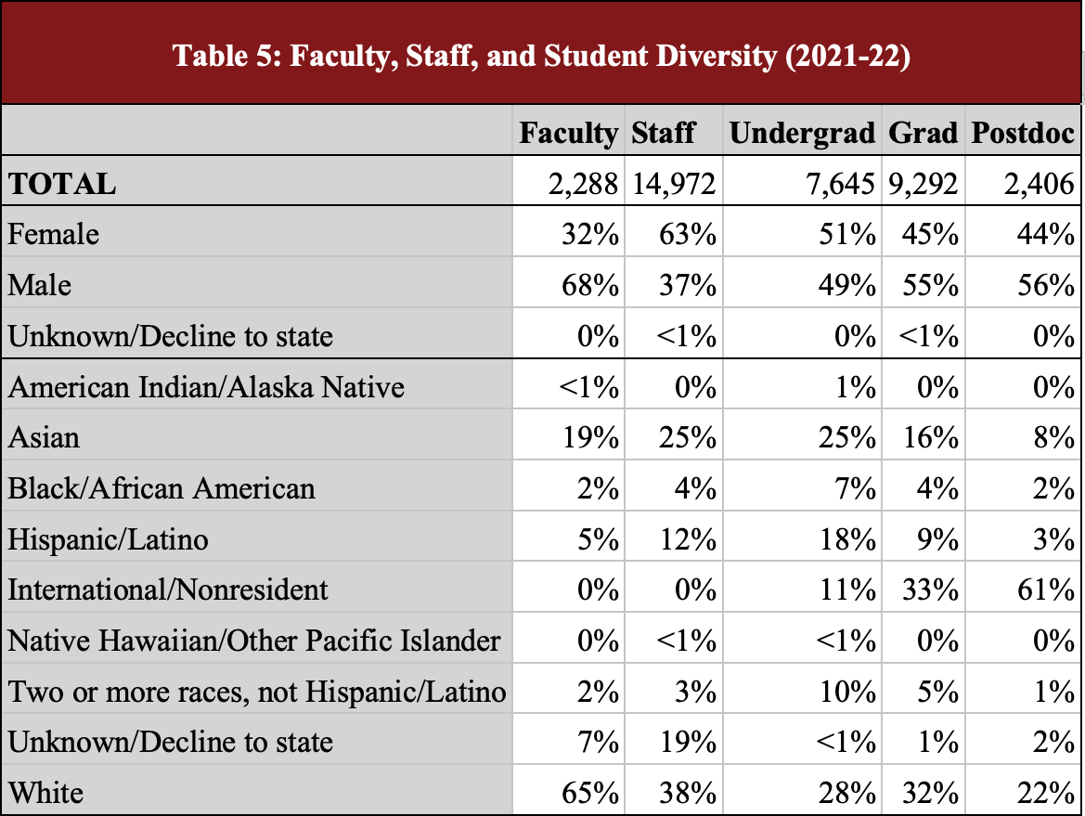
recruitment, fellowships, mentoring programs, support services, and multicultural centers. Each year, the Diversity and Access (D&A) Office develops the university’s Affirmative Action Plans for women, minorities, veterans, and
individuals with disabilities. Stanford has a proactive admission policy for students with disabilities and houses a Student Disability Resource Center in the Office of Accessible Education (OAE). With a staff of 18 members, OAE ensures that all university units and facilities comply with federal and state law as well as university standards of equal, fair access. Admission decisions are made without regard to an applicant’s financial status, and Stanford offers a comprehensive need-based financial aid program that makes it financially possible for admitted students to attend. Students whose parents make less than $75,000 a year are not expected to pay tuition or contribute to the costs of room and board and other expenses. Those

whose families make less than $150,000 a year do not pay tuition. Families earning over this amount still also qualify for assistance especially if more than one family member is enrolled in college. For current first-year students, the average amount of scholarships and grants from all sources received by need-based aid recipients is $58,494. SGS’ M.A. programs are made accessible to students of all economic backgrounds by awarding 14 academic year FLAS fellowships to incoming M.A. students. Other students may receive partial or full university funding. In 2020-21, SGS provided nearly $2 million in student aid and tuition allowances to support undergraduate and graduate students. All incoming Ph.D. students in the School of Humanities and Sciences are guaranteed a five-year funding package. Table 5 shows current diversity statistics for the Stanford faculty, staff, and student body.
The OAE is the campus office designated to work with Stanford students with disabilities, at both the undergraduate and graduate levels and provides a wide array of support services, accommodations, and programs to remove barriers to full participation in the life of the university. The D&A Office ensures university-wide compliance with federal, state, and local regulations concerning non-discrimination and disability access. The D&A Office provides an array of services and resources designed to ensure equal opportunity and equal access, and to address bias and discrimination prohibited by law or official university policy. The D&A Office also assists individuals with disabilities who have requests for accommodations in the workplace and access to Stanford facilities, programs, and activities, to ensure accessibility, equality, and fairness of its policies and programs.

(NRC) OUTREACH ACTIVITIES

Events play an important role in Stanford outreach, including cultural events, conferences, public lectures, and symposia organized by SGS , FSI, GSE, King Center for Global

Development, Stanford Institute for Human-Centered Artificial Intelligence (HAI), Stanford Institute for Economic Policy Research (SIEPR), and Stanford Institute for Innovation in Developing Countries (Seed). SGS advertises globally-focused events through a weekly newsletter, various center and program websites and social media platforms, the Stanford Events website, and local media outlets. Collectively, these events draw hundreds of thousands of participants from the education, government, private, and nonprofit sectors annually. Research findings and expert analysis on global issues are made widely available via university publication outlets including Stanford University Press and FSI Newsroom. SGS also publishes four newsletters and annual reports to inform its network of more than 2,500 program alumni and supporters about its programs and activities.
  - Elementary and Secondary Schools: Over the past four years, SGS has partnered with the Center to Support Excellence in Teaching in the GSE to host three-day professional learning institutes that combine content-rich presentations by leading international and area studies scholars with pedagogical training sessions for K-12 teachers. Drawing on the expertise of Stanford faculty from diverse disciplines, these institutes have covered a range of timely global issues such as citizenship and identity, great power competition, and race and rights. Between 2015 and 2021, more than 150 teachers from around the world participated in these institutes. GSE’s nationally renowned 12-month Stanford Teacher Education Program leads to a Master of Arts in Education and a California Multiple Subject or Single Subject Preliminary Credential and prepares between 60-80 teacher leaders per year who go on to serve institutions statewide. SPICE links the university’s research and teaching to elementary and secondary schools by producing award-winning curriculum materials and organizing teacher-training workshops on international and cross-cultural topics. With 22 full- and part-time staff, SPICE annually

distributes approximately 500 Asia-focused curricular units serving around 50,000 elementary and secondary students; 230 Latin America-focused curricular units serving an estimated 23,000 students; and 50 South Asia-focused curricular units that serve over 5,000 students, among additional materials covering other world regions. Stanford faculty advise on curricular projects and help lead SPICE’s regular educational workshops at the regional, national, and international levels. In cooperation with the National Consortium for Teaching about Asia (NCTA), SPICE offers free East Asia Summer Institutes for middle and high school teachers, reaching approximately 900 educators since the programs began. Finally, SPICE runs three highly selective pre-collegiate online courses for U.S.-based students focused on historical and contemporary China, Japan, and Korea that collectively have served nearly 1,000 students to date. SPICE is directly involved in the planning and implementation of several key outreach projects planned for this grant cycle, including the EPIC Community College Faculty Fellowship (Budget 8A), SPICE Global Workshops (Budget 8B), and SPICE Scholars Corner Videos and Lessons (8F).
  - Postsecondary Institutions: In the 2014-17 and 2018-21 NRC grant cycles, our comprehensive community college outreach programs–workshops, trainings, and symposia–under the umbrella of the Education Partnership for Internationalizing Curriculum (EPIC) served nearly 700 community college instructors from institutions across California, Illinois, Washington, New York, and Texas. Our faculty fellowship alone served 71 educators from 31 partner community colleges. Based on reported enrollments for community college and secondary instructors, conservative calculations indicate that these outreach efforts have benefitted more than 140,000 students throughout California and across the nation. Proposed projects for the 2022-25 NRC grant cycle (Budget items 8A-F) will leverage existing

institutional partnerships and digital technology to offer blended in-person and online activities that will significantly expand our reach to previously underserved community colleges and MSIs.
  - Business, Media, and the General Public: Last year, in response to the coronavirus pandemic, all 452 SGS events were hosted virtually, featuring scholars, performers, and other luminaries focused on diverse peoples, regions, and global issues and serving 36,225 attendees around the world. Other global programs similarly conducted extensive outreach to engage audiences representing the government, education, private, and non-profit sectors. FSI generates cross-disciplinary research and hosts events on topics in international affairs including governance, security, global health, energy, and international development. In 2020-21, FSI hosted 366 talks featuring prominent leaders in international studies and conducted 155 policy engagement activities. Research conducted last year by FSI faculty and fellows are available to external audiences through 275 international studies publications. A university-wide research center focused on alleviating global poverty and advancing global development, the King Center on Global Development regularly convenes researchers, students, policy makers, and private-sector leaders affiliated with Stanford and from around the world to share their knowledge with international audiences. More than 3,700 people from at least 34 countries attended the center’s events last year, which focused on a range of critical international topics including climate change, the global refugee crisis, and the future of foreign aid. HAI engages stakeholders in academia, industry, government, and civil society through public events on the uses and impacts of AI technologies around the world, attracting 85,000 participants through 54 virtual events in its inaugural year in 2019 alone. The Stanford Institute for Economic Policy and Research (SIEPR) organizes a variety of talks, workshops, and conferences on economic

challenges, opportunities, and policies affecting people around the world. Last year’s SIEPR Economic Summit drew in more than 5,000 viewers, and a total of 10,000 virtual attendees participated in its other events. The Cantor Arts Center regularly organizes seminars, workshops, and summer programs that feature its collections that span Africa, the Americas, Asia, Europe, and Oceania. In addition, Stanford University Press offers over 600 titles related to East Asia, 230 titles on Latin America, and 250 titles on the Middle East.

H. (FLAS) FLAS AWARDEE SELECTION PROCEDURES

1) FLAS Award Advertisement and Application Process: International FLAS awards will be administered directly by SGS, which will advertise the fellowship competition through 1) permanent posting of FLAS information on center, division, and university websites; 2) ongoing email notifications to all affiliated students and faculty; 3) inclusion of FLAS materials with SGS centers’ M.A. application and recruiting materials; 4) personal and email notification to departmental administrators and financial aid officers who in turn will notify their own students; and 5) inclusion of FLAS announcements by the Stanford Registrar in financial aid information. Special effort will be made to advertise in the professional schools and within SGS to ensure that non-Ph.D. students who are more likely to pursue government careers are given maximum consideration. Applications for continuing students will be announced formally in November each year, with a February application deadline for academic-year graduate and summer undergraduate and graduate awards, timed to coincide with the Free Application for Federal Student Aid (FAFSA) application deadline to allow consideration of financial need [FLAS CP 1]. Academic-year undergraduate awards will be announced in November with a May deadline. Continuing student applications will be submitted through a university-created funding opportunity portal which maintains all application data and ensures compliance with FERPA and

other regulations. Incoming SGS-affiliated M.A. applicants will submit program-specific statements of purpose directly to the department as supplements to their material submitted through the university application system. Applicants for both summer and academic-year awards will complete an online application specifying their current and intended language levels, program location and cost, and budget needs, and submit a statement of purpose, transcripts, and letters of recommendation from language instructors or other faculty.
An ad-hoc selection committee with a rotating membership consisting of SGS-affiliated faculty, fellows, and administrative staff representing a wide cross-section of disciplines and departments will convene each year to select fellows. Academic-year graduate and summer undergraduate and graduate applicants will typically have a 90-day application window, with a submission deadline in mid-February. Award decisions will be announced by mid-March to provide maximum flexibility in summer travel planning. Academic-year undergraduate award decisions will be announced in June. Applications will be ranked by five criteria: 1) overall academic achievement; 2) past performance in language courses; 3) clarity and feasibility of stated study/career goals; 4) strength of recommendations; and 5) financial need. Awards will be ranked foremost on academic merit, with preference given to eligible students who also demonstrate financial need. This entire process is designed to have the broadest reach across the Stanford student population and to ensure that the committee is able to support priority languages as outlined in [FLAS CP 2].
Advanced language study is a high priority for SGS-affiliated undergraduate and graduate students. SGS’ CEAS, CLAS, and CREEES awarded a combined 148 academic year and 119 summer FLAS fellowships over the past 2 grant cycles. FLAS awards supported undergraduate, master’s, doctoral, and professional school students who pursued intermediate- and

advanced-level training in more than 10 LCTLs. For the 2022-25 grant cycle, we are requesting 6 academic-year (5 graduate, 1 undergraduate) and 4 summer awards, totaling $235,000 annually (Budget 11A & 11B) to support growing demand for intermediate and advanced-level language courses in African Studies, Iranian Studies, Islamic Studies, and South Asian Studies. We expect that 100% of our awards will be made in non-French/German/Spanish priority languages [FLAS CP 2]. To ensure broad access, Stanford will continue to guarantee tuition top-offs for all FLAS awardees.

I. (NRC) PROGRAM PLANNING AND BUDGET

- Development Plan and Timeline: The current proposal has been carefully crafted, not

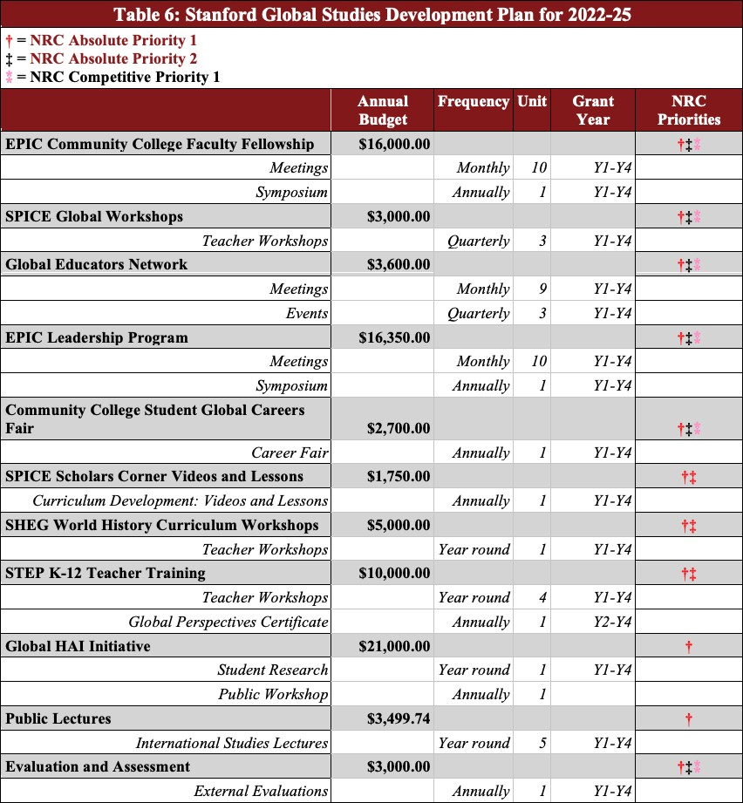
only to enhance programming during the 2022-25 grant cycle, but to also expand our capacity and impact in the years to come. SGS’ development plan (Table 6) provides an overview of our proposed projects, annual budget requests, implementation timeline, and fulfillment of absolute and competitive priorities. All projects

will involve significant Stanford contributions, often with multiple supporting units, and all are designed to provide benefits at the institutional, regional, national, and global levels.
Collaborative projects are designed to be institutionalized following completion of the grant cycle, adding permanent capacity and impact to the global program.
- Quality and Relevance of Programs: Stanford Global Studies and its 14 centers and programs, including its NRC centers—CEAS, CLAS, and, until 2018, CREEES—have a strong record in K-14 community engagement. The California Community College system, with its 116 campuses—over 70% of which are MSIs—and 1.8 million students, is the largest system of higher education in the country. Recognizing the key role that California’s community colleges play in our nation’s educational system and future, SGS and its NRC centers established a suite of outreach programs under the Education Partnership for Internationalizing Curriculum (EPIC) in 2013 to advance teacher training and curriculum internationalization at California community colleges and MSIs. Over the past eight years, we also broadened our outreach programming in service of K-12 teachers to help establish articulation points between secondary and postsecondary education.
For the 2022-2025 cycle, we propose to build on the partnerships and initiatives developed under EPIC to offer a comprehensive set of seven outreach programs (Budget 8A-G) designed for both K-12 and community college instruction in partnership with Stanford’s GSE and FSI. Our community college programs simultaneously accomplish three complementary goals: 1) they leverage Stanford’s expertise and resources in training teachers in languages, area, and international studies; 2) they ensure deep and sustained impact by building institutional-level support for curriculum internationalization at community colleges and MSIs; and 3) they create pipelines for students to pursue careers in government service and other areas of national need

while preparing them to participate in a globalized workforce. Similarly, our K-12 outreach aims to be comprehensive by prioritizing internationalized teacher training for both preservice and
in-service teachers, providing sustained opportunities for K-12 teachers at different stages of their careers. Collectively, these outreach programs serve to prepare and support teachers in global education along the entire K-14 continuum.
Teacher training through the EPIC Community College Faculty Fellowship is at the heart of EPIC programs. Since 2014, 71 fellows from 20 disciplines representing 31 community colleges across 4 states have participated. This competitive year-long fellowship program supports community college faculty in designing and implementing projects that internationalize core curricula and develop students’ global competencies based on the specific needs of their institutions. The hybrid fellowship begins with a three-day summer intensive that brings fellows to Stanford to engage with faculty affiliated with SGS and other internationally-focused programs. Fellows continue to meet monthly in three-hour workshops to explore cutting-edge research with Stanford scholars, develop innovative curricular and digital learning materials and extra-academic programs, and explore diverse perspectives and issues related to global teaching and learning. The fellows collaborate with curriculum design experts from the SPICE, and researchers from the Center for Spatial and Textual Analysis (CESTA) who provide guidance on using Stanford’s innovative digital resources. They also receive access to SUL’s vast digital holdings during the fellowship year. Results of fellows’ projects are shared at an end-of-year Symposium at Stanford that brings fellows together with 40-80 faculty and administrators from other community colleges and four-year universities across the state. Project outputs are also made available on the SGS website and shared via the Global Educators Network (below), and may serve as templates for similar implementation at other schools. We seek funding (Budget

8A, $16,000) to continue to seed new internationalization projects spearheaded by 10 fellows annually for each grant year at an ever-increasing number of community colleges/MSIs across California and nationally. [AP 1&2, CP 1]
To provide greater access to cutting-edge research on current issues of global relevance, we will offer quarterly virtual SPICE Global Workshops (Budget 8B, $3,000). Open to community college and K-12 educators nationwide, the workshops will feature presentations by Stanford faculty and research fellows complemented by pedagogical materials developed by SPICE curriculum specialists to enhance transferability to the classroom setting. Topics will vary in response to current affairs and input from EPIC fellows and workshop participants. We also propose to conduct two off-site, in-person workshops at institutions beyond Stanford’s immediate geographic region to further broaden reach and impact. Both virtual workshops and in-person workshops can serve up to 30 participants per session for a total of 150 attendees annually. [AP 1&2, CP 1]
Central to the success of the EPIC program has been the professional community that emerges among the fellows as they share institutional knowledge and best practices for advancing global education. To this end, we are requesting $3,600 (Budget 8C) to support the activities of the Global Educators Network (GEN). This thriving association of educators from community colleges and MSIs was established in 2020 by three EPIC Fellowship alumni and has grown to include more than 40 active members from institutions across California. GEN members will expand outreach by hosting workshops and colloquia at remote institutions, presenting at national conferences, and developing open-source online resources to inform, engage, and empower community college educators nationwide who are working to develop and institutionalize global studies on their campuses. [AP 1&2, CP 1]

Based on feedback from GEN and other community college faculty on the need for broader institutional-level support for international studies, we propose a new EPIC Leadership Program (Budget 8D, $16,350). In collaboration with Stanford’s Graduate School of Education and Graduate School of Business, we will bring together annually a cohort of 5-6 senior administrators from community colleges and MSIs across California to participate in leadership training and design programs at their home institutions to support international education.
Beginning with an in-person summer leadership institute, the program will feature quarterly online professional development workshops that will integrate targeted training on organizational leadership and institutional change with presentations by experts in internationalizing education. Fellows will develop an implementation goal and timeline for promoting international education at their home institutions in ways that achieve systematic and sustained impact. They will share these outputs for institutionalizing international education at community colleges and MSIs at the annual EPIC symposium. Significantly, this program will run in tandem with the successful EPIC Faculty Fellowship Program to provide vital opportunities for teachers and administrators to collaborate on internationalizing the community college curriculum both in and out of the classroom. Impact for this project will be measured by WestEd through metrics such as new courses offered, new degree programs implemented, or other institutional initiatives in support of global education. [AP 1&2, CP 1]
Finally, responding to numerous requests by community college/MSI faculty to directly engage students at community colleges/MSIs, we will host an annual online Community College Student Global Careers Fair (Budget 8E, $2,700). Students will learn from Stanford faculty about career pathways outside of academia that utilize international and area studies and language training, hear from transfer students currently enrolled at Stanford and other four-year

institutions in California about their academic trajectories, and participate in an innovative career exploration workshop grounded in Stanford’s revolutionary design thinking and led by career specialists. The first student fair held in 2021 drew over 100 students from 20 colleges across California, where participants engaged with scholars and practitioners from Stanford Law School, Graduate School of Business, FSI, and Stanford’s new school for climate and sustainability to learn about careers in government, education, business, and engineering. We anticipate 100 students per year will participate in the fair, and we will conduct active outreach to draw students from an ever-increasing number of community colleges/MSIs in the state and beyond. [AP 1, CP 1]
In addition to working with community colleges and MSIs, the EPIC program includes a strong focus on K-12 educators. Through a partnership with SPICE, we are requesting $1,750 (Budget 8F) to produce one SPICE Scholars Corner Video and Lesson per grant year. These open-access, online videos will feature talks by leading Stanford faculty on cutting-edge research in current international affairs, such as populism, civil conflict, and cybersecurity, and will be accompanied by free teaching and discussion guides crafted by SPICE’s award-winning curriculum designers. In the previous year, there were over 130,000 visits to the SPICE website and over 5,000 downloads of curricular materials to date. [AP 1&2]
Working with the Stanford History Education Group (SHEG) within GSE and other Stanford NRCs, we will underwrite registration fees for 15 K-12 educators to attend fee-based SHEG World History Curriculum Workshops (Budget 8G, $5,000) dedicated to international and regional topics in the K-12 world history curriculum. Workshops will be designed from the ground up around special topics in global history, drawing on the expertise of Stanford faculty affiliated with SGS and other international centers, and integrating SHEG’s nationally

recognized pedagogical approaches. Series topics will align with national curriculum standards and will, to the greatest extent possible, adapt relevant open-access and downloadable lessons to broaden training and resources on global historical topics. Building on SHEG’s existing record of more than 1 million website visitors and 2 million curricular downloads per year, we anticipate these workshops and corresponding curricular materials will serve thousands of teachers by the end of the grant cycle. [AP 1&2]
In addition to these collaborative projects that will be undertaken with Stanford’s NRCs under the EPIC banner, SGS will undertake an additional five international studies projects as part of its mission to advance globally-focused education, research, and community engagement.
Through a collaboration with GSE’s nationally renowned Stanford Teacher Education Program (STEP), we will offer global studies STEP K-12 Teacher Training ($10,000, Budget 8H) designed to empower future K-12 teachers with content knowledge and pedagogical training to internationalize their curricula. Each year, we will host a series of four professional learning workshops organized around an annual theme of global importance that will feature presentations on special topics by leading Stanford scholars, followed by subject-specific training by STEP Instructional Coaches who will assist with strategies and resources needed to adapt content information for pedagogical use. After the pilot year, we will also develop a Global Perspectives Certificate program to demonstrate the global knowledge and skills teachers have attained by participating in the training series. With each workshop serving an anticipated number of 70 STEP participants, we expect this series to reach hundreds of future teacher leaders by the end of the grant cycle. [AP 1&2]
Considering the profound global transformations and impacts of artificial intelligence (AI) technologies and the number of Stanford students who study AI within Computer Science

(Stanford’s top major and undergraduate degree awarded), SGS will launch a Global HAI Initiative (Budget 8I, $21,000) focused on internationalizing AI education in partnership with Stanford’s Institute on Human-Centered Artificial Intelligence (HAI). Student researchers will partner with experts in AI Education to design internationalized courses on AI and share curricular materials and research findings through workshop presentations, HAI’s public AI Curriculum Cache (available in 2022-23), and SGS’ and HAI’s websites. We will also collaborate with HAI to offer an annual Global AI in Society workshop featuring SGS-affiliated faculty and HAI experts who will share pioneering research on the intersections of AI technologies with opportunities and challenges in civil society around the globe. Based on current event enrollments, we anticipate that each annual workshop will serve 300-600 participants representing education, government, business, and civil society. [AP 1]
Funding for Public Lectures (Budget 8J, $3,499.74) will allow SGS to continue its role as Stanford’s hub for advancing diverse perspectives and knowledge about the world by bringing up to five guest scholars and practitioners to campus. When possible, events will be recorded and made available online to further expand their impact. [AP 1]
SGS is requesting funds for Library Acquisitions (Budget 5A, $20,000) to strengthen and expand the university’s area collections, which provide critical resources and services for education and research in international and area studies. Priority areas of acquisition include monographs, serials, and digital resources to strengthen and grow the African and Islamic and Middle Eastern collections. [AP 1]
In order to bolster and expand language training at Stanford, SGS will provide funding to teach two new LCTL course sequences beyond currently offered 1st-, 2nd-, or 3rd-levels in two African (North/Sub-Saharan) and/or South Asian languages. Specific offerings will prioritize

languages in these world regions historically underrepresented by Stanford NRCs, and be determined in consultation with SGS and the SLC. [AP 1]
As outlined in section I (FLAS) below, we are requesting $235,000 per year in FLAS Fellowship funding for 5 academic-year graduate awards, 1 academic-year undergraduate award, and 4 summer awards.
We are requesting support for key personnel (Budget 1A-C) to carry out the proposed activities listed above. Administration will be provided by the SGS Executive Director (Budget 1Ai, $18,000 plus fringe) and the SGS Finance Manager (Budget 1Aii, $8,000 plus fringe); Area and Other Instruction will be provided by two Language Instructors (Budget 1Bi-ii–positions to be filled, $20,000 each); and Outreach support will be provided by the SGS Outreach and Academic Coordinator (Budget 1Ci, $40,000 plus fringe) and a SPICE Curriculum Writer (Budget 1Cii, $2,000 plus fringe).
Project assessment and evaluation will be carried out by external Performance Measures Evaluators (Budget 8K, $3,000) through WestEd, a nonpartisan, nonprofit research, development, and service agency that provides evaluation services to institutions throughout the United States.
- Reasonableness of Costs: We seek to leverage Title VI funds with dean’s support, grants, and gifts to ensure these programs are self-sustaining by the end of the grant cycle. Funding for EPIC community college outreach will be jointly underwritten by Stanford’s five NRC applicants, in collaboration with FSI, GSE, and other international and area studies units. Library funding will be leveraged to maximize university contributions. Finally, costs for performance measurement and implementation of assessments (Budget 8K) will be shared among the five Stanford NRCs.

- Long-term Impact on Institution: Proposed seed funding for outreach programs will help sustain and grow permanent connections with K-12 and community college institutions, strengthen California secondary and post-secondary education, and significantly strengthen publicly available K-14 teaching resources on international and area studies topics. The Global Careers Fair will directly benefit community college students–including underserved or underrepresented student populations who might not otherwise have access to Stanford services and resources–by providing pathways for academic and career exploration in international fields. Access to research activities through the Global AI Initiative will provide hands-on training and practical experience for Stanford computer science students, support undergraduate curriculum development, and expand community engagement through public events. Advanced language instruction and FLAS support will increase LCTL offerings and enhance training for Stanford students most likely to enter government service or private industry. Library acquisitions will diversify and strengthen area and international studies resources available for educators, researchers, and students. Other projects will have similar program-enhancing or expanding effects, as described above.

I. (FLAS) COMPETITIVE PREFERENCE PRIORITIES

FLAS Competitive Preference Priority 1—Preference given to demonstrated financial need: Final award preference for all FLAS recipients will be given to those students who demonstrate financial need in addition to academic merit, as noted in section H. Financial-need data will be collected as appropriate through university and federal forms. Application review guidelines for ad-hoc faculty committees will prominently feature this language to ensure uniformity of approach across multiple years.

FLAS Competitive Preference Priority 2—Greater than 25% of academic-year awards in non-French, German, Spanish: For the 2022-25 grant cycle, we are requesting 6 academic year (5 graduate, 1 undergraduate) and 4 summer awards, totaling $235,000 annually (Budget 11A & 11B) to meet the growing demand for intermediate and advanced-level language courses in African Studies, Iranian Studies, Islamic Studies, and South Asian Studies. We expect that 100% of our awards will be made in non-French/German/Spanish priority languages [FLAS CP 2] as defined by the FY22 “Consultation With Federal Agencies On Areas Of National Need” published by the Department of Education. To ensure broad access, Stanford will continue to guarantee tuition top-offs for all FLAS awardees during this grant cycle.

J. (NRC) COMPETITIVE PREFERENCE PRIORITIES

We are seeking funding for 12 projects–as well as administrative, instruction, outreach, and evaluation support to implement them–as outlined in section I (NRC) above. Five key activities target MSI participation as summarized here with corresponding projects listed by budget item number.
Competitive Preference Priority 1: Partnership with Minority-Serving Institutions (MSIs) or Community Colleges: The EPIC Community College Faculty Fellowship (Budget 8A) was designed through direct collaboration with faculty, deans, and administrators at multiple community colleges designated as MSIs. While the program is open to all faculty from across California and the U.S., preference is given to applicants from minority-serving locations. To date, 71 fellows representing 34 institutions—including 25 MSIs—have participated in this program. SPICE Global Workshops (Budget 8B) will be designed in consultation with faculty from community colleges and MSIs to meet the specific international studies content knowledge and pedagogical needs of teachers. In addition, our proposed off-site, in-person workshops

beyond Stanford’s geographic region will be planned in collaboration with host community college and MSI faculty and provide the foundation for sustained direct institutional partnerships with Stanford around curriculum internationalization. As an outgrowth of Stanford’s long and sustained engagement with California Community Colleges, the Global Educators Network (Budget 8C) has grown organically to a robust 40+ members across 22 institutions, whose interest in global education is shaping the curricula at their home institutions. Established by four EPIC fellows who began outreach within their home institutions and local communities, GEN will now seek to broaden geographic representation and forge new relationships with rural and minority-serving colleges that have previously lacked sufficient resources to participate in these shared programs. The new EPIC Leadership Program (Budget 8D) was conceptualized based on feedback from multiple constituencies at local partner community colleges and MSIs on the need for support for internationalization at the institutional level. To start, applications for this program will be promoted within rural and minority-serving community colleges across the state of California to help broaden access to leadership opportunities in international studies; in the future, we hope to eventually expand participation beyond California as the program evolves. In 2021, SGS hosted an inaugural and highly successful Community College Student Global Careers Fair (Budget 8E), which attracted 103 participants from 20 community colleges across the state, 14 of which are MSIs. In the coming cycle we seek to continue this program, expanding participation to California State University and community college counselors, in order to more clearly define articulation pathways between two-year and four-year degree programs.

