The Graduate Assistance in Areas of National Need Program:
Performance Assessment of 2000 and 2001 Fellows



U.S. Department of Education
Office of Postsecondary Education
2006
U.S. Department of Education
Margaret Spellings
Secretary

Office of Postsecondary Education
James Manning
Acting Assistant Secretary

September 2006

This report is in the public domain. Authorization to reproduce it in whole or in part is granted. While permission to reprint this publication is not necessary, the citation should be: U.S. Department of Education, Office of Postsecondary Education, The Graduate Assistance in Areas of National Need Program: Performance Assessment of 2000 and 2001 Fellows, Washington, D.C., 2006.

This report is available on the Department’s Web site at: http://www.ed.gov/programs/gaann/performance.html.

On request, this publication is available in alternate formats, such as Braille, large print or computer diskette. For more information, please contact the Department’s Alternate Format Center at 202-260-0852 or 202-260-0818.

Contents

Tables…………………………………………………………………………………….. iii

Figures………………………………………………………………..…………………... iv

Executive Summary………………………………………………………………………. 1

Introduction……………………………………………………………………………….. 1

GAANN Program Funding……………………………………………………………….. 3

GAANN Program Performance Measures and Target Values…………………………… 4

Participants and Demographics……………………………………...……………………. 6

Evaluation of Program Performance for 111 Grantees…………………….……………... 7

Conclusion………………………………………………………………………………. 18

Tables

- Federally appropriated funding and number of grants and fellowships awarded for the GAANN Program, by fiscal year: 2000–05…………………………………………... 3

- Performance target and national average and benchmark values, by GAANN performance measures: 2004….. …………………………………………………..… 5

- Number of GAANN grants awarded and number and percentage of GAANN grants closed as of December 2004, by cohort year: 2000–01………………………………. 6

- Number and percentage of females and total enrollment in graduate school, by areas of national need: 2002…………………………………………….……….………….. 8

- Percentage of ethnic minorities enrolled in doctorate-granting institutions, by areas of national need: 2002………………………………………………………….………... 9

- Number and percentage of female GAANN fellows, by total number of fellows and type of institution: 2000 and 2001 cohorts…………………………………………... 10

- Academic status of GAANN fellows as of December 2004, by cohort: 2000 and 2001…………………………………………………………………………………. 14

- Median number of years taken by GAANN fellows to earn a Ph.D. as of December 2004, by cohort and type of institution: 2000 and 2001 cohorts……………………. 17

Figures

- Distribution of GAANN fellows between public and private institutions: 2000 and 2001 cohorts…………………………………………………………………………... 7

- Percentage of female GAANN fellows enrolled in graduate schools in areas of national need compared to the 2006 Program Performance Plan target and the national average: 2000 and 2001 cohorts……………………………………….….... 10

- Percentage of ethnic minority GAANN fellows enrolled in graduate schools in areas of national need compared to the 2006 Program Performance Plan target and the national average: 2000 and 2001 cohorts………………………………….…..…….. 11

- Percentage of ethnic minority GAANN fellows enrolled in graduate schools in the areas of national need compared to the 2006 Program Performance Plan target and the national average: 2000 and 2001 cohorts…………….…………………………... 12

- Percentage of ethnic minority GAANN fellows in public and private institutions, by cohort: 2000 and 2001………………………………………………………………. 13

- Percentage of GAANN fellows who completed a Ph.D. program or advanced to candidacy compared to the 2006 Program Performance Plan target and 2003 performance benchmark: 2000 and 2001 cohorts…………………………………… 14

- Academic status of GAANN fellows as of December 2004, by type of institution: 2000 and 2001 cohorts………………………………………………………………. 15

- Percentage of GAANN fellows from underrepresented groups, percentage of GAANN fellows who completed a Ph.D. program and the national average of students from underrepresented groups who received a Ph.D. in 2002: 2000 and 2001 cohorts……………………………………………………………………………….. 16

Executive Summary

The Graduate Assistance in Areas of National Need (GAANN) Program awards grants to postsecondary institutions to provide fellowships for graduate students of superior ability and financial need who are pursuing terminal degrees in areas of national need. As of 2004, the areas of national need were: biology; chemistry; computer and information sciences; engineering; geological and related sciences; mathematics; and physics.

This report describes data provided by GAANN grantees as of December 2004 for the cohorts of grants that first received their awards in program years 2000 and 2001. Generally, the data show that the program has had a positive impact to date:

- Nearly one half (49 percent) of the fellows advanced to candidacy or obtained a Ph.D. as of December 2004, exceeding the U.S. Department of Education’s (Department’s) target.
- Women received 41 percent of the fellowships, exceeding the Department’s target. This rate is nearly double the national graduate school enrollment rate of women.
- Ethnic minorities, as a whole, received 24 percent of the fellowships, which is well above the nation’s doctoral study enrollment rate for ethnic minorities and just above the Department’s cumulative target.
- Black or African-American fellows were the only ethnic minority that did not exceed the Department’s target. The proportion of African-Americans, 6.6 percent, rounded to the nearest whole percentage, just meets the Department’s target of 7 percent.
- The median time to achieve a doctorate (5.8–6.3 years) was shorter than both the Department’s target and the national average, thereby exceeding the Department’s goal.

Introduction

This report presents data on performance results reported to the U.S. Department of Education as of December 2004 by postsecondary institutions that received new GAANN grants in program years 2000 and 2001. Grantees provide the information required by the Government Performance and Results Act of 1993 (GPRA) when submitting their final (closing) performance reports. The performance data includes four measures that were developed for evaluating the overall effectiveness of the GAANN Program: 1) the percentage of fellows in the GAANN Program from traditionally underrepresented populations who enroll in programs offering a terminal degree in an area of national need, compared to the national average of enrollment in such programs; 2) the percentage of fellows in the GAANN Program who obtain a terminal degree in an area of national need; 3) the median duration of time from entering graduate school until degree completion, compared to the national average of comparable doctoral students; and 4) the program cost for each successful fellow.

Program Background

The GAANN Program began in 1988 with the reauthorization of the Higher Education Act of 1965 (HEA), as amended. The GAANN Program awards three-year grants to programs and academic units of postsecondary institutions to provide fellowships to graduate students of superior ability who demonstrate financial need and plan to pursue terminal degrees in areas of national need. The secretary of education designates areas of national need in a notice published in the Federal Register. The designated areas of national need in 2000 and 2001 were: biology; chemistry; computer and information sciences; engineering; geological and related sciences; mathematics; and physics. The terminal degree in these disciplines is a doctorate. The GAANN Program also encourages institutions to perform outreach activities to foster the enrollment of “talented students from traditionally underrepresented backgrounds” (Title VII, Part A, Subpart 2, Section 713(b)(3) of the HEA, as amended (20 U.S.C. 1132a et seq.)).

Postgraduate academic units of postsecondary institutions apply for the GAANN grants to provide a number of student fellowships. A typical GAANN Grant provides the academic unit or institution with a payment in lieu of charging fellows for tuition, fees or other expenses. The fellowship may also provide a stipend to the student based on financial need.

Although GAANN grants are awarded for a three-year period, only about one-quarter of the grantee institutions use their grants and submit final reports at the end of the third year. About 75 percent of the institutions take a one-year, no-cost extension into a fourth year, and approximately one-third of those in their fourth year apply and are approved for an additional one-year, no-cost extension into a fifth year. Thus, for some grants, there can be a waiting period of four or five years until information on performance outcomes is available.

GAANN Program Funding

Table 1 shows the federally appropriated funding levels for the GAANN Program for fiscal years (FY) 2000–05. The table also shows the numbers of fellowships supported. For FY 2004, appropriated funding for the GAANN Program was $30.6 million. This funding supported 51 new grants and 94 continuation grants. A total of 736 fellows benefited from the new and continuing grants. Historically, about every third year there has not been a GAANN grant competition because all available funds are used to provide continuation funding to grants awarded in the two previous years’ competitions.

Table 1. Federally appropriated funding and number of grants and fellowships awarded for the GAANN Program, by fiscal year: 2000–05

 | Appropriated funding (millions of dollars) | New grants awarded | Continuation grants awarded | Students receiving  new and continuing fellowships
Fiscal year
2005 | 30.4 | None | 145 | 736
2004 | 30.6 | 51 | 94 | 736
2003 | 30.8 | 94 | 86 | 937
2002 | 31.0 | None | 201 | 1070
2001 | 31.0 | 86 | 115 | 1070
2000 | 31.0 | 116 | 106 | 1207
Source: http://www.ed.gov/programs/gaann/funding.html (accessed July 21, 2006).

Each grantee institution receives no less than $100,000 and cannot receive more than $750,000 in a single fiscal year from its new and continuing grants. As an additional requirement, the grantee must match, from nonfederal sources, at least 25 percent of the amount of the grant.

GAANN Program Performance Measures and Target Values

Performance Measures

The U.S. Department of Education’s Fiscal Year (FY) 2006 Program Performance Plan (2006 Program Performance Plan) states the objective of the GAANN Program:

To increase the number of students of superior academic ability completing a terminal degree in designated areas of national need in order to alleviate the need.

To assess program performance based on this objective, the 2006 Program Performance Plan specifies four performance measures:

- Enrollment of underrepresented populations. The percentage of fellows from traditionally underrepresented groups by grantee cohort enrolled in a terminal degree program in the designated areas of national need will increase.

- Graduate school completion. The percentage of GAANN fellows who obtain a terminal degree in an area of national need will increase.

- Time to degree completion. The median time from entering graduate school until degree completion will be less for GAANN fellows than comparable doctoral students, as identified annually in the Survey of Earned Doctorates.

- The cost per successful GAANN fellow. This measure is calculated by taking the total funding for years one, two and three, divided by the number of GAANN Ph.D.s and those who pass preliminary exams during that period.

2004 Target Values for the Performance Measures

In addition to establishing programwide performance measures and benchmarking program performance against comparable national standards, the Department establishes goals, or targets, for increasing program performance. Targets have been set for the first three performance measures: enrollment rate, completion rate and time to degree completion. Currently, no target has been established for the cost per successful GAANN fellow measure.

Table 2 provides the performance targets and national averages and benchmark values for the first three performance measures for the reporting year 2004.

Table 2. Performance target and national average and benchmark values, by GAANN performance measures: 2004

 | Performance target values | National average/benchmark values
Performance measures
 |  |  | Percent
Enrollment of underrepresented populations
Women | 35 | 21
Asian or Pacific Islander | 6 | 7.0
Black or African-American | 7 | 2.9
Hispanic or Latino | 2 | 2.9
American Indian or Alaska Native | 0 | 0.2
Graduate school completion | 28 | 47
 |  |  | Years
Time to doctorate completion | 6.45 | 6.7–7
Source: 2006 Program Performance Plan, NSF: 2002; and 2002 Survey of Earned Doctorates.

This report presents results on three of the four previously mentioned performance measures as reported by grantees as of December 2004. The evaluation of the GAANN Program as of December 2004 includes data from final reports submitted by those institutions first funded in 2000 that closed their grants within four years and data from final reports submitted by those institutions first funded in 2001 that closed their grants at the end of three years.

Participants and Demographics

Descriptive Statistics of Programs at Postsecondary Institutions

In 2000 and 2001, 68 postsecondary institutions (46 public and 22 private) received 202 grants. As of December 2004, 87 grants originally awarded in 2000 and 24 grants originally awarded in 2001 had closed. This report presents performance data from those academic grants. The remaining grants (91) were approved for no-cost extensions for an additional year into 2005 (table 3).

Table 3. Number of GAANN grants awarded and number and percentage of GAANN grants closed as of December 2004, by cohort year: 2000–01

 | Number of grants awarded | Grants closed as of December 2004
 | Number of grants awarded | Number | Percent
Cohort year
2000 | 116 | 87 | 75
2001 | 86 | 24 | 28
Total | 202 | 111 | 55
Source: GAANN Program data; and GAANN Program Annual Performance Reports (APRs), 2004.
Note: Percent = number of grants closed x 100/number of grants awarded.

Descriptive Statistics of GAANN Fellows

An estimated 592 students were originally projected to receive fellowships from the 111 grants reported; however, a significantly larger number of students received the fellowships. The original projection assumed that institutions would provide fellowships equaling the maximum allowable stipend and institutional payment. In 2000 and 2001, the maximum allowable stipend and institutional payment for each student for the year, as determined by the secretary of education annually in accordance with legislation, was approximately $30,000. Therefore, the three-year fellowship amount for each student was approximately $90,000. However, since the stipend cannot exceed the fellow’s financial need as determined each year, many fellows received less than the maximum annual allowance of $30,000. Financial need is determined each year on the basis of the requirements for need analysis prescribed by Title IV, Part F of HEA.

In addition, many institutions far exceed the requirement that they match at least 25 percent of their grant amounts. Since matching funds must be used for the same purpose as the GAANN funds, the amount available for fellowships was larger than originally projected. As a result, fellowships were awarded to 2.5 times the number of GAANN fellows—a total of 1,501 for both the 2000 and 2001 cohorts.

Fellowship recipients were nearly three times more likely to attend public institutions than private (fig. 1). A total of 1,112 students (74 percent) attended public institutions, while 389 students (26 percent) attended private institutions.

Figure 1. Distribution of GAANN fellows between public and private institutions: 2000 and 2001 cohorts

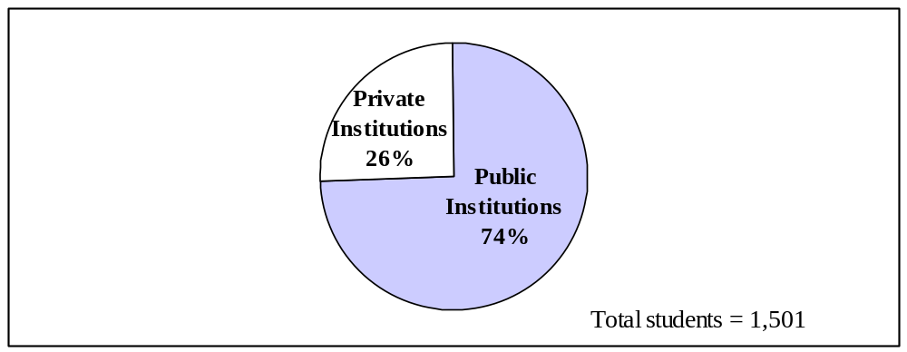Source: GAANN Program data; and GAANN Program APRs, 2004.

Evaluation of Program Performance for 111 Grantees

Enrollment of Underrepresented Populations

For the purpose of evaluating the GAANN Program, the 2006 Program Performance Plan defines underrepresented populations as women and the following ethnic groups: Asian or Pacific Islander; Black or African-American; Hispanic or Latino; and American Indian or Alaska Native. The 2006 Program Performance Plan sets the 2004 performance target for this measure at the actual 2003 performance target. The 2004 targets are: 35 percent for women; 6 percent for Asian or Pacific Islander; 7 percent for Black or African-American; 2 percent for Hispanic or Latino; and 0 percent for American Indian or Alaska Native. The authorizing legislation for the GAANN Program only recommends, but does not mandate, that institutions seek individuals from traditionally underrepresented groups when awarding fellowships. The goal of the GAANN Program is to maintain the 2003 levels of representation of women and ethnic minorities, while increasing terminal degree completion rates and reducing the median time to degree completion.

The 2004 performance is benchmarked against the national enrollment of underrepresented populations in areas of national need. The National Science Foundation regularly collects statistics on the participation of women, minorities and persons with disabilities in the science and engineering fields, including higher education enrollments. The Graduate Students and Postdoctorates in Science and Engineering: Fall 2002 Report (NSF: 2002) presents estimates of the total enrollments in science, engineering and health-related programs in 12,126 graduate academic units at 594 institutions in the United States and outlying areas.

The graduate enrollment of U.S. citizens and alien permanent residents (those who hold green cards but have not yet been granted U.S. citizenship) from underrepresented populations in areas of national need, as reported in the NSF: 2002, is: 21 percent for females (table 4); 7.0 percent for Asians or Pacific Islanders; 2.9 percent for Blacks or African-Americans; 2.9 percent for Hispanics or Latinos; 0.2 percent for American Indians or Alaska Natives; and 4.1 percent for other ethnic minorities (table 5). The aggregate percentage for ethnic minorities is 17.1 percent.

Table 4. Number and percentage of females and total enrollment in graduate school, by areas of national need: 2002

 | Female enrollmentª |  | Total enrollment^{b}
 | Number | Percent | Number
Areas of national need
Biological sciences | 26,352 | 43 | 61,132
Chemistry | 4,583 | 24 | 19,046
Computer sciences | 8,334 | 15 | 55,559
Engineering | 13,795 | 12 | 119,608
Geological sciences | 5,235 | 37 | 14,240
Mathematical sciences | 4,386 | 24 | 18,163
Physics | 1,166 | 10 | 11,701
Total | 63,851 | 21 | 299,449
Source: NSF: 2002.
ª Female enrollment includes U.S. citizens and alien permanent residents (those who hold green cards but have not yet been granted U.S. citizenship).
^{b} Total enrollment includes U.S. citizens, permanent residents (those who hold green cards but have not yet been granted U.S. citizenship), and students with temporary visas.

Table 5. Percentage of ethnic minorities enrolledª in doctorate-granting institutions, by areas of national need: 2002

 | Asian / Pacific Islander | Black Non-Hispanic | Hispanic | American Indian / Alaska Native | Other
Areas of national need
Biological sciences | 8.1 | 3.8 | 4.1 | 0.3 | 4.0
Chemistry | 4.7 | 3.1 | 3.4 | 0.3 | 2.8
Computer sciences | 10.1 | 3.3 | 1.7 | 0.1 | 5.9
Engineering | 6.7 | 2.5 | 2.7 | 0.2 | 3.5
Geological sciences | 2.3 | 1.8 | 2.8 | 0.6 | 3.5
Mathematical sciences | 5.4 | 2.9 | 2.6 | 0.1 | 4.3
Physics | 3.3 | 1.9 | 2.2 | 0.2 | 4.5
Total^{b} | 7.0 | 2.9 | 2.9 | 0.2 | 4.1
Source: NSF: 2002.
Note: Table categories duplicate those mentioned in the NSF:2002.
ª Ethnic minority enrollment includes U.S. citizens and alien permanent residents (those who hold green cards but have not yet been granted U.S. citizenship).
^{b} Total is the percentage of the ethnic minorities enrolled in programs of biological sciences, chemistry, computer sciences, engineering, geological sciences, mathematical sciences and physics at doctorate-granting institutions.

Enrollment of female GAANN fellows

Of the 1,501 fellows from the 2000 and 2001 grants closed as of December 2004, 41 percent (618) were women. This rate was significantly higher than the rate at which women across the nation enrolled in graduate schools in the areas of national need. Female U.S. citizens and alien permanent residents made up only 21 percent of the graduate school enrollment in areas of national need, as reported in the NSF: 2002. Further, the enrollment rate of female GAANN fellows also exceeded the 2006 Program Performance Plan target of 35 percent (fig. 2).

Figure 2. Percentage of female GAANN fellows enrolled in graduate schools in areas of national need compared to the 2006 Program Performance Plan target and the national average: 2000 and 2001 cohorts

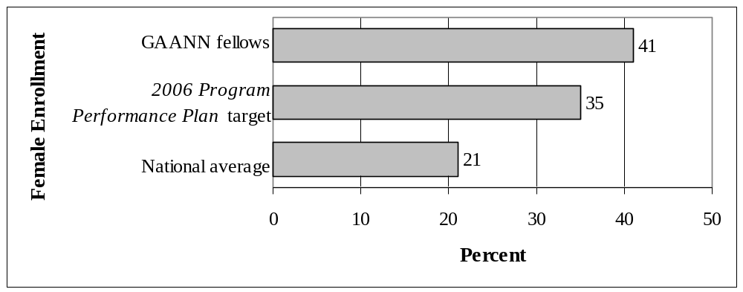
Source: GAANN Program APRs, 2004; 2006 Program Performance Plan; and NSF: 2002.
Note: Percentages are the percent of the total number of fellows.

There was no significant difference in the proportion of female fellows attending public and private institutions. Of the fellows attending public institutions, 42 percent (469) were female; of the fellows attending private institutions, 38 percent (149) were female (table 6).

Table 6. Number and percentage of female GAANN fellows, by total number of fellows and type of institution: 2000 and 2001 cohorts

 | Female fellows |  | Total fellows
 | Number | Percent | Number
Type of institution
Public | 469 | 42 | 1,112
Private | 149 | 38 | 389
Total | 618 | 41 | 1,501
Source: GAANN Program APRs, 2004.
Note: Percentages are based on the total number of fellows.

Enrollment of ethnic minority fellows

Minorities represented 24 percent (360) of the 1,501 GAANN fellows from the 2000 and 2001 cohorts reporting as of December 2004. This was a significantly greater proportion than the national average for ethnic minority doctoral degree enrollees (17 percent) in areas of national need, as reported in the NSF: 2002. The proportion of minority GAANN fellows enrolled also exceeded the 2006 Program Performance Plan target of 15 percent (fig. 3).

Figure 3. Percentage of ethnic minority GAANN fellows enrolled in graduate schools in areas of national need compared to the 2006 Program Performance Plan target and the national average: 2000 and 2001 cohorts

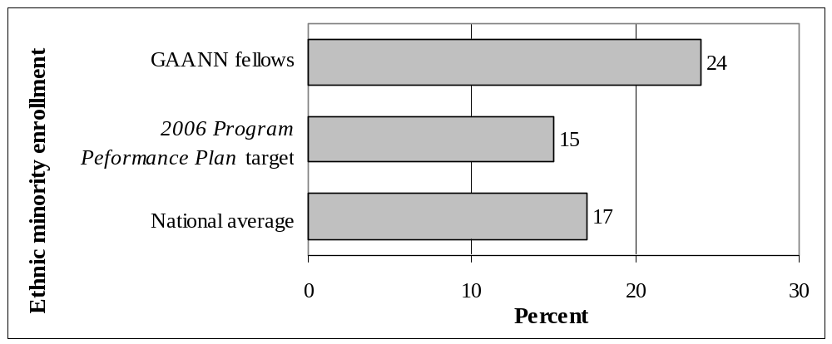Source: GAANN Program APRs, 2004; and NSF: 2002.

Although this performance measure was established to evaluate enrollments of ethnic minorities—Asians or Pacific Islanders; Blacks or African-Americans; Hispanics or Latinos; and American Indians or Alaska Natives—actual GAANN performance data was not collected on American Indians or Alaska Natives. Instead, the category “Others” was used. This category may have included American Indians or Alaska Natives and other ethnic minorities. The NSF: 2002 categories included American Indian or Alaska Native and Others. Given that people reporting mixed ethnic backgrounds are placed in the NSF: 2002 Other category, the categories as reported by GAANN grantees do not correspond to those reported in the NSF: 2002. Therefore, the results for American Indians or Alaska Natives will not be compared to the national average.

There was a significantly greater proportion of Asian or Pacific Islander (9.0 percent), Black or African-American (6.6 percent) and Hispanic or Latino (6.6 percent) GAANN fellows enrolled in graduate schools in the areas of national need as compared to the national doctoral study enrollments for each group (7.0 percent, 2.9 percent and 2.9 percent, respectively). The proportion of Asians or Pacific Islanders and Hispanics or Latinos also exceeded the 2006 Program Performance Plan targets of 6 percent and 2 percent. However, the proportion of Blacks or African-Americans fell short of the 7 percent 2006 Program Performance Plan target, if the actual GAANN proportion is not rounded up (fig. 4).

Figure 4. Percentage of ethnic minority GAANN fellows enrolled in graduate schools in the areas of national need compared to the 2006 Program Performance Plan target and the national average: 2000 and 2001 cohorts

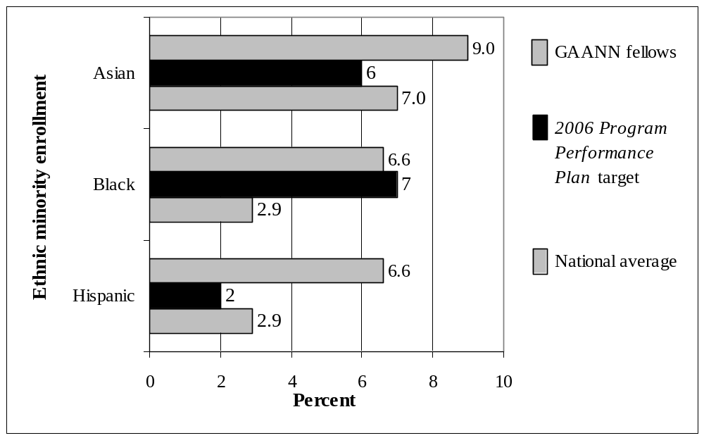
Source: GAANN Program APRs, 2004; and NSF: 2002.
Note: Percentages are the percent of the total number of fellows.

Overall, 77 percent (276) of the ethnic minority GAANN fellows attended public institutions, and 23 percent (84) attended private institutions. This compares closely with the proportion of all GAANN fellows, regardless of ethnicity, attending public and private institutions (fig. 1). A larger proportion of fellowships were awarded to ethnic minorities at public institutions in the 2000 cohort compared to the 2001 cohort (81 percent versus 65 percent, respectively; fig. 5).

While the proportions of Asians or Pacific Islanders and Blacks or African-Americans were approximately the same in both the 2000 and 2001 cohorts, the percentage of Hispanic or Latino fellows increased from 6 percent (64) in the 2000 cohort to 10 percent (35) in the 2001 cohort.

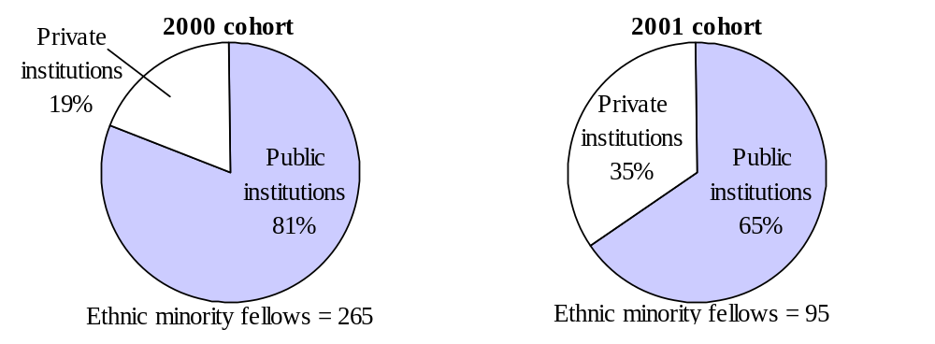
Figure 5. Percentage of ethnic minority GAANN fellows in public and private institutions, by cohort: 2000 and 2001

Source: GAANN Program APRs, 2004.

Doctoral Degree Completion and Candidacy

To be considered qualified for preparing and defending a doctoral thesis, candidates are required to pass a preliminary examination, thus advancing to candidacy. The doctoral degree completion measure counts students who advance to candidacy as well as students who receive a doctorate. Adding advancement to candidacy as a milestone to degree completion provides a more realistic assessment of fellows’ progress because the three-year grant award period is shorter than the average time required to obtain a doctorate.

The 2006 Program Performance Plan specifies a performance target of 28 percent for Ph.D. program completion or advancement to candidacy. The 2004 performance is also benchmarked against the actual 2003 performance of 47 percent, as reported in the 2006 Program Performance Plan.

As of December 2004, 49 percent (731) of GAANN fellows successfully completed their Ph.D. program or advanced to candidacy. Therefore, the actual performances exceeded both the target and the benchmark (fig. 6).

Figure 6. Percentage of GAANN fellows who completed a Ph.D. program or advanced to candidacy compared to the 2006 Program Performance Plan target and 2003 performance benchmark: 2000 and 2001 cohorts

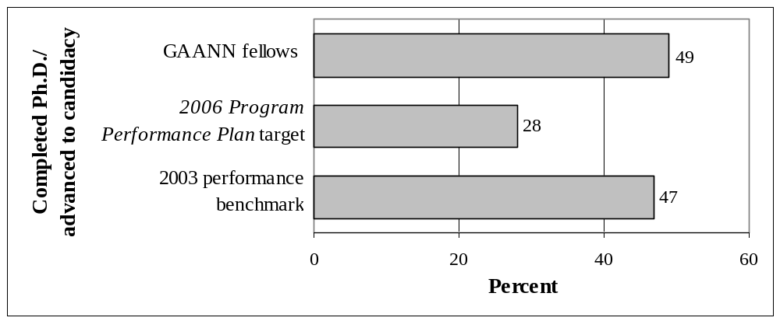
Source: GAANN Program APRs, 2004.

A higher proportion of fellows (16 percent) in the 2000 cohort have completed a Ph.D program, compared to fellows in the 2001 cohort (10 percent). The same proportion (34 percent) of fellows had advanced to candidacy (table 7).

Table 7. Academic status of GAANN fellows as of December 2004, by cohort: 2000 and 2001

 | Academic status |  |  |  | Total  fellows
 | Completed Ph.D. | Advanced to candidacy | Still enrolled as  a student | Completed  master’s degree or left the graduate program | Total  fellows
 | Percent
Cohort
2000 | 16 | 34 | 30 | 20 | 1,153
2001 | 10 | 34 | 45 | 11 | 348
Source: GAANN Program APRs, 2004.

Private postsecondary institutions that received GAANN grants showed a significantly higher rate of successful Ph.D. program completion and advancement to candidacy than did public institutions. A slightly larger percentage of fellows earned a Ph.D. at private institutions (17 percent) than those attending public institutions (14 percent). In private institutions, 47 percent (183) of the GAANN fellows advanced to candidacy. In public institutions, only 30 percent (329) of fellows advanced to candidacy (fig. 7).

Figure 7. Academic status of GAANN fellows as of December 2004, by type of institution: 2000 and 2001 cohorts

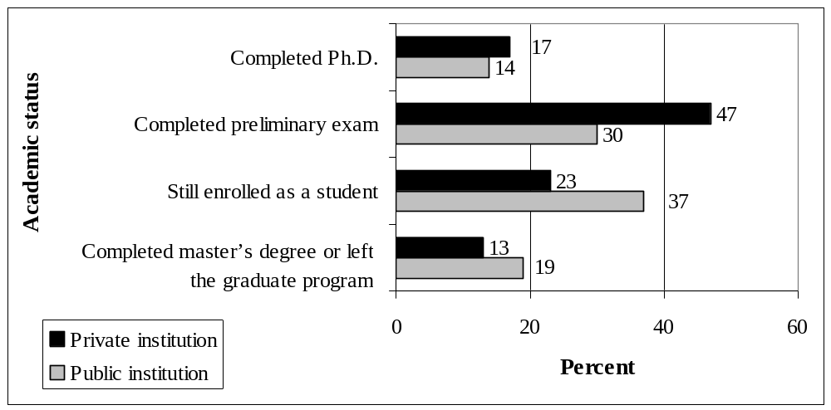
Source: GAANN Program APRs, 2004.
Note: There were 1,112 fellows in public institutions and 389 in private institutions.

In an effort to increase the number of Ph.D.s received by students from traditionally underrepresented groups, the GAANN Program encourages institutions to perform outreach activities to these groups to increase minority enrollment rates. Figure 8 illustrates the Ph.D. completion rates of GAANN fellows from underrepresented groups. It also compares the percentage of fellows from underrepresented groups who completed a Ph.D. program as of 2004 with the national percentage of students from underrepresented groups who received a Ph.D. in 2002. The national percentage is derived from the report Science and Engineering Doctorate Awards: 2002 (S&E Doctorates: 2002).

Figure 8. Percentage of GAANN fellows from underrepresented groups, percentage of GAANN fellows who completed a Ph.D. program and the national average of students from underrepresented groups who received a Ph.D. in 2002: 2000 and 2001 cohorts

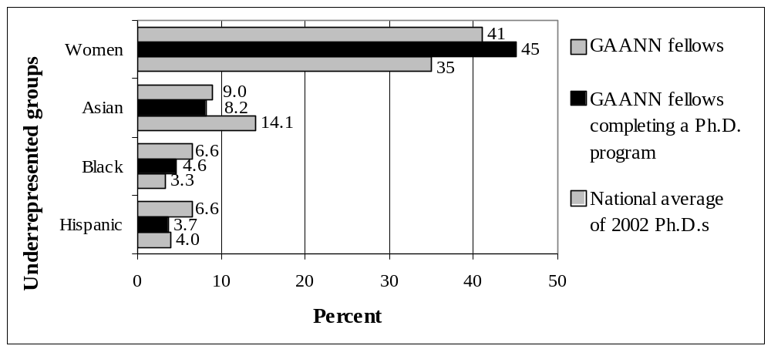
Source: GAANN Program APRs, 2004; and S&E Doctorates: 2002.
Note: The national average includes only U.S. citizens and alien permanent residents (those who hold green cards but have not yet been granted U.S. citizenship) in areas of national need.

The enrollment and completion rates for female GAANN fellows were approximately the same. Females received 41 percent of GAANN fellowships and earned 45 percent (98 of 219) of GAANN Ph.D.s. The GAANN Program, however, generated a higher proportion of female Ph.D.s than did the nation’s graduate programs (35 percent).

Although ethnic minorities received 24 percent of GAANN fellowships, they only earned 17 percent (38 of 219) of GAANN Ph.D.s. This represents a statistically significant difference at the 0.05 level. Asians or Pacific Islanders received 9 percent of GAANN fellowships and earned 8.2 percent of Ph.D.s among GAANN fellows. Blacks or African-Americans received 6.6 percent of GAANN fellowships and earned 4.6 percent of Ph.D.s among GAANN fellows. Hispanics or Latinos received 6.6 percent of GAANN fellowships and earned 3.7 percent of Ph.D.s among GAANN fellows.

The proportion of ethnic minorities who earned Ph.D.s as GAANN fellows, 17 percent, was lower than the proportion who earned Ph.D.s in the nation (21 percent). Although a lower percentage (8.2 percent) of Asians or Pacific Islanders earned Ph.D.s in the GAANN Program than in the nation as a whole (14.1 percent), a higher percentage (4.6 percent) of Blacks or African-Americans earned Ph.D.s in the GAANN Program than in the nation as a whole (3.3 percent). Hispanics or Latinos earned approximately the same percentage of Ph.D.s in the GAANN Program as in the nation (3.7 percent and 4.0 percent, respectively).

There is no significant difference in the proportion of ethnic minority GAANN fellows who earned Ph.D.s in public and private institutions. In public institutions, 16 percent (25) earned Ph.D.s, and in private institutions, 20 percent (13) earned Ph.D.s.

Time to Doctoral Degree Completion

The third performance measure, time to doctoral degree completion, is available only for that fraction of fellows completing a Ph.D. program. The 2006 Program Performance Plan has a 2005 performance target of 6.45 years. It also identifies the median length of time that fellows remained in graduate school to complete their Ph.D. program, as reported in the 2002 Survey of Earned Doctorates, the benchmark for this measure. Also, according to the 2002 Survey of Earned Doctorates, the median numbers of years to Ph.D. program completion in the fields that cover most of the GAANN areas of national need are 6.7 years for engineering, 6.8 years for the physical sciences, and seven years for life sciences.

As of December 2004, the 2000 cohort of GAANN fellows remained in graduate school to earn a doctorate for a shorter period of time than the 2001 cohort of fellows. The median length of time for the 2000 cohort of GAANN fellows who earned a doctorate was 5.8 years, and for the 2001 fellows, it was 6.3 years. There was little difference between public and private institutions (table 8).

Table 8. Median number of years taken by GAANN fellows to earn a Ph.D. as of December 2004, by cohort and type of institution: 2000 and 2001 cohorts

 | Median Number of Years
 | 2000 cohort | 2001 cohort | Combined cohorts
Type of institution
Public | 5.8 | 6.8 | 5.8
Private | 5.8 | 6.3 | 6.0
Total | 5.8 | 6.3 | 5.8
Source: GAANN Program APRs, 2004.

The median length of time that GAANN fellows in both cohorts stayed in school to earn a doctorate (5.8 years, 2000 cohort; 6.3 years, 2001 cohort; and 5.8 years, combined cohorts) was shorter than the 2006 Program Performance plan target of
6.45 years. These results were also shorter than the median numbers of years taken to earn a doctorate in the areas of national need, as reported in the 2002 Survey of Earned Doctorates: 6.7 years, engineering; 6.8 years, physical sciences; and seven years, life sciences.

It is important to note that the GAANN data were incomplete in two ways: 1) not all grantees with students in these cohorts have provided final report data as of the date of this report; and 2) not all the fellows who can be expected to complete a Ph.D. program have finished their work. Given that the data to be reported later can be expected to include fellows who have taken longer to complete their Ph.D.s, the median lengths of time to a doctorate for these cohorts can be expected to increase.

Cost per Successful GAANN Fellow

The cost-effectiveness measure is calculated by dividing the total amount of funds provided to one cohort by the number of successful GAANN fellows who earned a doctorate or advanced to candidacy. The measure is calculated for a single cohort once all grants in that cohort have closed. This allows the maximum time for fellows to be successful. Since a grantee is allowed up to five years to complete the grant, the 2004 cost-effectiveness measure would be based on the 1999 cohort. As there was no 1999 cohort, the cost-effectiveness measure for 2004 cannot be calculated.

Conclusion

The GAANN Program provides support to Ph.D. program students in areas of national need: biology; chemistry; computer and information sciences; engineering; geological and related sciences; mathematics; and physics. The U.S. Department of Education has compared the 1,501 fellows reported as of December 2004 from the 2000 and 2001 cohorts that received GAANN awards with the 276,477 graduate students in NSF: 2002 and the 10,215 doctorate recipients identified in the 2002 Survey of Earned Doctorates.

The GAANN Program’s graduate school enrollment of underrepresented populations exceeded expectations for all but one ethnic group. The actual program performance for the graduate school completion measure (49 percent) exceeded the 2006 Program Performance Plan target of 28 percent and 2003 performance benchmark of 47 percent.

The median length of time that the 2000 and 2001 GAANN fellows who earned a doctorate stayed in school was 5.8 years and 6.3 years, respectively. This was a shorter length of time than the performance target of 6.45 years, and significantly shorter than the national median in areas of national need (6.7–7.0 years).

In summary, analyses of interim data for the GAANN Program, based on the 2000 and 2001 cohorts, show that the program’s performance is, in most respects, equal to or better than the target levels set in the Department’s 2006 Program Performance Plan.

The GAANN Program is authorized in Title VII, Part A, Subpart 2 of the Higher Education Act of 1965, as amended (20 U.S.C. 1132a et seq.).
Some grantees who initially received awards in 2000 and 2001will not report final outcomes until 2005 and 2006, respectively; thus, data on those awards have not been included in this report.
GAANN fellows must be U.S. citizens, alien permanent residents of the United States or persons intending to become permanent residents with the proper documentation of their status. (See 34 CFR 648.40.)
Federal Register 64, no. 130 (July 1999): 36862–36863; and Federal Register 65, no. 176 (September 2000): 54844–54845.
Section 5 (“Enhance the Quality of and Access to Postsecondary and Adult Education”), subsection “HEA: Graduate Assistance in Areas of National Need (GAANN)”, available at http://www.ed.gov/about/reports/annual/2006plan/index.html (accessed July 21, 2006). Hereafter cited as 2006 Program Performance Plan.
Hoffer, T.B., S. Sederstrom, L. Selfa, V. Welch, M. Hess, S. Brown, S. Reyes, K. Webber, and I. Guzman-Barron. 2003. Doctorate Recipients from United States Universities: Summary Report 2002. Chicago: National Opinion Research Center. This report gives the results of data collected by the Survey of Earned Doctorates, conducted for six federal agencies—National Science Foundation, National Institutes of Health, U.S. Department of Education, National Endowment for the Humanities, U.S. Department of Agriculture and NASA—by the National Opinion Research Center. (Hereafter cited as the 2002 Survey of Earned Doctorates.)
National Science Foundation, Division of Science Resources Statistics. 2005. Graduate Students and Postdoctorates in Science and Engineering: Fall 2002. Arlington,Va.: Author. (Hereafter cited as NSF: 2002.)
Throughout this report, the years mentioned are academic years, except where explicitly noted as fiscal, or program, years. The reference to 1999, for instance, is for the academic year 1999–2000.
For the 2000 cohort, there were 34 public and 15 private institutions. For the 2001 cohort, there were 12 public and seven private institutions.
The GAANN Program is authorized in Title VII, Part A, Subpart 2 of the Higher Education Act of 1965, as amended (20 U.S.C. 1132a et seq.).
For the 2000 cohort, 1,153 fellowships were awarded instead of the 474 originally projected. For the 2001 cohort, 348 fellowships were awarded instead of the 118 originally projected.
Seventy-five percent (870) and 70 percent (242) of the students attended public institutions for the 2000 and 2001 cohorts, respectively.
NSF: 2002
While the 2002 Survey of Earned Doctorates provides enrollment data by ethnicity at doctorate-granting institutions in areas of national need, it only provides data by gender for all graduate institutions, including those that offer master’s degrees.
The percentage of female fellows in both the 2000 and 2001 cohorts was 41 percent (474 and 144, respectively).
Minorities represented 23 percent (265) of the 2000 cohort and 27 percent (95) of the 2001 cohort: 265 + 95 = 360/1,501 = .2398 (24 percent, rounded up). This is not a significant difference at the 0.05 confidence level.
Asians or Pacific Islanders and Blacks or African-Americans were 8.7 percent (100) and 6.9 percent (80) of the 2000 cohort. Asians or Pacific Islanders and Blacks or African-Americans were 10.1 percent (35) and 5.5 percent (19) of the 2001 cohort.
Of the 2000 cohort, 50 percent (578) received a Ph.D. or advanced to candidacy, and 44 percent (153) of the 2001 cohort received a Ph.D. or advanced to candidacy.
National Science Foundation, Division of Science Resources Statistics, 2003. Science and Engineering Doctorate Awards: 2002. Arlington, Va.: Author. (Hereafter cited as S&E Doctorates: 2002.)
In the 2000 cohort, 47 percent (87) of the fellows who earned a doctorate were women, and in the 2001 cohort, 31 percent (11) were women.
In the 2000 cohort, 20 percent (31) of the fellows who earned a doctorate were ethnic minorities, and in the 2001 cohort, 25 percent (7) were ethnic minorities.
In the 2000 cohort, 9 percent (17) and 3 percent (6) of the fellows who earned a doctorate were Asian or Pacific Islander and Black or African-American, respectively. In the 2001 cohort, 3 percent (1) and 11 percent (4) of the fellows who earned a doctorate were Asian or Pacific Islander and Black or African-American, respectively.
In the 2000 cohort, 4 percent (7) of the fellows who earned a doctorate were Hispanic or Latino, and in the 2001 cohort, 3 percent (1) were Hispanic or Latino.
In public institutions, 8 percent (12), 4 percent (6), and 4 percent (6) of the fellows who earned a doctorate were Asian or Pacific Islander, Black or African-American and Hispanic or Latino, respectively. In private institutions, 9 percent (6), 6 percent (4), and 3 percent (2) of the fellows who earned a doctorate were Asian or Pacific Islander, Black or African-American and Hispanic or Latino, respectively.

